DEPARTMENT OF SOFTWARE ENGINEERING
VERITAS UNIVERSITY, ABUJA
CSC301: DATA STRUCTURES
PRACTICAL LABORATORY MANUAL
Prepared By: Mr. Ikechukwu O. Izegbu

Lab Module 1: The Array Data Structure
Level: 300 (Third Year) | Language: Java (JDK 17+)
Learning Objectives
- Understand array traversal, in-place manipulation, and space/time trade-offs.
- Implement classical array algorithms in C and verify correctness by tracing execution.
- Analyse the time and space complexity of each algorithm using Big-O notation.
- Interpret pointer/index-based diagrams that model how each algorithm mutates the array.
General Instructions
- Type each program into a .java file matching its public class name exactly (e.g., MaxMin.java), then compile with: javac ClassName.java
- Run the compiled program with: java ClassName, and compare your output against the 'Expected Output' shown in this manual.
- Attempt the 'Laboratory Exercise' at the end of each problem before moving to the next.

Problem 1: Find the Maximum and Minimum Values in an Array

1. Objective
To scan a one-dimensional array once and determine its largest and smallest elements without sorting it.

2. Theory / Background
A naive approach sorts the array (O(n log n)) and reads off the first and last elements. A more efficient approach scans the array only once, updating two tracking variables, max and min, as each element is visited. This reduces the time complexity to O(n) and uses only O(1) extra space.
This problem introduces the linear-scan pattern used throughout array processing: initialise trackers from the first element, then compare every subsequent element against the trackers.

3. Algorithm
1. Initialise max and min to the value of the first array element, arr[0].
2. Traverse the array from index 1 to n-1.
3. If the current element is greater than max, update max.
4. Else if the current element is less than min, update min.
5. After the loop, max and min hold the required values.

4. Graphical Illustration
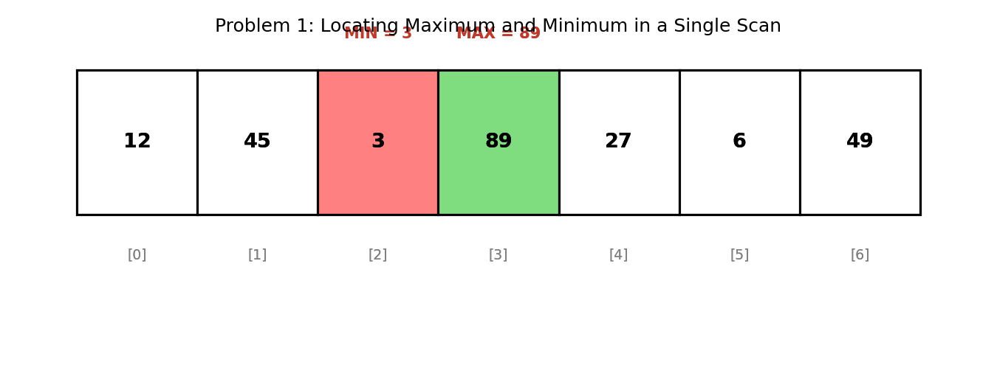

5. Java Program
public class MaxMin {

static int max, min;

static void findMaxMin(int[] arr) {
max = arr[0];
min = arr[0];
for (int i = 1; i < arr.length; i++) {
if (arr[i] > max) max = arr[i];
if (arr[i] < min) min = arr[i];
}
}

public static void main(String[] args) {
int[] arr = {12, 45, 3, 89, 27, 6, 49};

findMaxMin(arr);

System.out.print("Array: ");
for (int v : arr) System.out.print(v + " ");
System.out.println();
System.out.println("Maximum = " + max);
System.out.println("Minimum = " + min);
}
}

6. Expected Output
Array: 12 45 3 89 27 6 49
Maximum = 89
Minimum = 3

7. Complexity Analysis
- Time Complexity: O(n) — the array is scanned exactly once.
- Space Complexity: O(1) — only two extra variables (max, min) are used.
- This is optimal: any algorithm must inspect every element at least once, so Ω(n) is a lower bound.

8. Laboratory Exercise
Modify the program to also return the INDEX at which the maximum and minimum values occur. Test it with an array that contains duplicate maximum values and explain, in a comment, which index your program returns.

Problem 2: Reverse an Array In-Place

1. Objective
To reverse the order of elements in an array without allocating a second array.

2. Theory / Background
Reversing an array 'in place' means the transformation must happen using only the memory already occupied by the array, plus a small constant amount of temporary storage (a single swap variable). This is a foundational technique reused in more advanced problems such as array rotation (Problem 4).
The two-pointer technique is used: one pointer starts at the left end, another at the right end. Elements at the two pointers are swapped, then the pointers move toward each other until they meet or cross.

3. Algorithm
1. Set left = 0 and right = n - 1.
2. While left < right:
3. a. Swap arr[left] and arr[right] using a temporary variable.
4. b. Increment left and decrement right.
5. Stop when left >= right — the array is now reversed.

4. Graphical Illustration
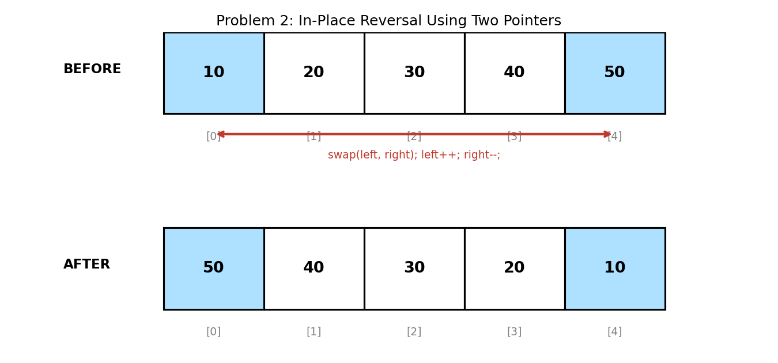

5. Java Program
import java.util.Arrays;

public class ReverseArray {

static void reverse(int[] arr) {
int left = 0, right = arr.length - 1;
while (left < right) {
int temp = arr[left];
arr[left] = arr[right];
arr[right] = temp;
left++;
right--;
}
}

public static void main(String[] args) {
int[] arr = {10, 20, 30, 40, 50};

System.out.println("Before: " + Arrays.toString(arr));
reverse(arr);
System.out.println("After: " + Arrays.toString(arr));
}
}

6. Expected Output
Before: [10, 20, 30, 40, 50]
After: [50, 40, 30, 20, 10]

7. Complexity Analysis
- Time Complexity: O(n) — approximately n/2 swaps are performed.
- Space Complexity: O(1) — only one temporary variable is used regardless of array size.
- Compare this to creating a new reversed array, which would cost O(n) additional space.

8. Laboratory Exercise
Rewrite the function recursively instead of iteratively (reverse the sub-array between left+1 and right-1 after swapping the outer pair). State the new space complexity, accounting for the recursion call stack.

Problem 3: Find All Pairs in an Array That Sum to a Given Target

1. Objective
To identify every pair of elements (a, b) in an array such that a + b equals a specified target value, using an efficient single-pass approach.

2. Theory / Background
The brute-force method compares every element with every other element using nested loops, costing O(n²) time. A faster method uses a hash set: while scanning the array, for each element x we check whether its complement (target - x) has already been seen. If it has, (complement, x) is a valid pair. Afterward, x itself is added to the set of seen values.
This trades a small amount of space (O(n) for the hash set) for a large improvement in time (O(n) instead of O(n²)).

3. Algorithm
1. Create an empty hash set called seen.
2. For each element x in the array:
3. a. Compute complement = target - x.
4. b. If complement exists in seen, print/record the pair (complement, x).
5. c. Insert x into seen.
6. Continue until the array is exhausted.

4. Graphical Illustration
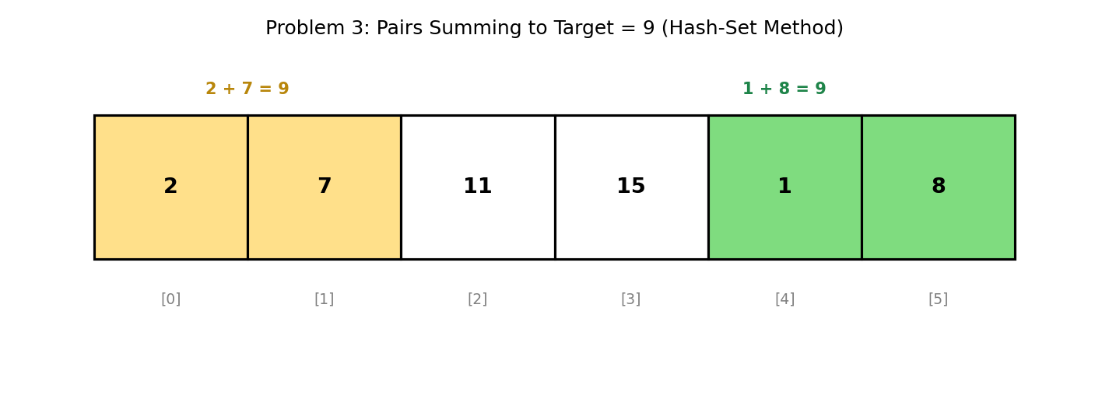

5. Java Program
import java.util.HashSet;

public class PairSum {

static void findPairs(int[] arr, int target) {
HashSet<Integer> seen = new HashSet<>();
int pairCount = 0;

System.out.println("Pairs that sum to " + target + ":");
for (int x : arr) {
int complement = target - x;
if (seen.contains(complement)) {
System.out.println(" (" + complement + ", " + x + ")");
pairCount++;
}
seen.add(x);
}
if (pairCount == 0) System.out.println(" No pairs found.");
}

public static void main(String[] args) {
int[] arr = {2, 7, 11, 15, 1, 8};
int target = 9;

findPairs(arr, target);
}
}

6. Expected Output
Pairs that sum to 9:
(2, 7)
(1, 8)

7. Complexity Analysis
- Time Complexity: O(n) average case, using O(1) average-time hash-set lookups.
- Space Complexity: O(n) — for storing seen elements in the hash set.
- Note: this program uses Java's built-in HashSet<Integer>, which handles negative numbers and arbitrarily large values correctly, unlike a fixed-size boolean array.

8. Laboratory Exercise
Modify the program to avoid printing the same pair twice when the array itself contains duplicate values (e.g., array = [3, 3, 6] with target = 6 should report (3,3) only once). Explain your fix.

Problem 4: Rotate an Array by k Positions (In-Place)

1. Objective
To shift every element of an array k positions to the left (with wrap-around) without using a second array.

2. Theory / Background
A naive rotation shifts elements one position at a time, k times, costing O(n·k) time. A far more elegant solution — the Reversal Algorithm — achieves the same result in O(n) time using only the in-place reversal technique from Problem 2, applied three times.
The insight is that rotating an array left by k is equivalent to: reversing the first k elements, reversing the remaining n-k elements, then reversing the entire array.

3. Algorithm
1. Compute k = k mod n (to safely handle k greater than n).
2. Reverse the sub-array from index 0 to k-1.
3. Reverse the sub-array from index k to n-1.
4. Reverse the entire array from index 0 to n-1.
5. The array is now rotated left by k positions.

4. Graphical Illustration
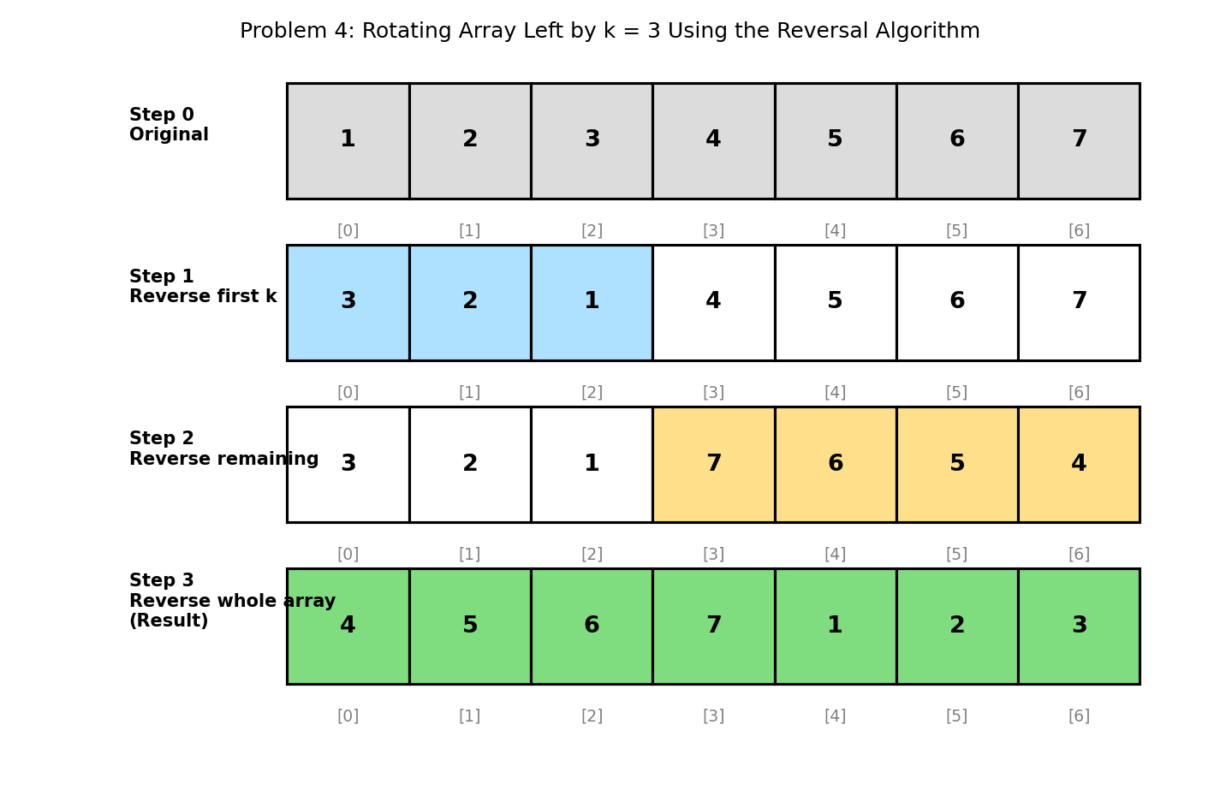

5. Java Program
import java.util.Arrays;

public class RotateArray {

static void reverse(int[] arr, int start, int end) {
while (start < end) {
int temp = arr[start];
arr[start] = arr[end];
arr[end] = temp;
start++;
end--;
}
}

static void rotateLeft(int[] arr, int k) {
int n = arr.length;
k = k % n; // handle k > n
reverse(arr, 0, k - 1); // Step 1: reverse first k elements
reverse(arr, k, n - 1); // Step 2: reverse remaining elements
reverse(arr, 0, n - 1); // Step 3: reverse the whole array
}

public static void main(String[] args) {
int[] arr = {1, 2, 3, 4, 5, 6, 7};
int k = 3;

System.out.println("Original: " + Arrays.toString(arr));
rotateLeft(arr, k);
System.out.println("Rotated left by " + k + ": " + Arrays.toString(arr));
}
}

6. Expected Output
Original: [1, 2, 3, 4, 5, 6, 7]
Rotated left by 3: [4, 5, 6, 7, 1, 2, 3]

7. Complexity Analysis
- Time Complexity: O(n) — each of the three reversal calls touches at most n elements, and the calls are sequential, not nested.
- Space Complexity: O(1) — no auxiliary array is allocated; all reversals happen in place.
- Contrast with the 'extra array' approach, which is also O(n) time but requires O(n) additional space.

8. Laboratory Exercise
Adapt the algorithm to rotate the array to the RIGHT by k positions instead of left. (Hint: a right rotation by k is equivalent to a left rotation by n-k.) Verify your answer using the same test array and k = 3.

Problem 5: Maximum Subarray Sum (Kadane's Algorithm)

1. Objective
To find the contiguous subarray within a one-dimensional array (containing at least one number) that has the largest possible sum, in a single pass.

2. Theory / Background
The brute-force approach checks the sum of every possible contiguous subarray, costing O(n²) or O(n³) time depending on implementation. Kadane's Algorithm reduces this to O(n) using dynamic programming: at each position, we decide whether to extend the previous subarray or start a new subarray from the current element.
The key recurrence is: maxEndingHere = max(arr[i], maxEndingHere + arr[i]). If the running sum becomes less useful than the current element alone, we 'restart' the subarray at the current position.

3. Algorithm
1. Initialise maxSoFar and maxEndingHere to arr[0]; record the current subarray start index.
2. For each subsequent element arr[i]:
3. a. If arr[i] alone exceeds (maxEndingHere + arr[i]), start a new subarray at i.
4. b. Otherwise, extend the existing subarray by adding arr[i].
5. c. If maxEndingHere exceeds maxSoFar, update maxSoFar and record the subarray's end index.
6. After the loop, maxSoFar holds the maximum subarray sum, bounded by the recorded start/end indices.

4. Graphical Illustration
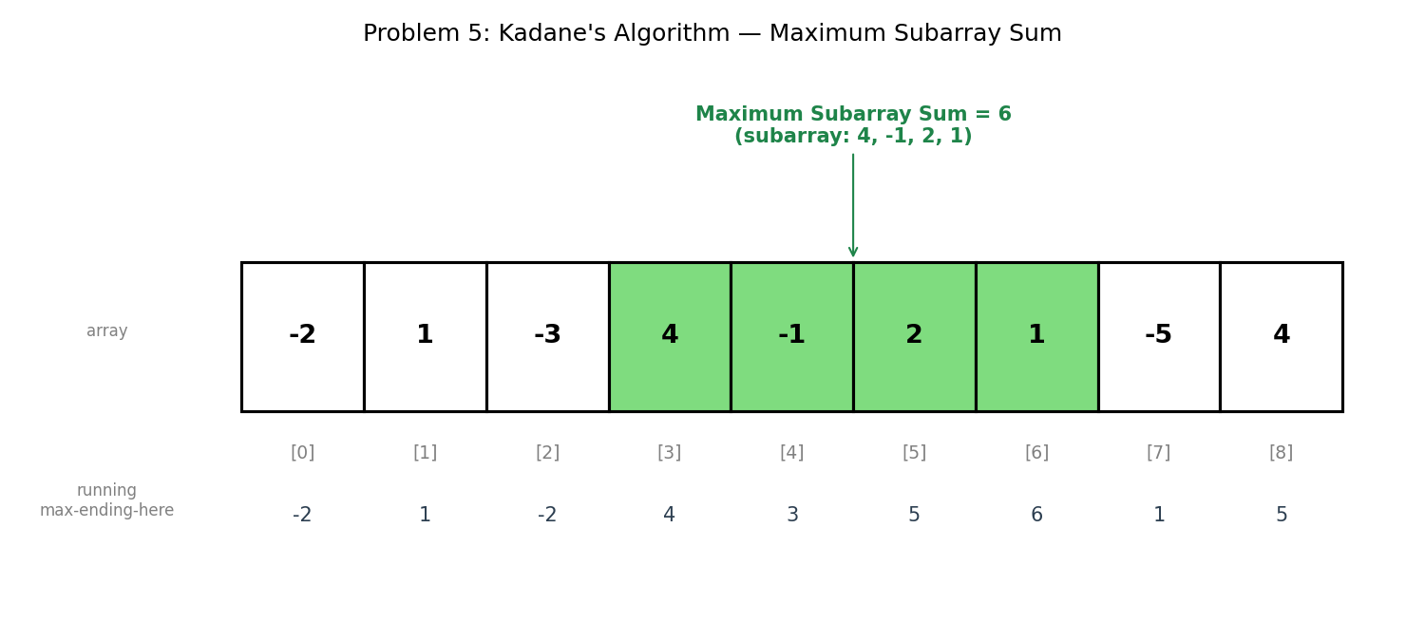

5. Java Program
import java.util.Arrays;

public class KadaneMaxSubarray {

static int start, end;

static int maxSubArraySum(int[] arr) {
int maxSoFar = arr[0];
int maxEndingHere = arr[0];
int tempStart = 0;
start = 0;
end = 0;

for (int i = 1; i < arr.length; i++) {
if (arr[i] > maxEndingHere + arr[i]) {
maxEndingHere = arr[i];
tempStart = i;
} else {
maxEndingHere = maxEndingHere + arr[i];
}

if (maxEndingHere > maxSoFar) {
maxSoFar = maxEndingHere;
start = tempStart;
end = i;
}
}
return maxSoFar;
}

public static void main(String[] args) {
int[] arr = {-2, 1, -3, 4, -1, 2, 1, -5, 4};

int maxSum = maxSubArraySum(arr);

System.out.println("Array: " + Arrays.toString(arr));
System.out.println("Maximum Subarray Sum = " + maxSum);
System.out.print("Subarray: ");
for (int i = start; i <= end; i++) System.out.print(arr[i] + " ");
System.out.println();
}
}

6. Expected Output
Array: [-2, 1, -3, 4, -1, 2, 1, -5, 4]
Maximum Subarray Sum = 6
Subarray: 4 -1 2 1

7. Complexity Analysis
- Time Complexity: O(n) — a single pass through the array with constant-time work per element.
- Space Complexity: O(1) — only a fixed number of tracking variables are needed.
- This is a classic example of Dynamic Programming applied to arrays: the optimal solution at position i is built directly from the optimal solution at position i-1.

8. Laboratory Exercise
Extend the program to correctly handle an array where ALL elements are negative (e.g., [-8, -3, -6, -2, -5]). Confirm that your program still returns a valid single-element subarray rather than 0, and explain why returning 0 would be incorrect.

Probable Examination Question — Module 1 (Arrays)
(a) Theory
Distinguish between an in-place algorithm and one that uses auxiliary space, using the array-reversal and array-rotation problems treated in this manual as examples. In your answer, state the space complexity of each approach discussed.
(b) Trace / Dry-run
Given the array A = {4, -1, 3, -2, 5, -8, 6}, dry-run Kadane's Algorithm on it step by step, showing the value of maxEndingHere and maxSoFar after each iteration. State the maximum subarray sum and identify the subarray that produces it.
(c) Programming
Write a complete Java program that:
- (i) Reads an array of n integers rotated left by an unknown amount k from an originally sorted array;
- (ii) Uses a modified binary search (not a linear scan) to locate a given target value in O(log n) time; and
- (iii) Prints the index of the target, or -1 if the target is not present.
Your program should compile and run without error. State the time complexity of your solution and justify why it is O(log n) rather than O(n).
(d) Short Answer
The reversal-based rotation algorithm performs three reversal passes over (parts of) the array, yet its overall time complexity remains O(n) rather than O(3n) or O(n²). Explain why, referencing how Big-O notation treats constant multipliers.

Lab Module 2: The Linked List Data Structure
Level: 300 (Third Year) | Language: Java (JDK 17+)
Learning Objectives
- Understand the structure of a singly linked list and how nodes reference one another via pointers.
- Implement classical linked-list algorithms in Java, including traversal, reversal, cycle detection, and merging.
- Analyse the time and space complexity of each algorithm using Big-O notation.
- Interpret node-and-pointer diagrams that model how each algorithm mutates the list.
General Instructions
- Type each program into a .java file matching its public class name exactly (e.g., ReverseList.java), then compile with: javac ClassName.java
- Run the compiled program with: java ClassName, and compare your output against the 'Expected Output' shown in this manual.
- Attempt the 'Laboratory Exercise' at the end of each problem before moving to the next.

Problem 1: Traverse a Singly Linked List and Print All Elements

1. Objective
To visit every node in a singly linked list, starting from the head, and print each node's data until the end (NULL) is reached.

2. Theory / Background
A singly linked list is a chain of nodes, where each node stores a data value and a reference (pointer) to the next node. Unlike an array, nodes are not stored in contiguous memory, so the only way to reach a node is by following the 'next' references starting from the head.
Traversal is the most fundamental linked-list operation: nearly every other operation (search, insertion, deletion, printing) is built on the same 'follow the pointers until NULL' pattern.

3. Algorithm
1. Set a temporary pointer, temp, to head.
2. While temp is not NULL:
3. a. Process (print) temp.data.
4. b. Move temp forward: temp = temp.next.
5. Stop when temp becomes NULL — every node has been visited exactly once.

4. Graphical Illustration
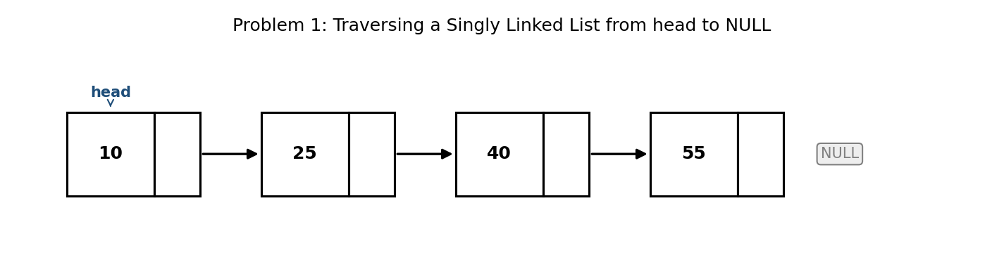

5. Java Program
public class Traversal {

static class Node {
int data;
Node next;
Node(int data) { this.data = data; }
}

static Node head;

static void insertAtEnd(int value) {
Node newNode = new Node(value);
if (head == null) { head = newNode; return; }
Node temp = head;
while (temp.next != null) temp = temp.next;
temp.next = newNode;
}

static void traverse() {
Node temp = head;
System.out.print("List: ");
while (temp != null) {
System.out.print(temp.data);
if (temp.next != null) System.out.print(" -> ");
temp = temp.next;
}
System.out.println(" -> NULL");
}

public static void main(String[] args) {
insertAtEnd(10);
insertAtEnd(25);
insertAtEnd(40);
insertAtEnd(55);

traverse();
}
}

6. Expected Output
List: 10 -> 25 -> 40 -> 55 -> NULL

7. Complexity Analysis
- Time Complexity: O(n) — each of the n nodes is visited exactly once.
- Space Complexity: O(1) — only a single temporary pointer is used regardless of list length.
- Unlike an array, there is no O(1) random access; reaching the k-th node still requires O(k) traversal steps.

8. Laboratory Exercise
Modify the program to also count and print the total number of nodes in the list as it traverses. Then write a second method that searches for a target value and prints its position (0-indexed), or -1 if not found.

Problem 2: Reverse a Singly Linked List

1. Objective
To reverse the direction of every 'next' pointer in a singly linked list, so that the last node becomes the new head.

2. Theory / Background
Reversing a linked list cannot be done the same way as reversing an array (Module 1), because a linked list has no index-based random access — only pointers. Instead, three pointers are tracked simultaneously: prev (the node behind), curr (the node being processed), and next (a temporary save of curr's original next node, taken before it is overwritten).
This is a foundational linked-list pattern reused in more advanced problems, such as reversing the list in fixed-size groups (Problem 5).

3. Algorithm
1. Initialise prev = null and curr = head.
2. While curr is not NULL:
3. a. Save next = curr.next (so the rest of the list is not lost).
4. b. Reverse the link: curr.next = prev.
5. c. Advance both pointers: prev = curr; curr = next.
6. When the loop ends, curr is NULL and prev points to the new head. Set head = prev.

4. Graphical Illustration
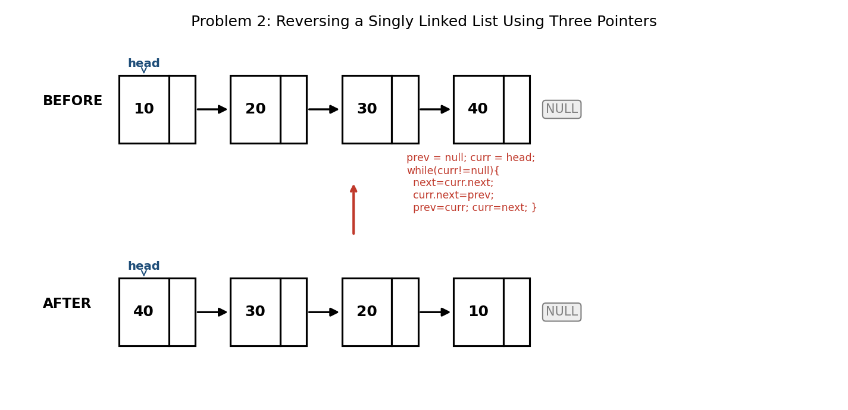

5. Java Program
public class ReverseList {

static class Node {
int data;
Node next;
Node(int data) { this.data = data; }
}

static Node head;

static void insertAtEnd(int value) {
Node newNode = new Node(value);
if (head == null) { head = newNode; return; }
Node temp = head;
while (temp.next != null) temp = temp.next;
temp.next = newNode;
}

static void reverse() {
Node prev = null;
Node curr = head;
while (curr != null) {
Node next = curr.next; // save next node
curr.next = prev; // reverse the pointer
prev = curr; // move prev forward
curr = next; // move curr forward
}
head = prev; // prev is the new head
}

static void print() {
Node temp = head;
while (temp != null) {
System.out.print(temp.data);
if (temp.next != null) System.out.print(" -> ");
temp = temp.next;
}
System.out.println(" -> NULL");
}

public static void main(String[] args) {
insertAtEnd(10);
insertAtEnd(20);
insertAtEnd(30);
insertAtEnd(40);

System.out.print("Before: ");
print();

reverse();

System.out.print("After: ");
print();
}
}

6. Expected Output
Before: 10 -> 20 -> 30 -> 40 -> NULL
After: 40 -> 30 -> 20 -> 10 -> NULL

7. Complexity Analysis
- Time Complexity: O(n) — every node's pointer is redirected exactly once.
- Space Complexity: O(1) — only three extra pointer variables are used, regardless of list length.
- Contrast this with reversing by copying data into a new list, which would also work but requires O(n) additional memory for the new nodes.

8. Laboratory Exercise
Rewrite the reverse() method recursively instead of iteratively. State the new space complexity of your recursive version, accounting for the function call stack, and explain under what circumstance the recursive version could cause a StackOverflowError.

Problem 3: Detect if a Linked List Contains a Cycle (Floyd's Algorithm)

1. Objective
To determine whether a linked list is a proper (NULL-terminated) list or contains a cycle, where some node's 'next' pointer eventually points back to an earlier node, without using any extra data structure.

2. Theory / Background
A naive approach stores every visited node's reference in a HashSet and checks for repeats — this works but costs O(n) extra space. Floyd's Cycle Detection Algorithm (also called the 'Tortoise and Hare' algorithm) achieves the same result in O(1) space by using two pointers that move at different speeds.
The slow pointer advances one node at a time; the fast pointer advances two nodes at a time. If there is no cycle, fast (or fast.next) will reach NULL. If a cycle exists, the fast pointer will eventually 'lap' the slow pointer and the two will meet at the same node — proving mathematically that a cycle exists.

3. Algorithm
1. Initialise slow = head and fast = head.
2. While fast is not NULL and fast.next is not NULL:
3. a. Move slow one step: slow = slow.next.
4. b. Move fast two steps: fast = fast.next.next.
5. c. If slow == fast (same node reference), a cycle exists — return true.
6. If the loop exits because fast or fast.next became NULL, no cycle exists — return false.

4. Graphical Illustration
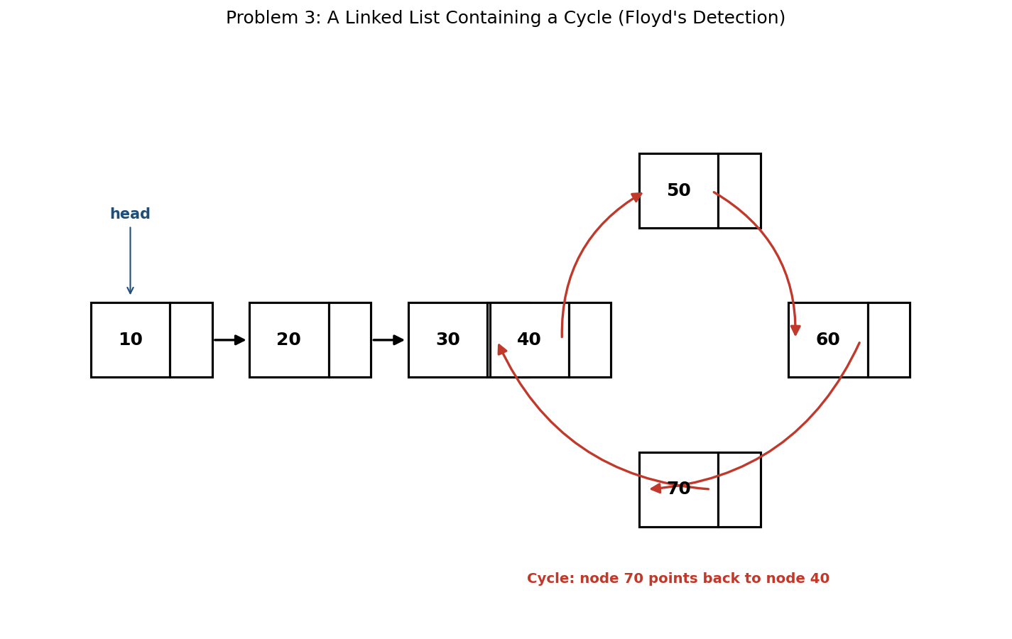

5. Java Program
public class CycleDetection {

static class Node {
int data;
Node next;
Node(int data) { this.data = data; }
}

static boolean hasCycle(Node head) {
Node slow = head;
Node fast = head;

while (fast != null && fast.next != null) {
slow = slow.next; // moves 1 step
fast = fast.next.next; // moves 2 steps
if (slow == fast) return true; // pointers met -> cycle exists
}
return false; // fast reached NULL -> no cycle
}

public static void main(String[] args) {
// Build list: 10 -> 20 -> 30 -> 40 -> 50 -> 60 -> 70 -> (back to 40)
Node n10 = new Node(10);
Node n20 = new Node(20);
Node n30 = new Node(30);
Node n40 = new Node(40);
Node n50 = new Node(50);
Node n60 = new Node(60);
Node n70 = new Node(70);

n10.next = n20;
n20.next = n30;
n30.next = n40;
n40.next = n50;
n50.next = n60;
n60.next = n70;
n70.next = n40; // creates the cycle

System.out.println("List has cycle: " + hasCycle(n10));

// A separate, cycle-free list for comparison
Node a = new Node(1);
a.next = new Node(2);
a.next.next = new Node(3);
System.out.println("Cycle-free list has cycle: " + hasCycle(a));
}
}

6. Expected Output
List has cycle: true
Cycle-free list has cycle: false

7. Complexity Analysis
- Time Complexity: O(n) — in the worst case, the fast pointer traverses at most twice the length of the list before either meeting slow or reaching NULL.
- Space Complexity: O(1) — only two pointer variables are used, no matter how long the list is.
- This is a significant improvement over the HashSet approach (O(n) time, O(n) space): Floyd's algorithm achieves the same O(n) time with constant space.

8. Laboratory Exercise
Extend the program with a findCycleStart(Node head) method that returns the node where the cycle BEGINS (not just whether one exists). (Hint: after slow and fast meet, reset one pointer to head and advance both one step at a time — they will meet again exactly at the start of the cycle.) Explain briefly why this technique works.

Problem 4: Merge Two Sorted Linked Lists into One Sorted List

1. Objective
To combine two linked lists, each already sorted in ascending order, into a single sorted linked list — reusing the existing nodes rather than creating new ones.

2. Theory / Background
Because both input lists are already sorted, we do not need to re-sort anything. Instead, we repeatedly compare the current heads of both lists, detach whichever is smaller, and append it to the result. This is the same core idea used in the 'merge' step of Merge Sort.
A dummy (placeholder) node is used to simplify the code: it gives the result list a fixed starting point, so no special-case logic is needed for attaching the very first real node.

3. Algorithm
1. Create a dummy node, and set a tail pointer to it.
2. While both lists (a and b) still have nodes:
3. a. Compare a.data and b.data.
4. b. Attach the smaller node to tail.next, then advance that list's pointer.
5. c. Advance tail to the newly attached node.
6. When one list is exhausted, attach the entire remainder of the other list directly to tail.next.
7. Return dummy.next as the head of the merged list.

4. Graphical Illustration
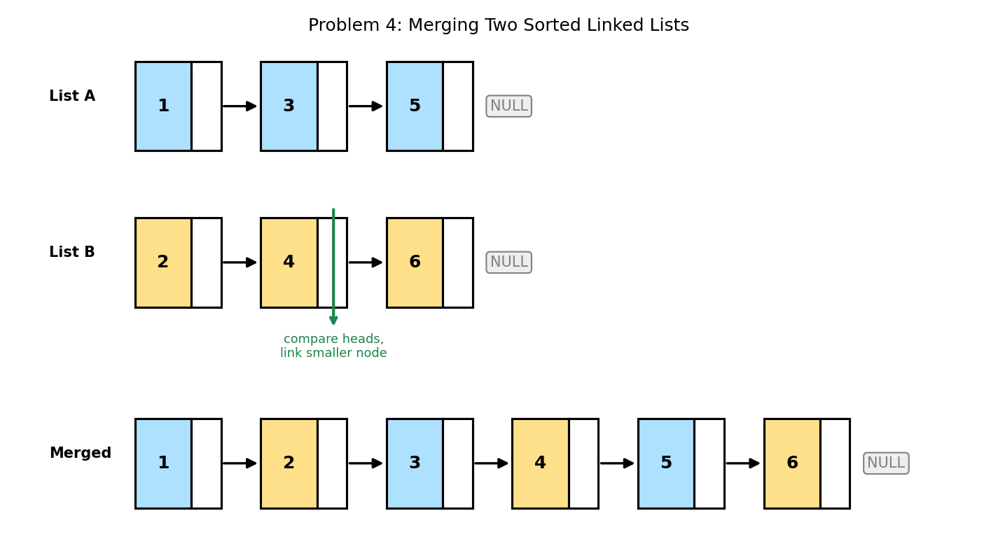

5. Java Program
public class MergeSortedLists {

static class Node {
int data;
Node next;
Node(int data) { this.data = data; }
}

static Node buildList(int[] values) {
Node head = null, tail = null;
for (int v : values) {
Node newNode = new Node(v);
if (head == null) { head = newNode; tail = newNode; }
else { tail.next = newNode; tail = newNode; }
}
return head;
}

static Node merge(Node a, Node b) {
Node dummy = new Node(0); // dummy node simplifies edge cases
Node tail = dummy;

while (a != null && b != null) {
if (a.data <= b.data) { tail.next = a; a = a.next; }
else { tail.next = b; b = b.next; }
tail = tail.next;
}
tail.next = (a != null) ? a : b; // attach whichever list remains

return dummy.next;
}

static void print(Node head) {
while (head != null) {
System.out.print(head.data);
if (head.next != null) System.out.print(" -> ");
head = head.next;
}
System.out.println(" -> NULL");
}

public static void main(String[] args) {
Node listA = buildList(new int[]{1, 3, 5});
Node listB = buildList(new int[]{2, 4, 6});

System.out.print("List A: "); print(listA);
System.out.print("List B: "); print(listB);

Node merged = merge(listA, listB);

System.out.print("Merged: "); print(merged);
}
}

6. Expected Output
List A: 1 -> 3 -> 5 -> NULL
List B: 2 -> 4 -> 6 -> NULL
Merged: 1 -> 2 -> 3 -> 4 -> 5 -> 6 -> NULL

7. Complexity Analysis
- Time Complexity: O(n + m) — where n and m are the lengths of the two lists; each node from both lists is visited exactly once.
- Space Complexity: O(1) additional space — existing nodes are re-linked, not copied; only the dummy node and a few pointers are created.
- This operation is the building block of the merge step in Merge Sort applied to linked lists, which sorts a list in O(n log n) time without requiring array-style random access.

8. Laboratory Exercise
Extend the program to merge k sorted linked lists (not just two), passed in as an array of list heads. State and justify the time complexity of your solution in terms of k (the number of lists) and n (the total number of nodes across all lists).

Problem 5: Reverse a Linked List in Groups of k Nodes

1. Objective
To reverse the nodes of a linked list, k nodes at a time, so that each group of k is individually reversed while the overall group order is preserved.

2. Theory / Background
This problem combines the pointer-reversal technique from Problem 2 with recursion. The list is processed one group of (up to) k nodes at a time: each group is reversed in place using the standard three-pointer technique, and then the ORIGINAL head of that group (now its tail) is linked to the result of recursively reversing the remaining groups.
If the final group has fewer than k remaining nodes, common practice (used here) is to still reverse whatever nodes remain.

3. Algorithm
1. If head is NULL, return NULL (base case).
2. Reverse the first k nodes as in Problem 2, keeping a count of how many nodes were actually reversed (curr and prev tracking).
3. After the loop, head (the original first node of this group) is now the TAIL of the reversed group.
4. If curr (the node after this group) is not NULL, recursively reverse the remaining list starting at curr, and set head.next to the result.
5. Return prev, which is the new head of this reversed group.

4. Graphical Illustration
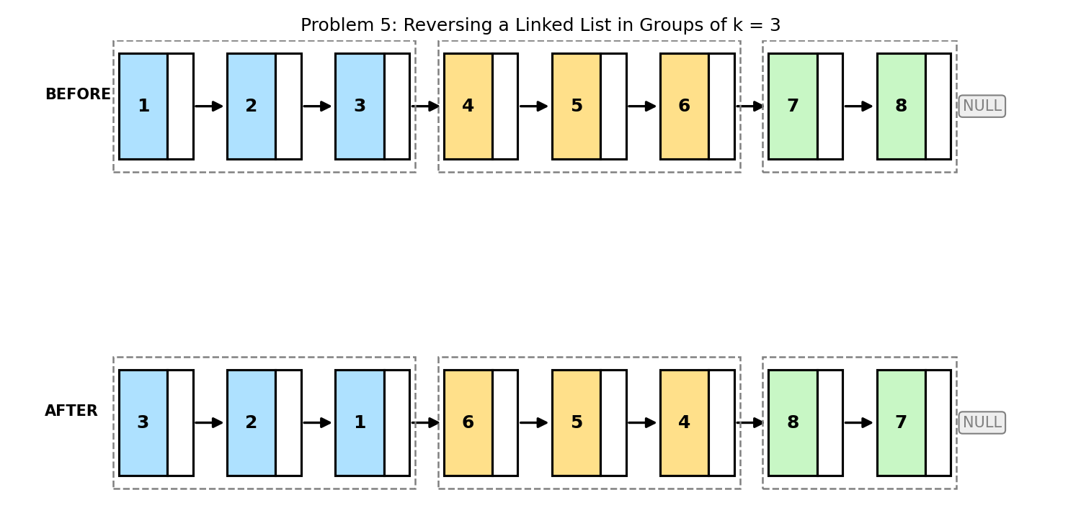

5. Java Program
public class ReverseInGroupsOfK {

static class Node {
int data;
Node next;
Node(int data) { this.data = data; }
}

static Node buildList(int[] values) {
Node head = null, tail = null;
for (int v : values) {
Node newNode = new Node(v);
if (head == null) { head = newNode; tail = newNode; }
else { tail.next = newNode; tail = newNode; }
}
return head;
}

static Node reverseInGroups(Node head, int k) {
if (head == null) return null;

Node curr = head;
Node prev = null;
int count = 0;

// reverse the first k nodes (or fewer, if the list runs out)
while (curr != null && count < k) {
Node next = curr.next;
curr.next = prev;
prev = curr;
curr = next;
count++;
}

// head is now the tail of this reversed group;
// its "next" must point to the head of the next reversed group.
if (curr != null) {
head.next = reverseInGroups(curr, k);
}

return prev; // prev is the new head of this group
}

static void print(Node head) {
while (head != null) {
System.out.print(head.data);
if (head.next != null) System.out.print(" -> ");
head = head.next;
}
System.out.println(" -> NULL");
}

public static void main(String[] args) {
Node head = buildList(new int[]{1, 2, 3, 4, 5, 6, 7, 8});
int k = 3;

System.out.print("Before: "); print(head);

head = reverseInGroups(head, k);

System.out.print("After: "); print(head);
}
}

6. Expected Output
Before: 1 -> 2 -> 3 -> 4 -> 5 -> 6 -> 7 -> 8 -> NULL
After: 3 -> 2 -> 1 -> 6 -> 5 -> 4 -> 8 -> 7 -> NULL

7. Complexity Analysis
- Time Complexity: O(n) — although the function calls itself recursively, each node is still visited and reversed exactly once across all recursive calls.
- Space Complexity: O(n/k) — due to the recursion call stack, which holds one stack frame per group of k nodes processed.
- Note that the final group (7, 8) has fewer than k = 3 nodes; the algorithm still reverses it correctly, demonstrating that the loop condition (curr != null && count < k) safely handles a short final group.

8. Laboratory Exercise
Rewrite reverseInGroups() iteratively instead of recursively, using an explicit loop over groups rather than function recursion. State the new space complexity and explain what practical advantage the iterative version has over the recursive version for very long lists.

Probable Examination Question — Module 2 (Linked Lists)
(a) Theory
Explain why an array-based reversal technique (swap left/right index) cannot be directly applied to a singly linked list. In your answer, describe what additional information a linked-list reversal algorithm must track that an array-based one does not.
(b) Trace / Dry-run
Given the singly linked list 5 -> 10 -> 15 -> 20 -> 25 -> NULL, dry-run Floyd's Cycle Detection Algorithm assuming NO cycle exists, showing the position of the slow and fast pointers after each iteration, and state what value each pointer holds when the loop terminates.
(c) Programming
Write a complete Java program that:
- (i) Builds a singly linked list from a given array of integers;
- (ii) Removes the N-th node from the END of the list in a single traversal (i.e., without first counting the length of the list in a separate pass); and
- (iii) Prints the resulting list.
Your program should compile and run without error. State the time complexity of your solution and explain how using two pointers, separated by N nodes, achieves the 'single traversal' requirement.
(d) Short Answer
The merge operation in Problem 4 re-links existing nodes rather than creating new ones. State one advantage and one limitation of this in-place approach compared to building a brand-new merged list from copied data.

Lab Module 3: The Stack Data Structure
Level: 300 (Third Year) | Language: Java (JDK 17+)
Learning Objectives
- Understand the Last-In-First-Out (LIFO) principle and how it is implemented using an array or Java's built-in Stack class.
- Implement classical stack-based algorithms in Java, including bracket matching, expression evaluation, and expression conversion.
- Analyse the time and space complexity of each algorithm using Big-O notation.
- Interpret stack-state diagrams that model how each algorithm's stack contents change over time.
General Instructions
- Type each program into a .java file matching its public class name exactly (e.g., MinStack.java), then compile with: javac ClassName.java
- Run the compiled program with: java ClassName, and compare your output against the 'Expected Output' shown in this manual.
- Attempt the 'Laboratory Exercise' at the end of each problem before moving to the next.

Problem 1: Implement a Stack Using an Array (push, pop, peek)

1. Objective
To implement the three fundamental stack operations — push, pop, and peek — using a fixed-size array as the underlying storage, and to enforce the Last-In-First-Out (LIFO) discipline.

2. Theory / Background
A stack only ever allows access to one end, called the TOP. Elements are added (pushed) and removed (popped) exclusively from the top, so the most recently inserted element is always the first one removed — hence 'Last-In-First-Out'.
When implemented with an array, a single integer variable, top, tracks the index of the current top element. top = -1 conventionally represents an empty stack. Pushing increments top before storing; popping reads the value at top before decrementing it.

3. Algorithm
1. Initialise an array arr[] of fixed capacity, and set top = -1.
2. push(value): if top == capacity - 1, report Stack Overflow. Otherwise, increment top and store arr[top] = value.
3. pop(): if top == -1, report Stack Underflow. Otherwise, return arr[top] and decrement top.
4. peek(): if top == -1, report that the stack is empty. Otherwise, return arr[top] without removing it.
5. isEmpty(): return true if and only if top == -1.

4. Graphical Illustration
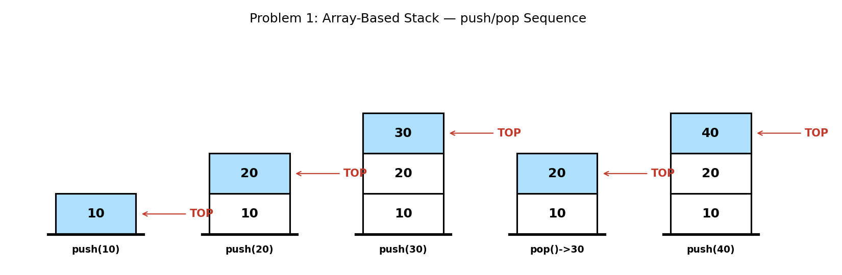

5. Java Program
public class ArrayStack {

static final int CAPACITY = 100;
static int[] arr = new int[CAPACITY];
static int top = -1; // -1 means the stack is empty

static boolean isEmpty() { return top == -1; }
static boolean isFull() { return top == CAPACITY - 1; }

static void push(int value) {
if (isFull()) { System.out.println("Stack Overflow"); return; }
arr[++top] = value;
}

static int pop() {
if (isEmpty()) { System.out.println("Stack Underflow"); return -1; }
return arr[top--];
}

static int peek() {
if (isEmpty()) { System.out.println("Stack is empty"); return -1; }
return arr[top];
}

public static void main(String[] args) {
push(10);
push(20);
push(30);
System.out.println("Peek: " + peek());

System.out.println("Pop: " + pop());
System.out.println("Pop: " + pop());

push(40);
System.out.println("Peek: " + peek());
System.out.println("Is empty? " + isEmpty());
}
}

6. Expected Output
Peek: 30
Pop: 30
Pop: 20
Peek: 40
Is empty? false

7. Complexity Analysis
- Time Complexity: O(1) for push, pop, and peek — each operation only touches the element at the top index.
- Space Complexity: O(n) — where n is the declared capacity of the underlying array, allocated up front.
- This is why arrays are a natural fit for stacks: no shifting of other elements is ever required, unlike inserting/deleting at the front of an array.

8. Laboratory Exercise
Rewrite the stack using Java's built-in java.util.ArrayList instead of a raw array, so that it grows dynamically and Stack Overflow can never occur (until memory itself is exhausted). Compare the trade-offs of the two designs.

Problem 2: Check if a String of Parentheses/Brackets Is Balanced

1. Objective
To determine whether every opening bracket in a string — (, {, or [ — has a matching closing bracket of the same type, in the correct order.

2. Theory / Background
A stack is the natural data structure for this problem because bracket matching is inherently LIFO: the most recently opened bracket must be the next one closed. As the string is scanned left to right, every opening bracket is pushed onto the stack. When a closing bracket is encountered, it must match whatever bracket is currently on top of the stack.
The expression is balanced if and only if: (a) every closing bracket matches the type on top of the stack when it is encountered, and (b) the stack is completely empty once the entire string has been scanned.

3. Algorithm
1. Create an empty stack.
2. For each character in the string:
3. a. If it is an opening bracket ( ( , { , [ ), push it onto the stack.
4. b. If it is a closing bracket, check whether the stack is empty (unmatched closer -> unbalanced). Otherwise pop the top and confirm it is the matching opener type.
5. c. Ignore all other characters (letters, operators, digits).
6. After scanning the whole string, it is balanced if and only if the stack is empty.

4. Graphical Illustration
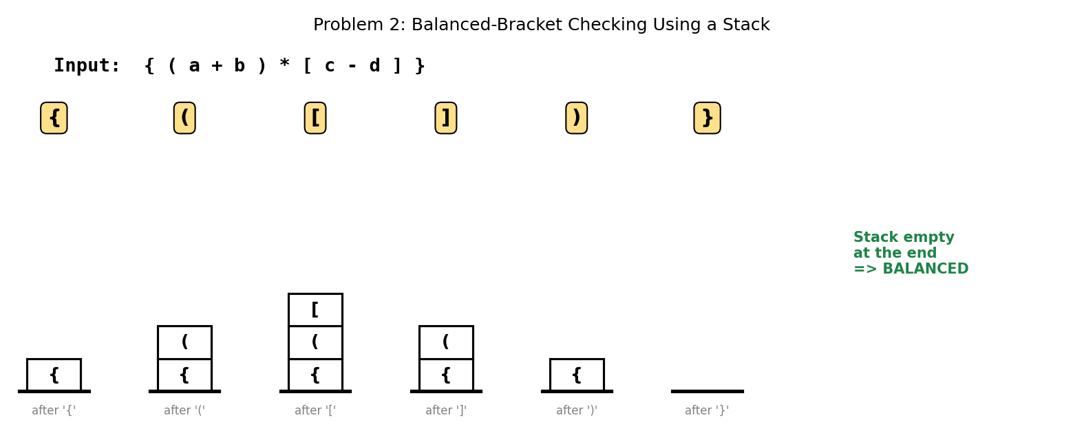

5. Java Program
import java.util.Stack;

public class BalancedBrackets {

static boolean isBalanced(String expr) {
Stack<Character> stack = new Stack<>();

for (char ch : expr.toCharArray()) {
if (ch == '(' || ch == '{' || ch == '[') {
stack.push(ch);
} else if (ch == ')' || ch == '}' || ch == ']') {
if (stack.isEmpty()) return false; // nothing to match
char open = stack.pop();
if (!matches(open, ch)) return false; // wrong bracket type
}
// any other character (letters, operators) is ignored
}
return stack.isEmpty(); // balanced only if every opener was matched
}

static boolean matches(char open, char close) {
return (open == '(' && close == ')') ||
(open == '{' && close == '}') ||
(open == '[' && close == ']');
}

public static void main(String[] args) {
String expr1 = "{(a+b)*[c-d]}";
String expr2 = "[(a+b)*(c-d]";

System.out.println(expr1 + " -> Balanced: " + isBalanced(expr1));
System.out.println(expr2 + " -> Balanced: " + isBalanced(expr2));
}
}

6. Expected Output
{(a+b)*[c-d]} -> Balanced: true
[(a+b)*(c-d] -> Balanced: false

7. Complexity Analysis
- Time Complexity: O(n) — the string is scanned exactly once, and each stack operation is O(1).
- Space Complexity: O(n) in the worst case — e.g., a string of nothing but opening brackets pushes every character onto the stack.
- This algorithm is the basis of syntax checking in compilers and code editors (matching braces, parentheses, and brackets in source code).

8. Laboratory Exercise
Extend the program to also report the INDEX of the first unmatched or mismatched bracket, so the error message can point the user directly to the offending character, similar to how a compiler reports a syntax error location.

Problem 3: Evaluate a Postfix (Reverse Polish) Expression

1. Objective
To compute the numeric result of an expression written in postfix (Reverse Polish) notation, in which every operator follows its operands, e.g., "2 3 4 * +" instead of "2 + 3 * 4".

2. Theory / Background
Postfix notation removes the need for parentheses or operator-precedence rules, because the order of operations is fully determined by the position of each operator relative to its operands. This makes postfix expressions especially easy to evaluate mechanically using a stack.
The rule is simple: whenever a number is encountered, push it. Whenever an operator is encountered, pop the top two numbers, apply the operator, and push the result back. At the end, exactly one value remains on the stack — the final answer.

3. Algorithm
1. Create an empty stack of numbers.
2. For each token in the postfix expression (space-separated):
3. a. If the token is a number, push it onto the stack.
4. b. If the token is an operator, pop the top two values (b, then a — b was pushed last), compute a OP b, and push the result.
5. After all tokens are processed, the single value remaining on the stack is the result.

4. Graphical Illustration
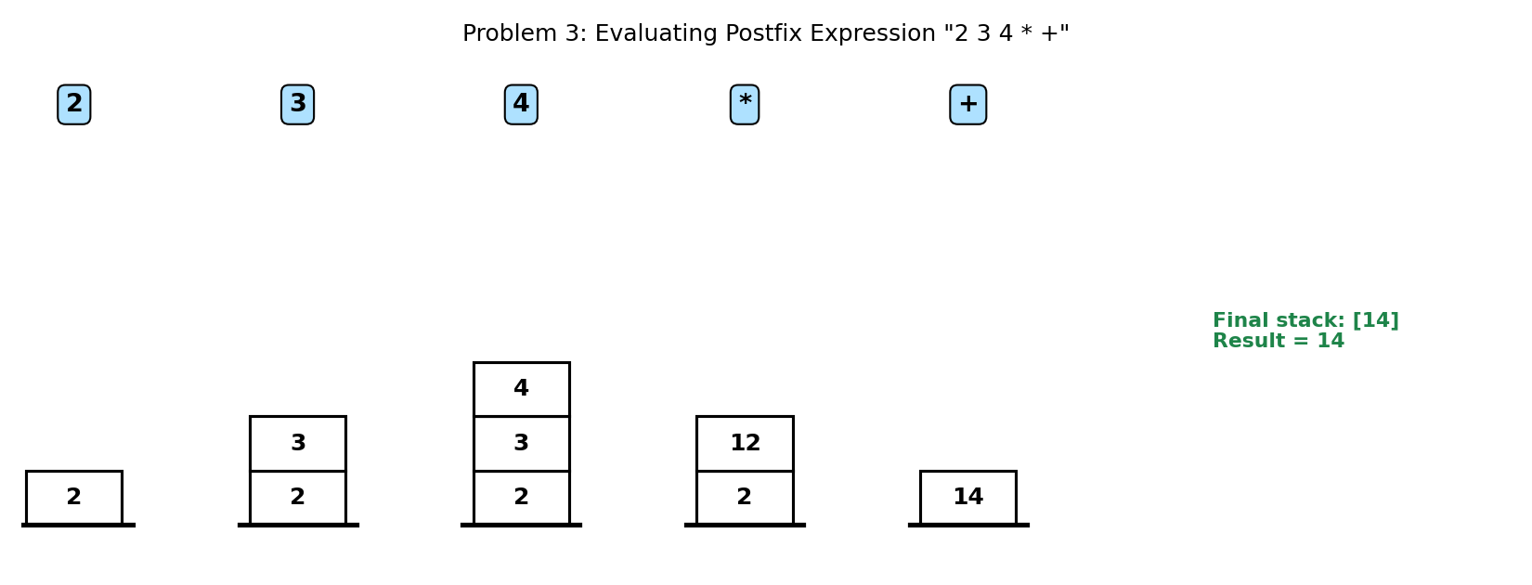

5. Java Program
import java.util.Stack;

public class PostfixEvaluator {

static int evaluate(String expr) {
Stack<Integer> stack = new Stack<>();
String[] tokens = expr.trim().split("\\s+");

for (String token : tokens) {
if (isOperator(token)) {
int b = stack.pop(); // second operand (pushed last)
int a = stack.pop(); // first operand
stack.push(applyOp(a, b, token.charAt(0)));
} else {
stack.push(Integer.parseInt(token));
}
}
return stack.pop(); // final result is the only value left
}

static boolean isOperator(String token) {
return token.equals("+") || token.equals("-") ||
token.equals("*") || token.equals("/");
}

static int applyOp(int a, int b, char op) {
switch (op) {
case '+': return a + b;
case '-': return a - b;
case '*': return a * b;
case '/': return a / b;
}
throw new IllegalArgumentException("Invalid operator: " + op);
}

public static void main(String[] args) {
String postfix = "2 3 4 * +"; // equivalent to 2 + (3 * 4)
System.out.println("Postfix expression: " + postfix);
System.out.println("Result = " + evaluate(postfix));
}
}

6. Expected Output
Postfix expression: 2 3 4 * +
Result = 14

7. Complexity Analysis
- Time Complexity: O(n) — where n is the number of tokens; each token triggers exactly one O(1) stack operation (or two pops plus one push for operators).
- Space Complexity: O(n) in the worst case — for an expression consisting mostly of operands before any operator reduces the stack.
- Postfix evaluation is exactly how many real calculators and virtual machines (including the JVM's own operand stack) evaluate expressions internally, precisely because it avoids the need for precedence parsing at evaluation time.

8. Laboratory Exercise
Extend the evaluator to support prefix (Polish) notation instead, e.g., "+ 2 * 3 4", where operators precede their operands. (Hint: you will need to scan the expression from RIGHT to LEFT.) Test it on the equivalent prefix form of this problem's example.

Problem 4: Implement a Stack That Retrieves the Minimum Element in O(1)

1. Objective
To design a stack that supports the standard push and pop operations, plus a getMin() operation that returns the current minimum element, all in O(1) time.

2. Theory / Background
A naive getMin() would scan the entire stack every time it is called, costing O(n) per call. To achieve O(1), a second, auxiliary stack (the 'min stack') is maintained alongside the main stack. At every push, the min stack also gets a new entry: either the newly pushed value (if it is a new minimum) or a repeat of the current minimum (if the new value is not smaller).
Because the two stacks are always pushed to and popped from together, the top of the min stack always reflects the minimum of exactly the elements currently in the main stack — no matter how many pops have occurred.

3. Algorithm
1. Maintain two stacks: mainStack (actual data) and minStack (running minimum).
2. push(value): push value onto mainStack. If minStack is empty or value <= minStack.peek(), push value onto minStack; otherwise push a repeat of minStack.peek().
3. pop(): pop from both mainStack and minStack together, keeping them in sync; return the popped mainStack value.
4. getMin(): simply return minStack.peek() — no scanning needed.

4. Graphical Illustration
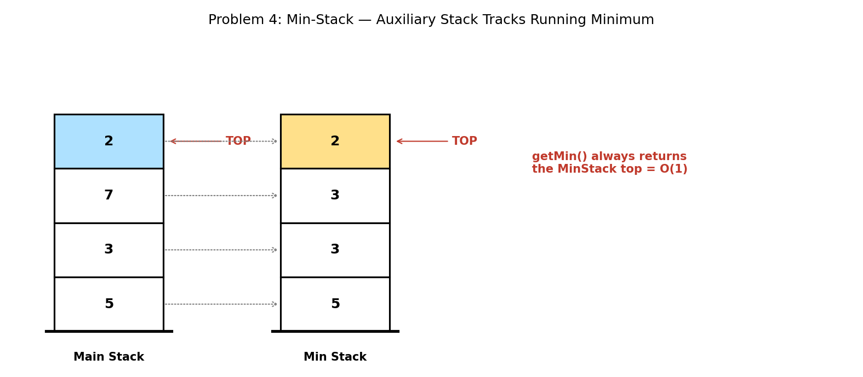

5. Java Program
import java.util.Stack;

public class MinStack {

static Stack<Integer> mainStack = new Stack<>();
static Stack<Integer> minStack = new Stack<>(); // top = current minimum

static void push(int value) {
mainStack.push(value);
if (minStack.isEmpty() || value <= minStack.peek()) {
minStack.push(value); // new minimum (or tie)
} else {
minStack.push(minStack.peek()); // repeat current minimum
}
}

static int pop() {
minStack.pop(); // keep both stacks in sync
return mainStack.pop();
}

static int getMin() {
return minStack.peek(); // O(1) — no scanning required
}

public static void main(String[] args) {
push(5);
push(3);
push(7);
push(2);

System.out.println("Current minimum: " + getMin()); // 2

pop(); // removes 2
System.out.println("Current minimum: " + getMin()); // 3

pop(); // removes 7
System.out.println("Current minimum: " + getMin()); // 3
}
}

6. Expected Output
Current minimum: 2
Current minimum: 3
Current minimum: 3

7. Complexity Analysis
- Time Complexity: O(1) for push, pop, and getMin — every operation touches only the top of one or both stacks.
- Space Complexity: O(n) — the auxiliary min stack stores one entry per element in the main stack, doubling the memory used compared to a plain stack.
- A common follow-up optimisation is to only push onto minStack when a NEW minimum occurs (storing it alongside a count of how many times it currently applies), which reduces the auxiliary stack's average size.

8. Laboratory Exercise
Modify the design so that minStack only stores a new entry when the minimum actually changes (rather than repeating unchanged minimums on every push). Update pop() accordingly, and explain the memory trade-off of your optimised version versus the original.

Problem 5: Convert an Infix Expression to Postfix Notation Using a Stack

1. Objective
To convert a human-readable infix expression (e.g., a+b*c), where operators sit between their operands and precedence/parentheses determine evaluation order, into an equivalent postfix expression (e.g., abc*+) that can be evaluated unambiguously without precedence rules.

2. Theory / Background
This conversion uses Edsger Dijkstra's Shunting-Yard Algorithm. An operator stack temporarily holds operators until it is their turn to be moved to the output. Operands go straight to the output. When a new operator arrives, any operators already on the stack with GREATER OR EQUAL precedence are popped to the output first — this is what encodes precedence rules (e.g., * before +) directly into the resulting postfix order.
Parentheses are handled specially: '(' is pushed to mark a boundary, and when ')' is encountered, operators are popped to the output until the matching '(' is found and discarded.

3. Algorithm
1. Create an empty operator stack and an empty output string.
2. For each character in the infix expression:
3. a. If it is an operand (letter/digit), append it directly to the output.
4. b. If it is '(', push it onto the operator stack.
5. c. If it is ')', pop operators to the output until '(' is found, then discard the '('.
6. d. If it is an operator, pop any stack-top operators with precedence >= the current operator's precedence to the output, then push the current operator.
7. After the expression is fully scanned, pop any remaining operators from the stack to the output.

4. Graphical Illustration
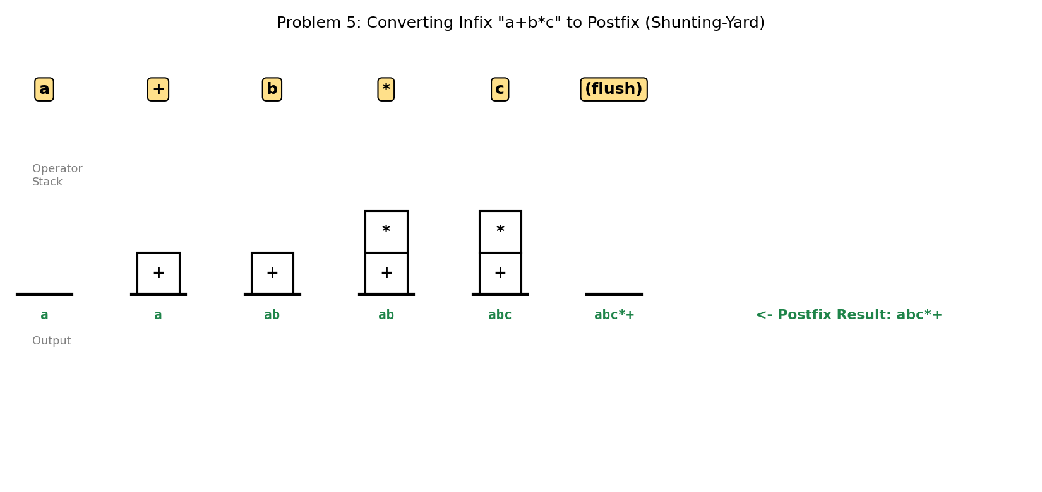

5. Java Program
import java.util.Stack;

public class InfixToPostfix {

static int precedence(char op) {
switch (op) {
case '+': case '-': return 1;
case '*': case '/': return 2;
default: return -1;
}
}

static boolean isOperator(char c) {
return c == '+' || c == '-' || c == '*' || c == '/';
}

static String convert(String infix) {
StringBuilder output = new StringBuilder();
Stack<Character> opStack = new Stack<>();

for (char ch : infix.toCharArray()) {
if (Character.isLetterOrDigit(ch)) {
output.append(ch); // operand -> output
} else if (ch == '(') {
opStack.push(ch);
} else if (ch == ')') {
while (!opStack.isEmpty() && opStack.peek() != '(') {
output.append(opStack.pop());
}
opStack.pop(); // discard the '('
} else if (isOperator(ch)) {
while (!opStack.isEmpty() && opStack.peek() != '(' &&
precedence(opStack.peek()) >= precedence(ch)) {
output.append(opStack.pop());
}
opStack.push(ch);
}
}
while (!opStack.isEmpty()) {
output.append(opStack.pop()); // flush remaining
}
return output.toString();
}

public static void main(String[] args) {
String infix = "a+b*c";
System.out.println("Infix: " + infix);
System.out.println("Postfix: " + convert(infix));

String infix2 = "(a+b)*(c-d)";
System.out.println("Infix: " + infix2);
System.out.println("Postfix: " + convert(infix2));
}
}

6. Expected Output
Infix: a+b*c
Postfix: abc*+
Infix: (a+b)*(c-d)
Postfix: ab+cd-*

7. Complexity Analysis
- Time Complexity: O(n) — each character is processed once, and each operator is pushed and popped from the stack at most once overall.
- Space Complexity: O(n) in the worst case — e.g., an expression consisting entirely of nested opening parentheses or same-precedence operators.
- Notice that a+b*c correctly becomes abc*+ (multiplication grouped first), demonstrating that precedence is respected purely through the stack's pop condition, without any explicit parsing of precedence levels beyond the precedence() lookup.

8. Laboratory Exercise
Extend the program to support the exponentiation operator ^, which is both higher precedence than * and / and right-associative (unlike + , -, *, /, which are left-associative). Explain what change to the popping condition is required to correctly handle right-associativity, and test it on the expression a^b^c (which should evaluate as a^(b^c), i.e., postfix abc^^).

Probable Examination Question — Module 3 (Stacks)
(a) Theory
Define the Last-In-First-Out (LIFO) principle and explain, with reference to the balanced-bracket problem (Problem 2), why a stack — rather than a queue — is the natural choice of data structure for that problem.
(b) Trace / Dry-run
Dry-run the evaluation of the postfix expression "6 2 3 + - 4 *" step by step, showing the contents of the stack after each token is processed, and state the final result.
(c) Programming
Write a complete Java program that:
- (i) Accepts an infix expression containing single-digit operands and the operators +, -, *, /, and parentheses;
- (ii) Converts it to postfix notation using the Shunting-Yard algorithm (as in Problem 5); and
- (iii) Evaluates the resulting postfix expression (as in Problem 3) and prints the final numeric result.
Your program should compile and run without error on the input (3+4)*2-1. State the overall time complexity of your combined solution.
(d) Short Answer
The Min-Stack design in Problem 4 uses O(n) auxiliary space to achieve O(1) getMin(). Explain, in your own words, the general trade-off being made here, and name one other problem area in computer science where a similar time-versus-space trade-off commonly arises.

Lab Module 4: The Queue Data Structure
Level: 300 (Third Year) | Language: Java (JDK 17+)
Learning Objectives
- Understand the First-In-First-Out (FIFO) principle and how it contrasts with the LIFO behaviour of a stack.
- Implement classical queue-based algorithms in Java, including array-based, circular, and stack-composed queues.
- Analyse the time and space complexity of each algorithm using Big-O notation.
- Interpret front/rear-pointer diagrams that model how each algorithm's queue contents change over time.
General Instructions
- Type each program into a .java file matching its public class name exactly (e.g., CircularQueue.java), then compile with: javac ClassName.java
- Run the compiled program with: java ClassName, and compare your output against the 'Expected Output' shown in this manual.
- Attempt the 'Laboratory Exercise' at the end of each problem before moving to the next.

Problem 1: Implement a Queue Using an Array (enqueue, dequeue)

1. Objective
To implement the two fundamental queue operations — enqueue and dequeue — using an array as the underlying storage, and to enforce the First-In-First-Out (FIFO) discipline.

2. Theory / Background
A queue only allows insertion at one end (the REAR) and removal from the other end (the FRONT), so the first element inserted is always the first one removed — hence 'First-In-First-Out'. This models real-world queues, such as people waiting in a line.
A simple array-based implementation tracks two indices: front (where the next dequeue will read from) and rear (where the next enqueue will write to). Unlike a stack, a queue's activity happens at BOTH ends, which is what makes a plain (non-circular) array implementation subtly wasteful, as later problems in this module will show.

3. Algorithm
1. Initialise front = 0, rear = -1, and count = 0 (count tracks how many elements are currently stored).
2. enqueue(value): if count == capacity, report Queue Overflow. Otherwise, increment rear and store arr[rear] = value; increment count.
3. dequeue(): if count == 0, report Queue Underflow. Otherwise, read arr[front], increment front, decrement count, and return the value read.
4. peekFront(): if count == 0, report that the queue is empty. Otherwise, return arr[front] without removing it.
5. isEmpty(): return true if and only if count == 0.

4. Graphical Illustration
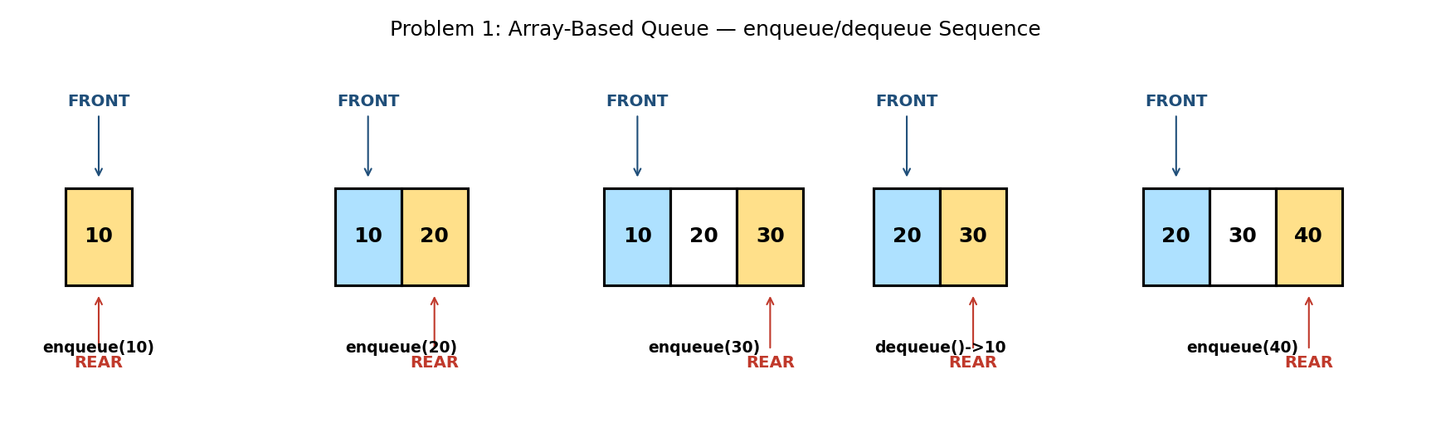

5. Java Program
public class ArrayQueue {

static final int CAPACITY = 100;
static int[] arr = new int[CAPACITY];
static int front = 0; // index of the front element
static int rear = -1; // index of the rear element
static int count = 0; // current number of elements

static boolean isEmpty() { return count == 0; }
static boolean isFull() { return count == CAPACITY; }

static void enqueue(int value) {
if (isFull()) { System.out.println("Queue Overflow"); return; }
rear = rear + 1;
arr[rear] = value;
count++;
}

static int dequeue() {
if (isEmpty()) { System.out.println("Queue Underflow"); return -1; }
int value = arr[front];
front++;
count--;
return value;
}

static int peekFront() {
if (isEmpty()) { System.out.println("Queue is empty"); return -1; }
return arr[front];
}

public static void main(String[] args) {
enqueue(10);
enqueue(20);
enqueue(30);
System.out.println("Front: " + peekFront());

System.out.println("Dequeue: " + dequeue());

enqueue(40);
System.out.println("Front: " + peekFront());
System.out.println("Is empty? " + isEmpty());
}
}

6. Expected Output
Front: 10
Dequeue: 10
Front: 20
Is empty? false

7. Complexity Analysis
- Time Complexity: O(1) for enqueue, dequeue, and peekFront — each touches only one array index.
- Space Complexity: O(n) — where n is the declared capacity, allocated up front.
- Limitation: because front only ever increases and never wraps back to 0, the array slots before front become permanently unusable once vacated. After enough dequeue/enqueue cycles, the queue reports Overflow even though many slots are actually free. Problem 3 (Circular Queue) fixes this.

8. Laboratory Exercise
Enqueue and dequeue elements repeatedly until front has advanced past several array slots, then attempt to enqueue enough elements to fill the remaining capacity. Confirm experimentally that Queue Overflow is reported even while count is well below the array's true length, and explain why in your own words.

Problem 2: Implement a Queue Using Two Stacks

1. Objective
To implement FIFO queue behaviour (enqueue, dequeue) using only two LIFO stacks as the underlying building blocks, without any direct array or linked-list queue logic.

2. Theory / Background
A stack naturally reverses order (LIFO), while a queue preserves order (FIFO). Interestingly, reversing a sequence TWICE restores the original order — this is the key insight behind implementing a queue with two stacks.
New elements are always pushed onto inStack. When a dequeue is requested, if outStack is empty, every element is popped from inStack and pushed onto outStack — this single reversal means the OLDEST element (originally at the bottom of inStack) ends up on TOP of outStack, ready to be popped in correct FIFO order. If outStack is already non-empty, its top is returned directly without touching inStack.

3. Algorithm
1. Maintain two stacks: inStack and outStack.
2. enqueue(value): simply push value onto inStack.
3. dequeue(): if outStack is empty, pop every element from inStack and push it onto outStack (reversing their order).
4. After the transfer step (or if outStack was already non-empty), pop and return the top of outStack.

4. Graphical Illustration
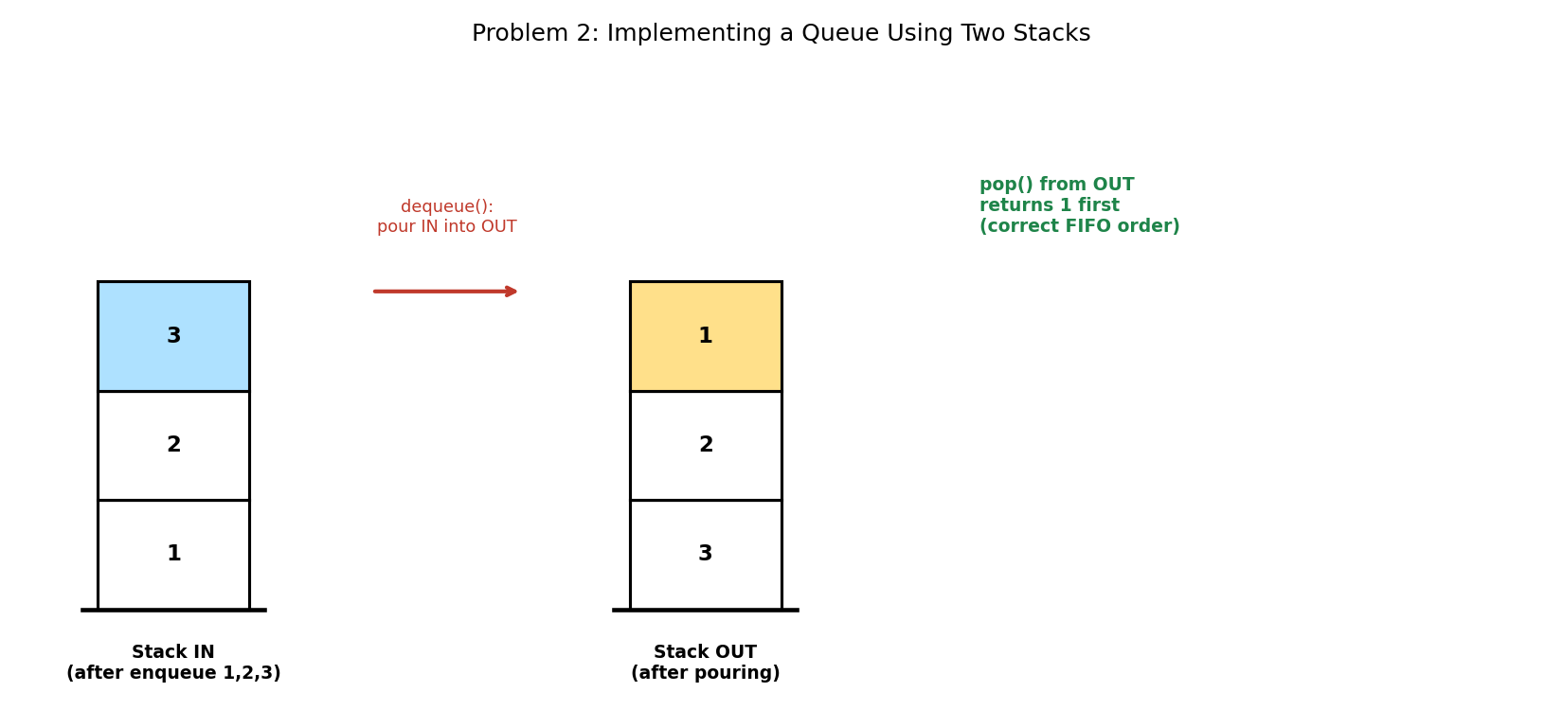

5. Java Program
import java.util.Stack;

public class QueueUsingTwoStacks {

static Stack<Integer> inStack = new Stack<>(); // receives new elements
static Stack<Integer> outStack = new Stack<>(); // serves dequeue calls

static void enqueue(int value) {
inStack.push(value);
}

static int dequeue() {
if (outStack.isEmpty()) {
// pour everything from inStack into outStack, reversing the order
while (!inStack.isEmpty()) {
outStack.push(inStack.pop());
}
}
if (outStack.isEmpty()) {
System.out.println("Queue Underflow");
return -1;
}
return outStack.pop();
}

public static void main(String[] args) {
enqueue(1);
enqueue(2);
enqueue(3);

System.out.println("Dequeue: " + dequeue()); // expect 1 (FIFO order)

enqueue(4); // added while outStack is not yet empty

System.out.println("Dequeue: " + dequeue()); // expect 2
System.out.println("Dequeue: " + dequeue()); // expect 3
System.out.println("Dequeue: " + dequeue()); // expect 4
}
}

6. Expected Output
Dequeue: 1
Dequeue: 2
Dequeue: 3
Dequeue: 4

7. Complexity Analysis
- Time Complexity: O(1) amortised per operation. A single element may be moved from inStack to outStack once, but once moved it is popped directly — so across n operations, the total work remains O(n), giving O(1) amortised cost per call.
- Space Complexity: O(n) — every enqueued element is stored in exactly one of the two stacks at any given time.
- This technique demonstrates 'amortised analysis': although a single dequeue() call can occasionally cost O(n) (when outStack must be refilled), this expensive step happens rarely enough that the AVERAGE cost per operation remains constant.

8. Laboratory Exercise
Trace through the program's four dequeue() calls by hand and identify EXACTLY which call triggers the O(n) transfer from inStack to outStack, and which calls are O(1) because outStack was already non-empty. Write your trace as a short table.

Problem 3: Design a Circular Queue With a Fixed Size

1. Objective
To implement a fixed-capacity queue that reuses vacated array slots by wrapping the front and rear indices back to the beginning of the array, eliminating the 'lost slots' limitation identified in Problem 1.

2. Theory / Background
In a circular queue, the underlying array is treated as if its end connects back to its beginning, forming a logical ring. Instead of ever-increasing front and rear indices, both are advanced using the modulo operator: index = (index + 1) % capacity. This means front and rear naturally wrap from the last array slot back to index 0.
A circular queue must also correctly distinguish between 'full' and 'empty' states, since both can otherwise look identical (front == rear can mean either, depending on convention). This implementation tracks an explicit count of stored elements to remove that ambiguity entirely.

3. Algorithm
1. Initialise front = 0, rear = -1, count = 0, for an array of fixed capacity.
2. enqueue(value): if count == capacity, report Queue Overflow. Otherwise, set rear = (rear + 1) % capacity, store arr[rear] = value, and increment count.
3. dequeue(): if count == 0, report Queue Underflow. Otherwise, read arr[front], set front = (front + 1) % capacity, decrement count, and return the value read.
4. Because rear and front both wrap via modulo, a slot vacated near the end of the array can be reused by a later enqueue that wraps around to the beginning.

4. Graphical Illustration
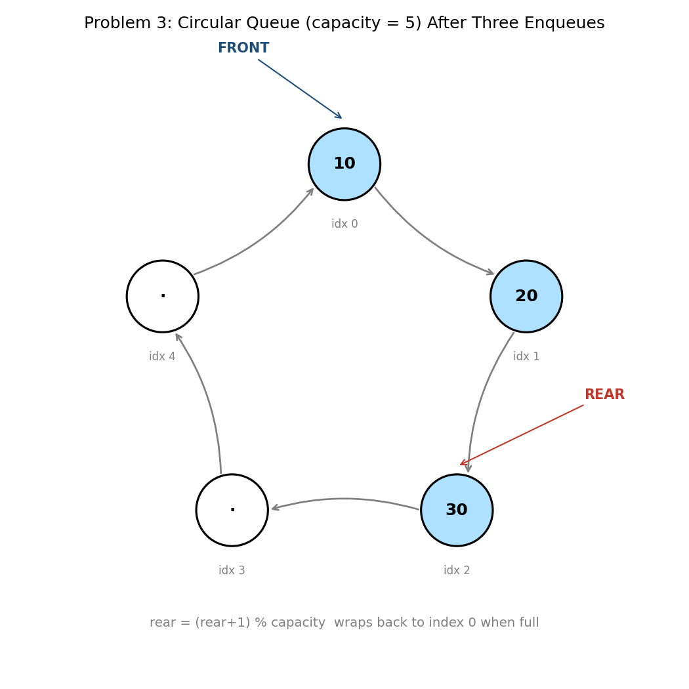

5. Java Program
public class CircularQueue {

int[] arr;
int front, rear, count, capacity;

CircularQueue(int capacity) {
this.capacity = capacity;
arr = new int[capacity];
front = 0;
rear = -1;
count = 0;
}

boolean isEmpty() { return count == 0; }
boolean isFull() { return count == capacity; }

void enqueue(int value) {
if (isFull()) { System.out.println("Queue Overflow"); return; }
rear = (rear + 1) % capacity; // wrap around when reaching the end
arr[rear] = value;
count++;
}

int dequeue() {
if (isEmpty()) { System.out.println("Queue Underflow"); return -1; }
int value = arr[front];
front = (front + 1) % capacity; // wrap around when reaching the end
count--;
return value;
}

int peekFront() {
if (isEmpty()) { System.out.println("Queue is empty"); return -1; }
return arr[front];
}

public static void main(String[] args) {
CircularQueue q = new CircularQueue(5);

q.enqueue(10);
q.enqueue(20);
q.enqueue(30);
System.out.println("Dequeue: " + q.dequeue()); // removes 10
System.out.println("Dequeue: " + q.dequeue()); // removes 20

// Enqueue enough elements to force wrap-around past index 4
q.enqueue(40);
q.enqueue(50);
q.enqueue(60); // rear wraps back to index 0
q.enqueue(70); // fills the queue to capacity

System.out.println("Front: " + q.peekFront()); // expect 30
System.out.println("Is full? " + q.isFull()); // 5/5 slots used
}
}

6. Expected Output
Dequeue: 10
Dequeue: 20
Front: 30
Is full? true

7. Complexity Analysis
- Time Complexity: O(1) for enqueue and dequeue — identical to the plain array queue, since only the modulo calculation is added.
- Space Complexity: O(n) — a fixed array of size n (the declared capacity); crucially, ALL n slots remain usable indefinitely, unlike Problem 1.
- This is the data structure typically used to implement fixed-size buffers in real systems, such as producer-consumer pipelines, streaming audio/video buffers, and CPU task scheduling queues.

8. Laboratory Exercise
Modify the program to support a resize() operation that doubles the array's capacity once the queue becomes full, copying existing elements into the new array in correct logical order (starting from front). State the amortised time complexity of enqueue once resizing is supported.

Problem 4: Find the First Non-Repeating Character in a Stream Using a Queue

1. Objective
To process a stream of characters one at a time and, after each character arrives, report the first character seen so far that has not (yet) repeated — without re-scanning the entire stream from the beginning at each step.

2. Theory / Background
A queue is used to hold 'candidate' characters — those seen so far that MIGHT still be the answer — in the order they first appeared. A hash map tracks how many times each character has occurred. Whenever a character at the FRONT of the candidate queue is found to have a frequency greater than 1, it can never be the answer again, so it is permanently removed from the front of the queue.
Because characters are removed only from the front of the queue as they become invalid, and added only at the rear as they arrive, the front of the queue (once cleaned up) always holds the correct answer for the stream processed so far.

3. Algorithm
1. Create an empty queue of candidate characters and an empty frequency map.
2. For each character in the incoming stream:
3. a. Increment its count in the frequency map.
4. b. Add it to the rear of the candidate queue.
5. c. While the character at the front of the queue has frequency > 1, remove it from the front.
6. d. Report the character now at the front of the queue as the current answer (or 'None' if the queue is empty).

4. Graphical Illustration
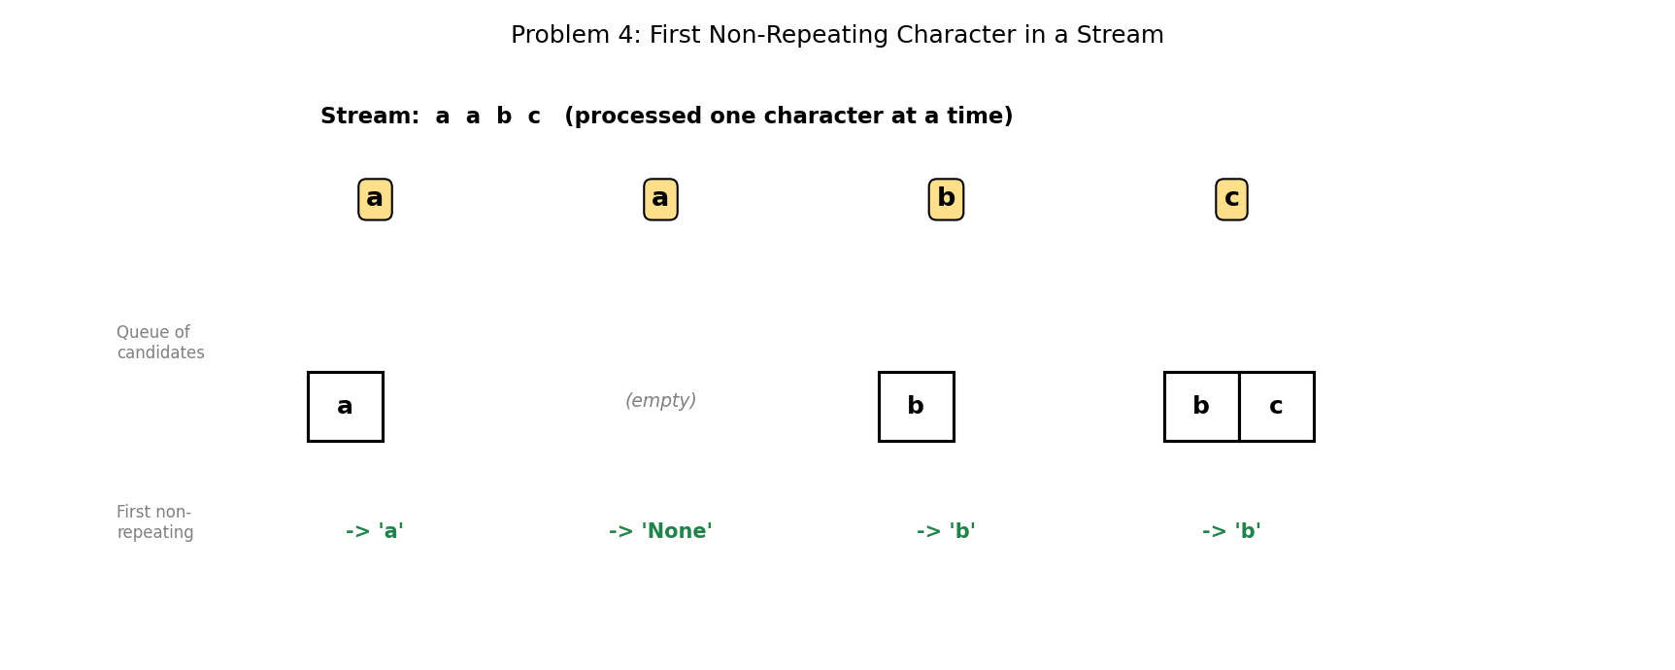

5. Java Program
import java.util.LinkedList;
import java.util.Queue;
import java.util.HashMap;
import java.util.Map;

public class FirstNonRepeating {

static void processStream(String stream) {
Queue<Character> candidates = new LinkedList<>();
Map<Character, Integer> freq = new HashMap<>();

for (char ch : stream.toCharArray()) {
freq.put(ch, freq.getOrDefault(ch, 0) + 1);
candidates.add(ch);

// discard candidates from the front that have become repeated
while (!candidates.isEmpty() && freq.get(candidates.peek()) > 1) {
candidates.poll();
}

char result = candidates.isEmpty() ? '#' : candidates.peek();
System.out.println("After '" + ch + "': first non-repeating = " +
(result == '#' ? "None" : result));
}
}

public static void main(String[] args) {
processStream("aabc");
}
}

6. Expected Output
After 'a': first non-repeating = a
After 'a': first non-repeating = None
After 'b': first non-repeating = b
After 'c': first non-repeating = b

7. Complexity Analysis
- Time Complexity: O(1) amortised per character. Although the inner while loop can remove several candidates, each character is added to and removed from the queue at most once across the ENTIRE stream, so the total cost for n characters is O(n).
- Space Complexity: O(k) — where k is the number of distinct characters possible (e.g., O(26) for lowercase English letters, or O(1) if the alphabet size is treated as a constant).
- This same 'sliding validity window enforced via a queue' pattern appears in many streaming algorithms, where old, now-invalid candidates must be efficiently discarded from the front as new data arrives.

8. Laboratory Exercise
Extend the program to also support a 'stream ended' query that reports whether AT LEAST ONE character in the entire stream never repeated at all — even if it is not currently at the front of the queue. (Hint: you already have all the information you need in the frequency map alone.)

Problem 5: Implement a Sliding Window Maximum Using a Deque

1. Objective
To compute the maximum value within every contiguous window of size k, as the window slides from the start to the end of an array, in overall linear time.

2. Theory / Background
A naive approach recomputes the maximum of each window from scratch, costing O(n*k) time overall. A double-ended queue (deque) achieves O(n) instead by storing candidate INDICES (not values) in decreasing order of their corresponding array values.
Before adding the current index, any indices at the BACK of the deque whose values are less than or equal to the current value are removed — they can never be the maximum again while the current, larger element remains in the window. The FRONT of the deque always holds the index of the current window's maximum, and is removed once it slides outside the window.

3. Algorithm
1. Create an empty deque (to store array indices).
2. For each index i in the array:
3. a. While the deque is non-empty and arr[back of deque] <= arr[i], remove from the back.
4. b. Add index i to the back of the deque.
5. c. If the index at the front of the deque has fallen outside the window (front == i - k), remove it from the front.
6. d. Once the first full window has formed (i >= k - 1), the value at arr[front of deque] is the maximum for the current window.

4. Graphical Illustration
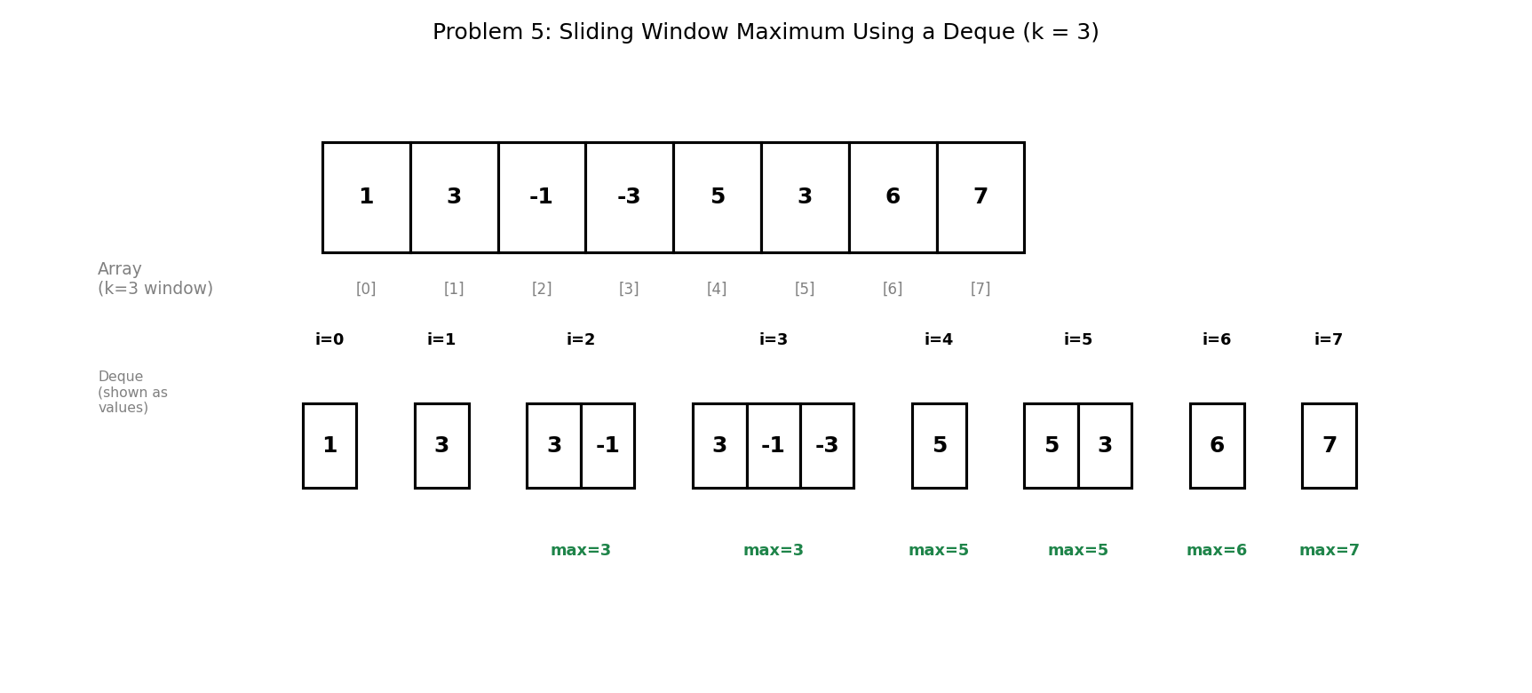

5. Java Program
import java.util.ArrayDeque;
import java.util.Deque;

public class SlidingWindowMax {

static int[] maxSlidingWindow(int[] arr, int k) {
int n = arr.length;
int[] result = new int[n - k + 1];
Deque<Integer> deque = new ArrayDeque<>(); // indices, decreasing

for (int i = 0; i < n; i++) {
// remove indices whose values are smaller than arr[i];
// they can never be the window maximum from now on
while (!deque.isEmpty() && arr[deque.peekLast()] <= arr[i]) {
deque.pollLast();
}
deque.addLast(i);

// remove the front index if it has left the window
if (deque.peekFirst() == i - k) {
deque.pollFirst();
}

// record a result once the first full window has been formed
if (i >= k - 1) {
result[i - k + 1] = arr[deque.peekFirst()];
}
}
return result;
}

public static void main(String[] args) {
int[] arr = {1, 3, -1, -3, 5, 3, 6, 7};
int k = 3;

int[] result = maxSlidingWindow(arr, k);

System.out.print("Array: ");
for (int v : arr) System.out.print(v + " ");
System.out.println("\nWindow size k = " + k);
System.out.print("Maximums: ");
for (int v : result) System.out.print(v + " ");
System.out.println();
}
}

6. Expected Output
Array: 1 3 -1 -3 5 3 6 7
Window size k = 3
Maximums: 3 3 5 5 6 7

7. Complexity Analysis
- Time Complexity: O(n) — although there are nested-looking operations, each index is added to the deque exactly once and removed at most once across the entire algorithm, giving amortised O(1) work per index.
- Space Complexity: O(k) — the deque never holds more than k indices at a time, since indices outside the current window are always removed.
- This is a significant improvement over the naive O(n*k) approach, and the same 'monotonic deque' technique generalises to other sliding-window minimum/maximum problems.

8. Laboratory Exercise
Adapt the program to compute the sliding window MINIMUM instead of the maximum, by changing only the comparison direction in the removal condition. Test your adaptation on the same array and window size used in this problem, and state the expected output.

Probable Examination Question — Module 4 (Queues)
(a) Theory
Define the First-In-First-Out (FIFO) principle and explain the specific limitation of the plain array-based queue (Problem 1) that motivates the design of the circular queue (Problem 3).
(b) Trace / Dry-run
Dry-run the sliding window maximum algorithm (Problem 5) on the array [4, 2, 9, 1, 7, 3] with window size k = 2, showing the contents of the deque after each index is processed, and state the final list of window maximums.
(c) Programming
Write a complete Java program that:
- (i) Implements a circular queue of fixed capacity n (as in Problem 3);
- (ii) Adds a peekRear() method that returns the most recently enqueued element without removing it; and
- (iii) Adds an isFull() and isEmpty() method, both operating in O(1) time.
Your program should compile and run without error, correctly handling the case where the queue wraps around after several enqueue/dequeue cycles. State the time complexity of each of the three added/used methods.
(d) Short Answer
The two-stack queue (Problem 2) achieves O(1) AMORTISED time per operation, rather than O(1) WORST-CASE time. Explain the difference between these two guarantees, and describe a specific sequence of enqueue/dequeue calls that would trigger the more expensive O(n) step.
Lab Module 5: The Hash Table Data Structure
Level: 300 (Third Year) | Language: Java (JDK 17+)
Learning Objectives
- Understand how a hash function maps keys to bucket indices, and why this enables average O(1) lookup.
- Apply Java's HashMap and HashSet to solve classical counting, matching, and grouping problems.
- Understand what a hash collision is and implement separate chaining to resolve it.
- Analyse the average-case versus worst-case time complexity of hash-based operations.
General Instructions
- Type each program into a .java file matching its public class name exactly (e.g., CustomHashMap.java), then compile with: javac ClassName.java
- Run the compiled program with: java ClassName, and compare your output against the 'Expected Output' shown in this manual.
- Attempt the 'Laboratory Exercise' at the end of each problem before moving to the next.

Problem 1: Count the Frequency of Each Element in an Array

1. Objective
To determine how many times each distinct value occurs in an array, using a hash table to accumulate counts in a single pass.

2. Theory / Background
A hash table (in Java, HashMap) stores key-value pairs and uses a hash function to convert each key into an array index called a bucket. Because the bucket is computed directly from the key rather than found by searching, lookups and insertions cost O(1) on average rather than O(n).
For frequency counting, each distinct array value becomes a KEY and its running count becomes the VALUE. A naive alternative would compare every element against every other element, costing O(n squared); the hash table reduces this to a single O(n) pass.

3. Algorithm
1. Create an empty HashMap with the element type as the key and Integer as the value.
2. For each value in the array:
3. a. Look up the value's current count, treating a missing key as 0 (getOrDefault).
4. b. Store the value back into the map with its count incremented by one.
5. After the single pass, iterate over the map's entries to report each key and its count.

4. Graphical Illustration
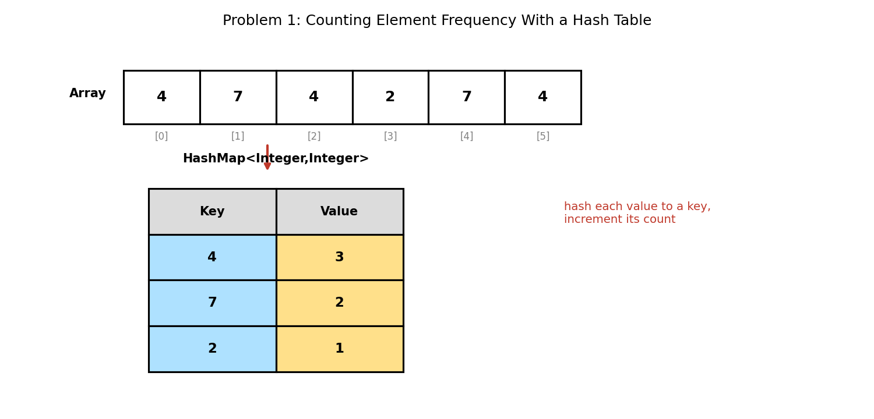

5. Java Program
import java.util.HashMap;
import java.util.Map;

public class FrequencyCount {

static void countFrequency(int[] arr) {
Map<Integer, Integer> freq = new HashMap<>();

for (int value : arr) {
// getOrDefault avoids a separate containsKey() check
freq.put(value, freq.getOrDefault(value, 0) + 1);
}

System.out.println("Element frequencies:");
for (Map.Entry<Integer, Integer> entry : freq.entrySet()) {
System.out.println(" " + entry.getKey() + " -> "
+ entry.getValue());
}
}

public static void main(String[] args) {
int[] arr = {4, 7, 4, 2, 7, 4};

System.out.print("Array: ");
for (int v : arr) System.out.print(v + " ");
System.out.println();

countFrequency(arr);
}
}

6. Expected Output
Array: 4 7 4 2 7 4
Element frequencies:
2 -> 1
4 -> 3
7 -> 2

7. Complexity Analysis
- Time Complexity: O(n) on average — one hash computation and one O(1) bucket access per element.
- Space Complexity: O(k) — where k is the number of DISTINCT values, since only distinct keys occupy the map.
- Important observation: the output above lists 2 before 4 before 7, which is NOT the order the values appeared in the array. A HashMap makes no ordering guarantee whatsoever. Use LinkedHashMap to preserve insertion order, or TreeMap to keep keys sorted.

8. Laboratory Exercise
Modify the program to also report which element occurs MOST frequently (and how many times). If two elements tie for the highest count, decide and document what your program does. Then switch the HashMap to a LinkedHashMap and describe how the output changes.

Problem 2: Check if Two Strings Are Anagrams Using a Hash Map

1. Objective
To determine whether two strings contain exactly the same characters with exactly the same frequencies, differing only in the order of those characters.

2. Theory / Background
Two strings are anagrams if their character-frequency maps are identical. A common alternative is to sort both strings and compare them, which costs O(n log n); the hash-map approach achieves O(n) instead by counting rather than ordering.
This implementation uses a single map and a build-then-cancel strategy: characters from the first string increment counts, and characters from the second string decrement them. If the two strings are true anagrams, every count cancels exactly to zero and the map ends up empty. Any leftover entry, negative count, or unknown character proves they are not anagrams.

3. Algorithm
1. If the two strings differ in length, return false immediately (a cheap early rejection).
2. Create an empty HashMap from Character to Integer.
3. For each character of the first string, increment its count in the map.
4. For each character of the second string:
5. a. If the character is not present in the map at all, return false.
6. b. Otherwise decrement its count, and remove the key entirely once its count reaches zero.
7. Return true if and only if the map is empty at the end.

4. Graphical Illustration
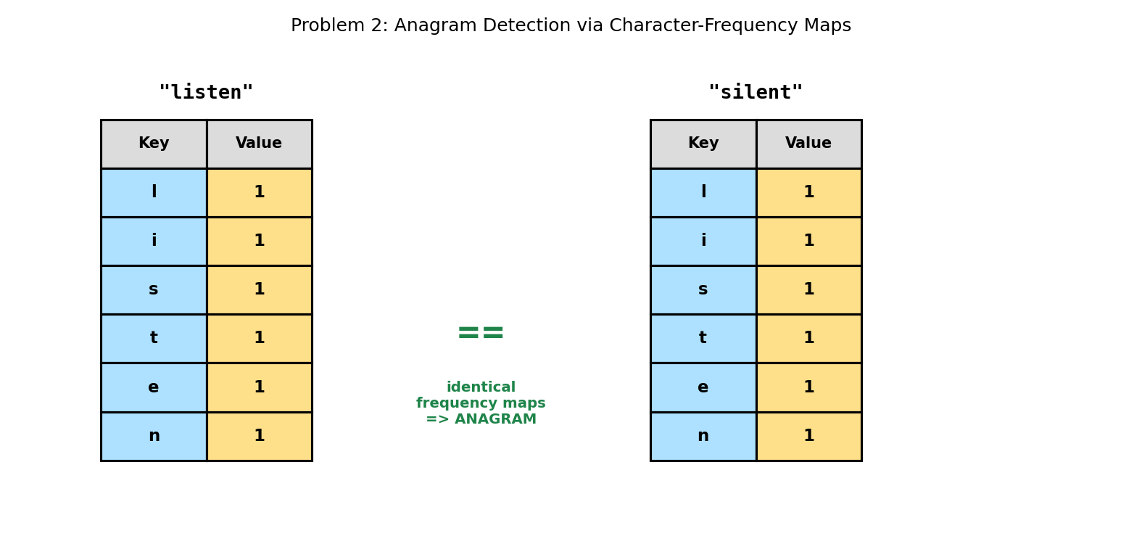

5. Java Program
import java.util.HashMap;
import java.util.Map;

public class AnagramCheck {

static boolean areAnagrams(String a, String b) {
if (a.length() != b.length()) return false; // quick rejection

Map<Character, Integer> freq = new HashMap<>();

// count characters of the first string
for (char ch : a.toCharArray()) {
freq.put(ch, freq.getOrDefault(ch, 0) + 1);
}

// subtract characters of the second string
for (char ch : b.toCharArray()) {
if (!freq.containsKey(ch)) return false; // not in first string
freq.put(ch, freq.get(ch) - 1);
if (freq.get(ch) == 0) freq.remove(ch);
}

return freq.isEmpty(); // empty => perfectly balanced => anagram
}

public static void main(String[] args) {
System.out.println("listen/silent -> "
+ areAnagrams("listen", "silent"));
System.out.println("hello/world -> "
+ areAnagrams("hello", "world"));
System.out.println("aab/abb -> "
+ areAnagrams("aab", "abb"));
}
}

6. Expected Output
listen/silent -> true
hello/world -> false
aab/abb -> false

7. Complexity Analysis
- Time Complexity: O(n) — each string is scanned exactly once, with O(1) average-cost map operations per character.
- Space Complexity: O(k) — where k is the number of distinct characters (at most the alphabet size, so O(1) when the alphabet is fixed).
- Note the third test case: "aab" and "abb" use the same LETTERS but in different QUANTITIES. A naive check that only compares the SET of characters present would wrongly report these as anagrams; counting frequencies correctly rejects them.

8. Laboratory Exercise
Extend the program with a case-insensitive, whitespace-ignoring variant so that phrases such as "Dormitory" and "Dirty Room" are correctly identified as anagrams. Explain which pre-processing step you added and why it must happen before counting.

Problem 3: Find the First Non-Repeating Element in an Array

1. Objective
To identify the first element (in original array order) that occurs exactly once, using a hash map to avoid repeatedly re-scanning the array.

2. Theory / Background
This problem requires combining two pieces of information: how OFTEN each value occurs (which a hash map provides efficiently) and the ORDER in which values first appear (which the original array already provides). Because a HashMap does not preserve order, the array itself must supply the ordering.
The solution therefore uses two passes. The first pass builds the frequency map; the second pass walks the array in its original order and returns the first value whose recorded count equals one. Two passes over the array is still O(n) overall, far better than the O(n squared) nested-loop alternative.

3. Algorithm
1. PASS 1: Traverse the array, building a HashMap of value to occurrence count.
2. PASS 2: Traverse the SAME array again, in its original left-to-right order.
3. a. For each value, look up its count in the map.
4. b. If the count is exactly 1, return that value immediately — it is the answer.
5. If the second pass completes without finding any count of 1, return a sentinel value (here, -1) to signal that every element repeats.

4. Graphical Illustration
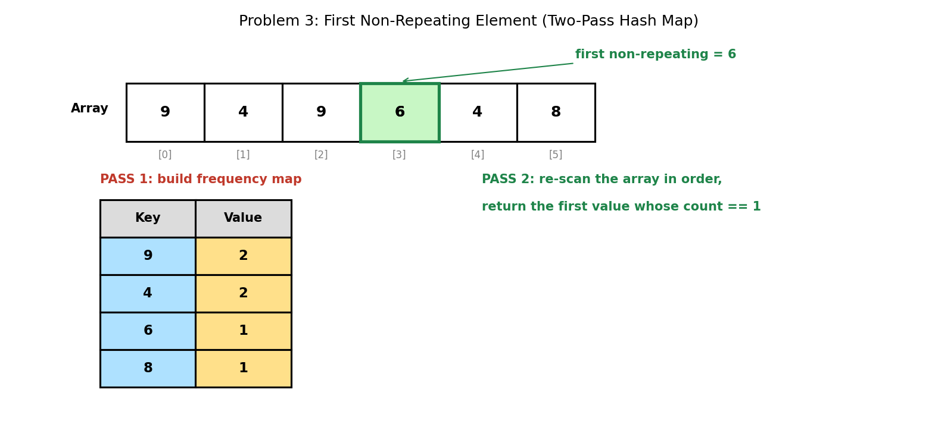

5. Java Program
import java.util.HashMap;
import java.util.Map;

public class FirstNonRepeating {

static int findFirstNonRepeating(int[] arr) {
Map<Integer, Integer> freq = new HashMap<>();

// PASS 1: count how many times each value occurs
for (int value : arr) {
freq.put(value, freq.getOrDefault(value, 0) + 1);
}

// PASS 2: re-scan in ORIGINAL order, return first value with count 1
for (int value : arr) {
if (freq.get(value) == 1) return value;
}

return -1; // sentinel: every element repeats
}

public static void main(String[] args) {
int[] arr = {9, 4, 9, 6, 4, 8};

System.out.print("Array: ");
for (int v : arr) System.out.print(v + " ");
System.out.println();

int result = findFirstNonRepeating(arr);
System.out.println("First non-repeating element: " + result);

int[] allRepeat = {5, 5, 3, 3};
System.out.println("All-repeating array result: " +
findFirstNonRepeating(allRepeat));
}
}

6. Expected Output
Array: 9 4 9 6 4 8
First non-repeating element: 6
All-repeating array result: -1

7. Complexity Analysis
- Time Complexity: O(n) — two separate passes over the array, and 2n is still O(n).
- Space Complexity: O(k) — where k is the number of distinct values stored in the frequency map.
- Design note: the sentinel -1 is only safe because it cannot be confused with a legitimate answer in this test data. In production code, returning Optional<Integer> or throwing an exception would be safer, since -1 could itself be a valid array element.

8. Laboratory Exercise
Replace the -1 sentinel with Java's Optional<Integer> return type, so the 'no answer exists' case cannot be confused with a legitimate array value of -1. Update main() to handle both cases, and explain why this design is more robust.

Problem 4: Group Anagrams Together From a List of Strings

1. Objective
To partition a list of words into groups, where each group contains all words that are anagrams of one another.

2. Theory / Background
The central insight is that every anagram of a given word produces the SAME string when its letters are sorted. For example, "eat", "tea", and "ate" all sort to "aet". That sorted string therefore makes a perfect hash KEY: all members of an anagram family map to the same key automatically.
The map's value is a list of the original words sharing that key. A naive approach would compare every word against every other word, costing O(n squared) comparisons; the hash-key approach reduces this to a single pass over the word list.

3. Algorithm
1. Create an empty HashMap from String (the sorted key) to List<String> (the group members).
2. For each word in the input list:
3. a. Convert the word to a character array, sort it, and convert it back to a String — this is the group key.
4. b. If the key is not yet present in the map, associate it with a new empty list (putIfAbsent).
5. c. Add the ORIGINAL (unsorted) word to the list stored under that key.
6. Return the map's collection of values — each value is one complete anagram group.

4. Graphical Illustration
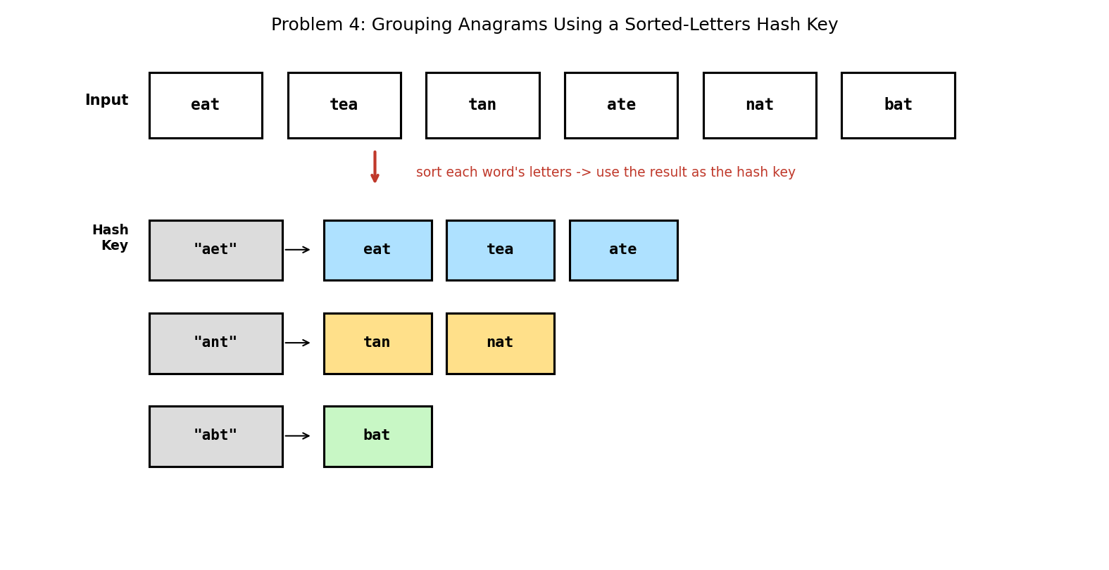

5. Java Program
import java.util.ArrayList;
import java.util.Arrays;
import java.util.HashMap;
import java.util.List;
import java.util.Map;

public class GroupAnagrams {

static List<List<String>> groupAnagrams(String[] words) {
Map<String, List<String>> groups = new HashMap<>();

for (String word : words) {
// sorting the letters gives all anagrams an identical key
char[] letters = word.toCharArray();
Arrays.sort(letters);
String key = new String(letters);

groups.putIfAbsent(key, new ArrayList<>());
groups.get(key).add(word);
}

return new ArrayList<>(groups.values());
}

public static void main(String[] args) {
String[] words = {"eat", "tea", "tan", "ate", "nat", "bat"};

System.out.println("Input: " + Arrays.toString(words));
System.out.println("Grouped anagrams:");

for (List<String> group : groupAnagrams(words)) {
System.out.println(" " + group);
}
}
}

6. Expected Output
Input: [eat, tea, tan, ate, nat, bat]
Grouped anagrams:
[eat, tea, ate]
[bat]
[tan, nat]

7. Complexity Analysis
- Time Complexity: O(n * m log m) — where n is the number of words and m is the maximum word length; sorting each word's letters costs O(m log m), and this is done once per word.
- Space Complexity: O(n * m) — every input word is stored exactly once across the groups, plus one key per distinct anagram family.
- Note again that the GROUPS themselves appear in no particular order (the [bat] group prints before [tan, nat]), because HashMap does not order its values. The words WITHIN each group do retain their original relative order, because each list is appended to in input order.

8. Laboratory Exercise
Replace the sort-based key with a frequency-based key — for example, a 26-character count signature such as "a1e1t1" — so that no sorting is required. State the new time complexity and explain under what circumstances (word length versus alphabet size) this alternative would be faster.

Problem 5: Design and Implement Your Own Hash Map With Collision Handling

1. Objective
To implement a hash map from first principles — including the hash function, bucket array, and separate-chaining collision resolution — supporting put, get, remove, and size operations.

2. Theory / Background
A hash map is built on an array of BUCKETS. A hash function converts each key into a bucket index. Because the number of possible keys vastly exceeds the number of buckets, two different keys will sometimes produce the same index — this is called a COLLISION, and it is unavoidable in practice.
SEPARATE CHAINING resolves collisions by making each bucket the head of a linked list (a 'chain') of entries. Colliding keys simply join the same chain, and lookups scan that short chain comparing keys with equals(). In the verified output below, 'fig' and 'apple' both hash to bucket 0 and are therefore chained together, while every other key occupies a bucket alone.
Note that put() must first scan the chain for an EXISTING matching key so that re-inserting a key updates its value rather than creating a duplicate entry.

3. Algorithm
1. Define an Entry class holding a key, a value, and a next reference (forming the chain).
2. Create an array of Entry of the chosen bucket count; every bucket starts as null.
3. getBucketIndex(key): return Math.abs(key.hashCode()) % numBuckets.
4. put(key, value): compute the index, scan that bucket's chain for a matching key; if found, overwrite its value and return. Otherwise create a new Entry, link it at the HEAD of the chain, and increment size.
5. get(key): compute the index and walk the chain, returning the value of the entry whose key equals the search key, or null if the chain is exhausted.
6. remove(key): walk the chain tracking the previous node, then unlink the matching entry by re-pointing either the bucket head or the previous node's next reference.

4. Graphical Illustration
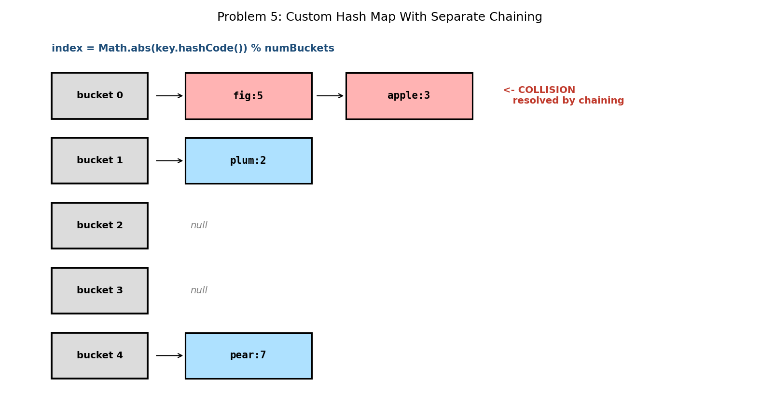

5. Java Program
public class CustomHashMap {

// Each bucket holds a singly linked chain of entries
static class Entry {
String key;
int value;
Entry next;
Entry(String key, int value) {
this.key = key;
this.value = value;
}
}

private Entry[] buckets;
private int numBuckets;
private int size;

CustomHashMap(int numBuckets) {
this.numBuckets = numBuckets;
this.buckets = new Entry[numBuckets];
this.size = 0;
}

// maps any key to a valid bucket index
private int getBucketIndex(String key) {
return Math.abs(key.hashCode()) % numBuckets;
}

void put(String key, int value) {
int index = getBucketIndex(key);
Entry head = buckets[index];

// if the key already exists in this chain, update it
Entry current = head;
while (current != null) {
if (current.key.equals(key)) {
current.value = value;
return;
}
current = current.next;
}

// otherwise insert a new entry at the head of the chain
Entry newEntry = new Entry(key, value);
newEntry.next = head;
buckets[index] = newEntry;
size++;
}

Integer get(String key) {
int index = getBucketIndex(key);
Entry current = buckets[index];

while (current != null) {
if (current.key.equals(key)) return current.value;
current = current.next;
}
return null; // key not found
}

boolean remove(String key) {
int index = getBucketIndex(key);
Entry current = buckets[index];
Entry prev = null;

while (current != null) {
if (current.key.equals(key)) {
if (prev == null) buckets[index] = current.next;
else prev.next = current.next;
size--;
return true;
}
prev = current;
current = current.next;
}
return false;
}

int size() { return size; }

void printTable() {
for (int i = 0; i < numBuckets; i++) {
System.out.print("bucket " + i + ": ");
Entry current = buckets[i];
if (current == null) System.out.print("null");
while (current != null) {
System.out.print(current.key + ":" + current.value);
if (current.next != null) System.out.print(" -> ");
current = current.next;
}
System.out.println();
}
}

public static void main(String[] args) {
CustomHashMap map = new CustomHashMap(5);

map.put("apple", 3);
map.put("pear", 7);
map.put("plum", 2);
map.put("fig", 5);

map.printTable();

System.out.println("get(\"plum\") = " + map.get("plum"));
System.out.println("get(\"mango\") = " + map.get("mango"));

map.put("apple", 10); // update existing key
System.out.println("after update, apple = " + map.get("apple"));

System.out.println("remove(\"pear\") = " + map.remove("pear"));
System.out.println("size = " + map.size());
}
}

6. Expected Output
bucket 0: fig:5 -> apple:3
bucket 1: plum:2
bucket 2: null
bucket 3: null
bucket 4: pear:7
get("plum") = 2
get("mango") = null
after update, apple = 10
remove("pear") = true
size = 3

7. Complexity Analysis
- Time Complexity: O(1) AVERAGE for put, get, and remove — assuming the hash function distributes keys evenly, each chain stays very short.
- Time Complexity: O(n) WORST CASE — if every key collides into a single bucket, the structure degenerates into one long linked list and every operation must scan it.
- Space Complexity: O(n + b) — where n is the number of stored entries and b is the number of buckets allocated.
- The LOAD FACTOR (entries divided by buckets) governs performance. Java's own HashMap resizes and rehashes once the load factor exceeds 0.75, and since Java 8 it converts an over-long chain into a balanced tree, improving that worst case from O(n) to O(log n).

8. Laboratory Exercise
Add a resize() method that doubles the bucket count once the load factor exceeds 0.75, REHASHING every existing entry into the enlarged bucket array. Explain why entries must be recomputed rather than simply copied across, and state the amortised time complexity of put() once resizing is supported.

Probable Examination Question — Module 5 (Hash Tables)
(a) Theory
Define a hash collision and explain why collisions are mathematically unavoidable in any hash table. Describe the separate-chaining technique used in Problem 5, and briefly contrast it with open addressing (linear probing) as an alternative collision-resolution strategy.
(b) Trace / Dry-run
A hash table has 4 buckets and uses the hash function index = key % 4 with separate chaining. Insert the keys 12, 5, 8, 16, 4 and 21 in that order, inserting each new entry at the HEAD of its chain. Draw the final state of all four buckets, state which bucket holds the longest chain, and explain why the chain order is the reverse of the insertion order.
(c) Programming
Write a complete Java program that:
- (i) Accepts an array of integers and a target sum;
- (ii) Uses a HashMap to find and print a pair of array elements that add up to the target, in a SINGLE pass over the array (not nested loops); and
- (iii) Prints a clear message if no such pair exists.
Your program should compile and run without error on the array {2, 7, 11, 15, 3} with target 9. State the time and space complexity of your solution, and explain why the single-pass hash approach beats the O(n squared) nested-loop approach.
(d) Short Answer
Hash table operations are described as O(1) AVERAGE but O(n) WORST CASE. Explain what circumstance produces the worst case, and name two techniques a real implementation (such as Java's HashMap) uses to make that worst case unlikely or less severe.

Lab Module 6: The Binary Search Tree (BST)
Level: 300 (Third Year) | Language: Java (JDK 17+)
Learning Objectives
- Understand the Binary Search Tree ordering invariant and why it enables O(log n) operations on a balanced tree.
- Implement classical BST algorithms in Java, including insertion, search, deletion, and lowest-common-ancestor queries.
- Analyse the average-case versus worst-case time complexity of BST operations, and relate worst case to tree shape.
- Interpret node-and-edge tree diagrams that model how each algorithm traverses or restructures the tree.
General Instructions
- Type each program into a .java file matching its public class name exactly (e.g., BSTDelete.java), then compile with: javac ClassName.java
- Run the compiled program with: java ClassName, and compare your output against the 'Expected Output' shown in this manual.
- Attempt the 'Laboratory Exercise' at the end of each problem before moving to the next.

Problem 1: Insert a Series of Values Into a BST and Print an In-Order Traversal

1. Objective
To build a Binary Search Tree by inserting a sequence of values one at a time, and to verify the tree's correctness by printing its contents in sorted order via an in-order traversal.

2. Theory / Background
A Binary Search Tree maintains a simple but powerful invariant at EVERY node: all values in its left subtree are smaller than the node's own value, and all values in its right subtree are larger. Insertion respects this invariant by comparing the new value against each node starting from the root, moving left or right until an empty spot is found.
An in-order traversal (left subtree, then the node itself, then right subtree) visits every node of a valid BST in strictly ascending sorted order. This is not a coincidence — it is a direct consequence of the BST invariant, and printing a sorted in-order sequence is itself a quick way to sanity-check that a tree was built correctly.

3. Algorithm
1. To insert a value into a subtree rooted at node: if node is null, create a new node here and return it (this is the base case — an empty spot was found).
2. If the value is less than node's value, recursively insert it into node's LEFT subtree.
3. If the value is greater than node's value, recursively insert it into node's RIGHT subtree.
4. (If the value is equal, this implementation ignores it — no duplicates are stored.)
5. To print in-order: recursively visit the left subtree, then print the current node's value, then recursively visit the right subtree.

4. Graphical Illustration
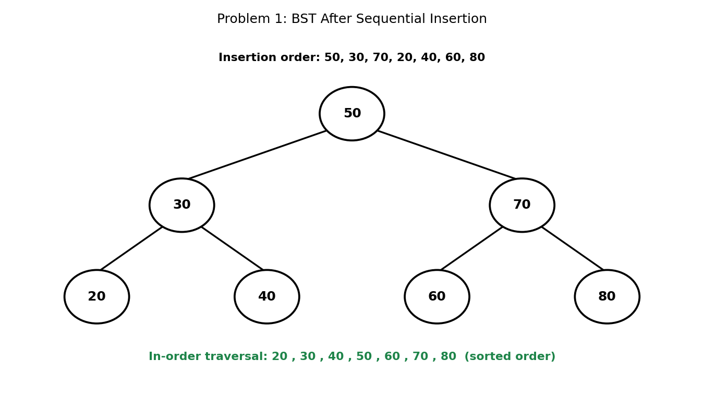

5. Java Program
public class BSTInsertTraverse {

static class Node {
int data;
Node left, right;
Node(int data) { this.data = data; }
}

static Node root;

static Node insert(Node node, int value) {
if (node == null) return new Node(value); // found the empty spot

if (value < node.data) {
node.left = insert(node.left, value); // left subtree
} else if (value > node.data) {
node.right = insert(node.right, value); // right subtree
}
// if value == node.data, ignore (no duplicates here)
return node;
}

static void inorder(Node node, StringBuilder sb) {
if (node == null) return;
inorder(node.left, sb);
sb.append(node.data).append(" ");
inorder(node.right, sb);
}

public static void main(String[] args) {
int[] values = {50, 30, 70, 20, 40, 60, 80};

for (int v : values) {
root = insert(root, v);
}

StringBuilder sb = new StringBuilder();
inorder(root, sb);

System.out.print("Insertion order: ");
for (int v : values) System.out.print(v + " ");
System.out.println();
System.out.println("In-order traversal: " + sb.toString().trim());
}
}

6. Expected Output
Insertion order: 50 30 70 20 40 60 80
In-order traversal: 20 30 40 50 60 70 80

7. Complexity Analysis
- Time Complexity: O(h) per insertion, where h is the current height of the tree — so O(log n) on a balanced tree, but O(n) in the worst case (see the Laboratory Exercise below).
- Space Complexity: O(h) for the recursion call stack during insertion, plus O(n) overall to store all n nodes.
- The full in-order traversal of n nodes costs O(n) time and O(h) auxiliary space for its own recursion stack, regardless of how the values were inserted.

8. Laboratory Exercise
Insert the values 10, 20, 30, 40, 50 (already sorted) into a fresh BST, one at a time, and print the resulting in-order traversal. Then describe, in one or two sentences, what SHAPE this tree has and why every insertion in this particular sequence costs O(n) rather than O(log n).

Problem 2: Search for a Given Value in a BST

1. Objective
To determine whether a given value exists in a BST, using the ordering invariant to eliminate half of the remaining tree at every step, rather than checking every node.

2. Theory / Background
Because every node in a BST partitions its subtree into 'smaller' (left) and 'larger' (right) halves, searching does not need to visit every node. At each step, comparing the target against the current node immediately tells us whether to continue into the left subtree, the right subtree, or stop because a match was found.
This mirrors binary search on a sorted array, but implemented over a tree's pointer structure rather than array indices. The number of comparisons needed is proportional to the HEIGHT of the tree, not the number of nodes.

3. Algorithm
1. Start at the root, and repeat while the current node is not null:
2. a. If the target equals the current node's value, the search succeeds — return true.
3. b. If the target is less than the current node's value, move to the LEFT child.
4. c. Otherwise, move to the RIGHT child.
5. If the current node becomes null before a match is found, the target does not exist in the tree — return false.

4. Graphical Illustration
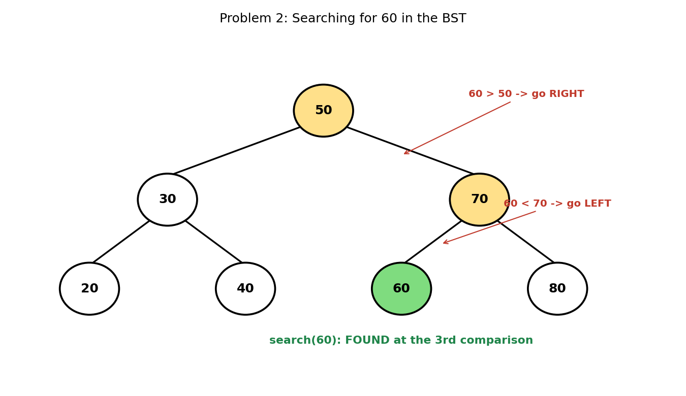

5. Java Program
public class BSTSearch {

static class Node {
int data;
Node left, right;
Node(int data) { this.data = data; }
}

static Node root;
static int comparisons;

static Node insert(Node node, int value) {
if (node == null) return new Node(value);
if (value < node.data) node.left = insert(node.left, value);
else if (value > node.data) node.right = insert(node.right, value);
return node;
}

static boolean search(Node node, int target) {
comparisons = 0;
while (node != null) {
comparisons++;
if (target == node.data) return true;
node = (target < node.data) ? node.left : node.right;
}
return false;
}

public static void main(String[] args) {
int[] values = {50, 30, 70, 20, 40, 60, 80};
for (int v : values) root = insert(root, v);

boolean found = search(root, 60);
System.out.println("search(60) -> " + found +
" (comparisons: " + comparisons + ")");

boolean notFound = search(root, 65);
System.out.println("search(65) -> " + notFound +
" (comparisons: " + comparisons + ")");
}
}

6. Expected Output
search(60) -> true (comparisons: 3)
search(65) -> false (comparisons: 3)

7. Complexity Analysis
- Time Complexity: O(h) — where h is the tree's height; O(log n) for a balanced tree, O(n) for a severely unbalanced (e.g., sorted-insertion) tree.
- Space Complexity: O(1) for the iterative version shown here, since no recursion stack is used (contrast with a recursive search, which would use O(h) stack space).
- Notice that BOTH the successful search for 60 and the failed search for 65 took exactly 3 comparisons in this particular tree — a failed search costs the same as a search for a value that would occupy that same empty spot.

8. Laboratory Exercise
Rewrite search() as a recursive method instead of an iterative loop. Then add a countNodesVisited feature to your recursive version and confirm it reports the same comparison counts as the iterative version for both search(60) and search(65).

Problem 3: Delete a Node From a BST While Maintaining BST Properties

1. Objective
To remove a specified value from a BST while preserving the BST invariant for every remaining node, correctly handling all three structural cases that deletion can encounter.

2. Theory / Background
Deleting a node is the most involved of the three basic BST operations because the node being removed might have zero, one, or two children, and each case requires different handling to avoid breaking the tree's structure.
CASE 1 (no children): the node is a leaf and can simply be removed. CASE 2 (one child): the node is replaced by its single child, effectively skipping over it. CASE 3 (two children, illustrated below): the node's value is overwritten with its INORDER SUCCESSOR — the smallest value in its right subtree — and then that successor's original node (which has at most one child, by definition of being the smallest) is deleted from its original position using cases 1 or 2.

3. Algorithm
1. Search for the value to delete, recursing left or right exactly as in Problem 2.
2. Once the target node is found, check its children:
3. a. No children: return null, detaching this node from its parent.
4. b. One child: return that child, so the parent links directly to it.
5. c. Two children: find the inorder successor (leftmost node of the right subtree), copy its value into the current node, then recursively delete the successor's original node from the right subtree.
6. Return the (possibly updated) node reference at every level, so parent links are correctly reattached as the recursion unwinds.

4. Graphical Illustration
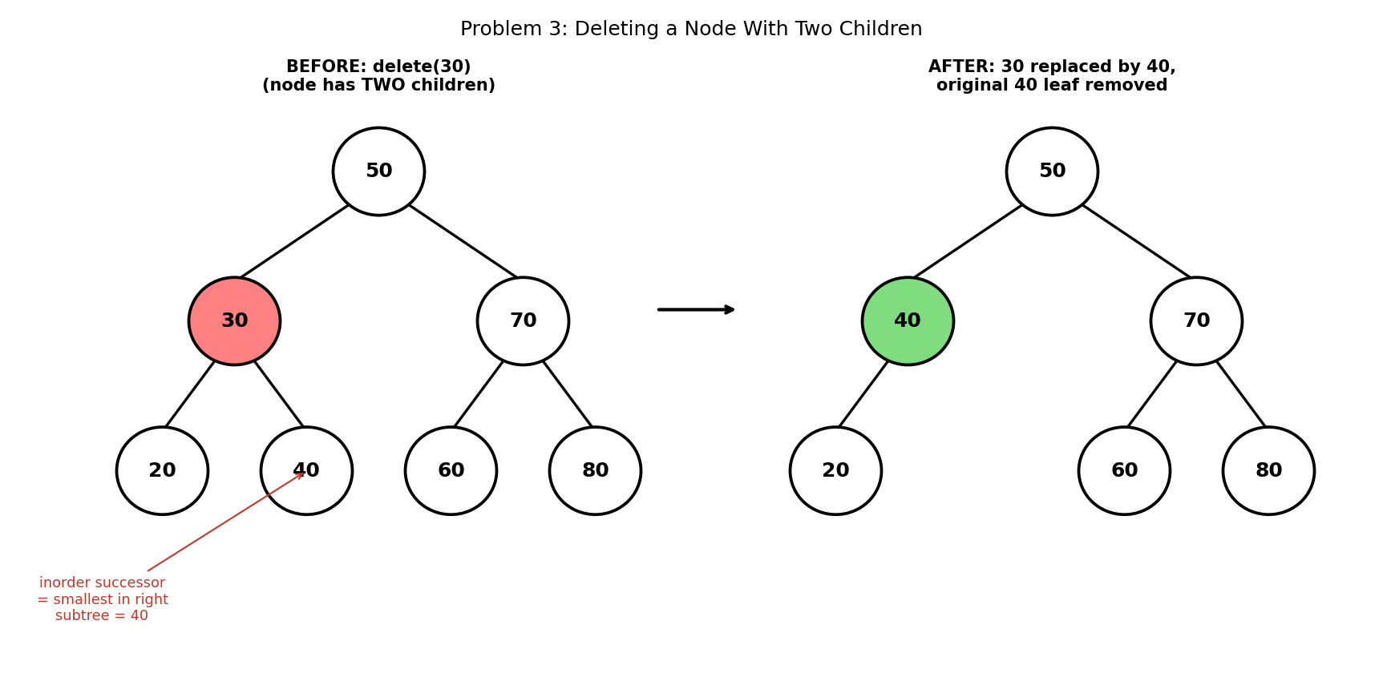

5. Java Program
public class BSTDelete {

static class Node {
int data;
Node left, right;
Node(int data) { this.data = data; }
}

static Node root;

static Node insert(Node node, int value) {
if (node == null) return new Node(value);
if (value < node.data) node.left = insert(node.left, value);
else if (value > node.data) node.right = insert(node.right, value);
return node;
}

static Node delete(Node node, int value) {
if (node == null) return null; // value not found

if (value < node.data) {
node.left = delete(node.left, value);
} else if (value > node.data) {
node.right = delete(node.right, value);
} else {
// FOUND the node to delete - three cases:

// Case 1: no children (leaf) - simply remove it
if (node.left == null && node.right == null) {
return null;
}
// Case 2: exactly one child - replace node with that child
if (node.left == null) return node.right;
if (node.right == null) return node.left;

// Case 3: two children - replace with the INORDER SUCCESSOR
// (the smallest value in the right subtree), then delete
// that successor from its original position.
Node successor = findMin(node.right);
node.data = successor.data;
node.right = delete(node.right, successor.data);
}
return node;
}

static Node findMin(Node node) {
while (node.left != null) node = node.left;
return node;
}

static void inorder(Node node, StringBuilder sb) {
if (node == null) return;
inorder(node.left, sb);
sb.append(node.data).append(" ");
inorder(node.right, sb);
}

public static void main(String[] args) {
int[] values = {50, 30, 70, 20, 40, 60, 80};
for (int v : values) root = insert(root, v);

StringBuilder before = new StringBuilder();
inorder(root, before);
System.out.println("Before delete(30): " + before.toString().trim());

root = delete(root, 30); // two-children case

StringBuilder after = new StringBuilder();
inorder(root, after);
System.out.println("After delete(30): " + after.toString().trim());
}
}

6. Expected Output
Before delete(30): 20 30 40 50 60 70 80
After delete(30): 20 40 50 60 70 80

7. Complexity Analysis
- Time Complexity: O(h) — dominated by the initial search for the node, plus (in Case 3) a second O(h)-bounded search for the inorder successor.
- Space Complexity: O(h) for the recursion call stack.
- Observe that the in-order traversal after deletion (20 40 50 60 70 80) is still perfectly sorted with 30 removed — confirming the BST invariant was preserved, even though the tree's internal SHAPE changed (40 now sits where 30 used to be).

8. Laboratory Exercise
Test your program by deleting a LEAF node (e.g., 20) and then a node with exactly ONE child (e.g., delete 70 after first deleting 80, leaving 70 with only a left child 60). For each case, print the in-order traversal before and after, and identify in a short comment which of the three deletion cases was triggered.

Problem 4: Find the Lowest Common Ancestor (LCA) of Two Nodes in a BST

1. Objective
To find the deepest node in a BST that has both of two given values as descendants (a node is considered its own descendant for this purpose).

2. Theory / Background
A general binary tree requires an O(n) search to find the LCA of two nodes. A BST allows a much faster approach because the ordering invariant tells us, at every node, which direction BOTH targets must lie in — without needing to search both subtrees blindly.
The key insight: starting from the root, if both target values are smaller than the current node, the LCA must be somewhere in the left subtree (both targets are there). If both are larger, the LCA must be in the right subtree. The moment the two targets are NOT on the same side (one smaller, one larger, or one equal to the current node), the current node is exactly where their paths diverge — making it the LCA.

3. Algorithm
1. Start at the root as the current node.
2. While the current node is not null:
3. a. If both target values are less than the current node's value, move to the LEFT child and repeat.
4. b. If both target values are greater than the current node's value, move to the RIGHT child and repeat.
5. c. Otherwise (the values are on different sides, or one equals the current node), the current node IS the LCA — return it.

4. Graphical Illustration
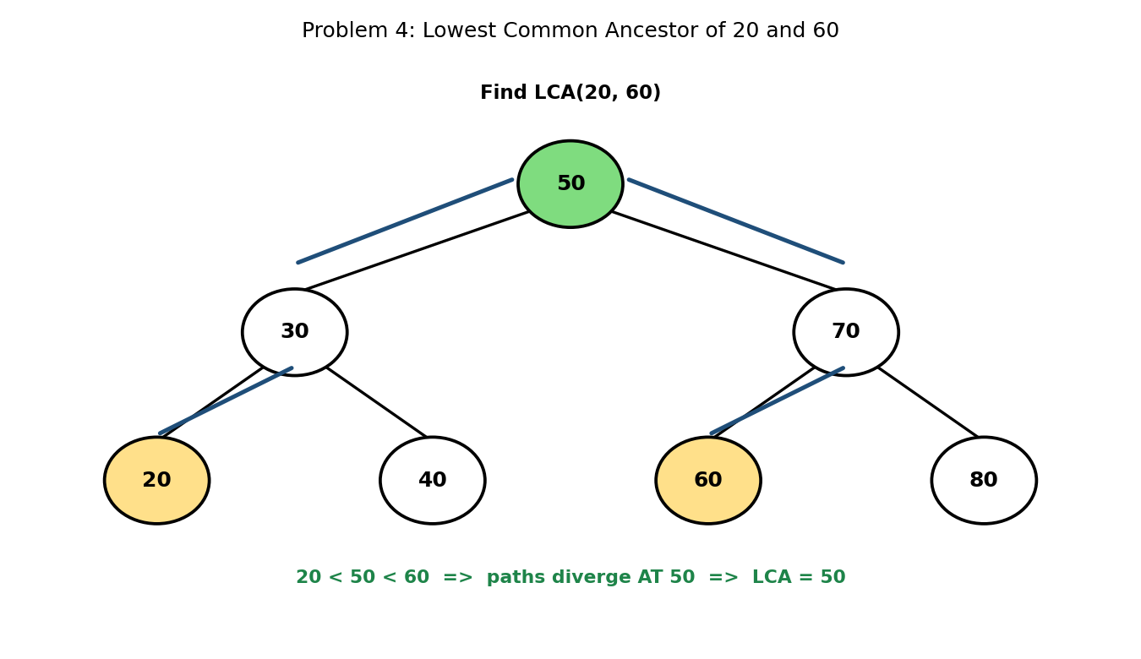

5. Java Program
public class BSTLowestCommonAncestor {

static class Node {
int data;
Node left, right;
Node(int data) { this.data = data; }
}

static Node root;

static Node insert(Node node, int value) {
if (node == null) return new Node(value);
if (value < node.data) node.left = insert(node.left, value);
else if (value > node.data) node.right = insert(node.right, value);
return node;
}

static Node findLCA(Node node, int a, int b) {
if (node == null) return null;

// if both values are smaller, the LCA must be in the left subtree
if (a < node.data && b < node.data) {
return findLCA(node.left, a, b);
}
// if both values are larger, the LCA must be in the right subtree
if (a > node.data && b > node.data) {
return findLCA(node.right, a, b);
}
// otherwise paths diverge HERE (or one equals node.data)
return node;
}

public static void main(String[] args) {
int[] values = {50, 30, 70, 20, 40, 60, 80};
for (int v : values) root = insert(root, v);

Node result1 = findLCA(root, 20, 60);
System.out.println("LCA(20, 60) = " + result1.data);

Node result2 = findLCA(root, 20, 40);
System.out.println("LCA(20, 40) = " + result2.data);
}
}

6. Expected Output
LCA(20, 60) = 50
LCA(20, 40) = 30

7. Complexity Analysis
- Time Complexity: O(h) — a single downward pass from the root, exactly like search, so O(log n) on a balanced tree and O(n) in the worst case.
- Space Complexity: O(1) for an iterative version; O(h) if implemented recursively, due to the call stack.
- Compare the two results: LCA(20, 60) = 50 because 20 and 60 are on OPPOSITE sides of 50, so their paths diverge immediately at the root. LCA(20, 40) = 30 because both values are LESS than 50 (so the search moves left past the root first) but then diverge at 30, since 20 < 30 < 40.

8. Laboratory Exercise
Extend the program so that it also PRINTS the full path from the root to each of the two target values (not just the LCA itself). Use this to explain, referencing the printed paths, exactly why 30 (and not 50) is the correct LCA for the pair (20, 40).

Problem 5: Validate Whether a Given Binary Tree Is a Valid BST

1. Objective
To determine whether an arbitrary binary tree satisfies the BST ordering invariant at EVERY node, not merely between each node and its immediate children.

2. Theory / Background
A common but INCORRECT approach checks only that each node's immediate left child is smaller and immediate right child is larger. This misses violations that occur further down the tree: a node deep in the right subtree of some ancestor A must be greater than A, not merely greater than its own immediate parent.
The correct approach tracks a valid (min, max) RANGE for every node as the tree is walked top-down. The root may hold any value (an unbounded range). When moving into a left subtree, the max bound tightens to the parent's value; when moving into a right subtree, the min bound tightens to the parent's value. A node is valid only if it falls strictly within the range inherited from ALL of its ancestors, not just its parent.

3. Algorithm
1. Define a recursive check taking the current node plus a min bound and a max bound (initially unbounded for the root).
2. If the current node is null, the (empty) subtree is trivially valid — return true.
3. If the current node's value is less than or equal to min, or greater than or equal to max, the tree is INVALID — return false immediately.
4. Otherwise, recursively validate the left subtree with the SAME min but the max tightened to the current node's value, AND recursively validate the right subtree with the SAME max but the min tightened to the current node's value.
5. The tree is valid only if both recursive calls return true.

4. Graphical Illustration
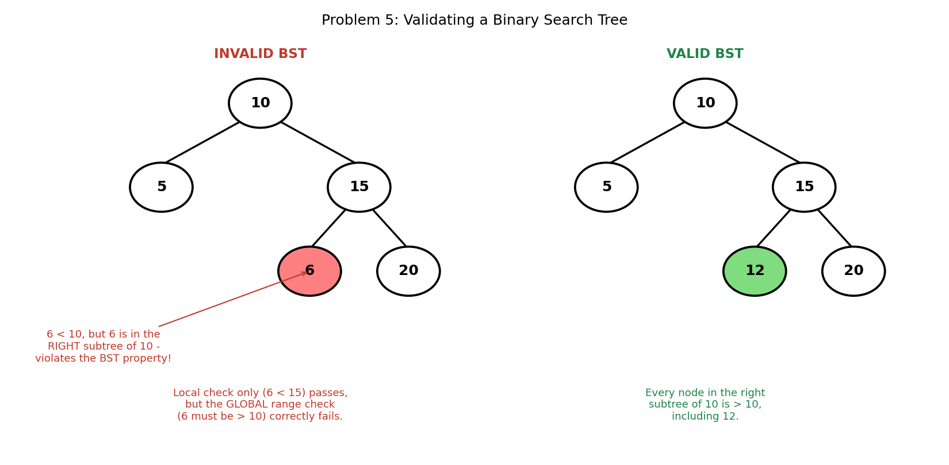

5. Java Program
public class ValidateBST {

static class Node {
int data;
Node left, right;
Node(int data) { this.data = data; }
}

// Recursively checks that every node's value falls within the
// (min, max) range allowed by ALL of its ancestors so far -
// not just its immediate parent.
static boolean isValidBST(Node node, Integer min, Integer max) {
if (node == null) return true; // an empty tree is valid

if ((min != null && node.data <= min) ||
(max != null && node.data >= max)) {
return false; // violates a range set by some ANCESTOR
}

return isValidBST(node.left, min, node.data) &&
isValidBST(node.right, node.data, max);
}

public static void main(String[] args) {
// INVALID tree, built manually (bypassing normal insert()):
// 10
// / \
// 5 15
// / \
// 6 20 <-- 6 is < 10 but placed in the RIGHT subtree
Node invalidRoot = new Node(10);
invalidRoot.left = new Node(5);
invalidRoot.right = new Node(15);
invalidRoot.right.left = new Node(6);
invalidRoot.right.right = new Node(20);

System.out.println("Invalid tree is a valid BST? " +
isValidBST(invalidRoot, null, null));

// VALID tree for comparison:
// 10
// / \
// 5 15
// / \
// 12 20
Node validRoot = new Node(10);
validRoot.left = new Node(5);
validRoot.right = new Node(15);
validRoot.right.left = new Node(12);
validRoot.right.right = new Node(20);

System.out.println("Valid tree is a valid BST? " +
isValidBST(validRoot, null, null));
}
}

6. Expected Output
Invalid tree is a valid BST? false
Valid tree is a valid BST? true

7. Complexity Analysis
- Time Complexity: O(n) — every node is visited exactly once, regardless of whether the tree turns out to be valid or invalid.
- Space Complexity: O(h) for the recursion call stack, where h is the tree's height.
- The invalid example is deliberately chosen to defeat a 'check immediate children only' approach: 6 correctly satisfies 6 < 15 (its immediate parent), yet the tree is invalid because 6 also needs to be greater than 10 (its GRANDPARENT), which it is not, since 6 lies in 10's right subtree.

8. Laboratory Exercise
Write a second validation method that instead performs a full in-order traversal into a list and then checks that the list is strictly increasing. Run it on both trees from this problem to confirm it agrees with the range-based method, then state one advantage the range-based method has over this traversal-based alternative.

Probable Examination Question — Module 6 (Binary Search Trees)
(a) Theory
State the BST ordering invariant. Explain, with reference to Problem 5, why checking a node only against its immediate parent is insufficient to validate a BST, and describe what additional information the correct algorithm must track.
(b) Trace / Dry-run
Starting from an empty BST, insert the values 45, 25, 65, 15, 35, 55, 75, 30 in that order. Draw the resulting tree, then state its in-order traversal and its height (the number of edges on the longest root-to-leaf path).
(c) Programming
Write a complete Java program that:
- (i) Builds a BST from a given array of integers using repeated insertion (as in Problem 1);
- (ii) Computes the HEIGHT of the tree (the number of edges on the longest root-to-leaf path), without using any built-in library method; and
- (iii) Determines whether the tree is HEIGHT-BALANCED — meaning that for every node, the heights of its left and right subtrees differ by no more than 1.
Your program should compile and run without error on the array {50, 30, 70, 20, 40, 60, 80}. State the time complexity of your balance check, and explain why a naive implementation that recomputes each subtree's height from scratch at every node can degrade to O(n squared).
(d) Short Answer
Problem 3 replaces a deleted two-children node's value with its INORDER SUCCESSOR rather than its inorder PREDECESSOR (the largest value in the left subtree). Explain why using the predecessor instead would work equally correctly, and state one reason an implementer might prefer one over the other in practice.

Lab Module 7: Balanced Trees (AVL / Red-Black)
Level: 300 (Third Year) | Language: Java (JDK 17+)
Learning Objectives
- Understand why an unbalanced BST degrades to O(n) performance, and how height-balance guarantees O(log n).
- Compute the height and balance factor of every node in a binary tree, and identify the four AVL imbalance cases (LL, RR, LR, RL).
- Implement AVL insertion and deletion in Java, including all four rotation cases and correct height bookkeeping.
- Understand the Red-Black tree colour invariants and implement insertion with recolouring and rotation.
General Instructions
- Type each program into a .java file matching its public class name exactly (e.g., AVLInsertion.java), then compile with: javac ClassName.java
- Run the compiled program with: java ClassName, and compare your output against the 'Expected Output' shown in this manual.
- Attempt the 'Laboratory Exercise' at the end of each problem before moving to the next.

Problem 1: Explain and Calculate the Balance Factor of Nodes in a Given Binary Tree

1. Objective
To compute, for every node in a binary tree, its height and its BALANCE FACTOR (the difference between the heights of its left and right subtrees), and to determine whether the tree as a whole is height-balanced.

2. Theory / Background
A plain Binary Search Tree offers no guarantee on its shape: inserting values in sorted order produces a tree that degenerates into a linked list, turning O(log n) operations into O(n). Balanced trees such as AVL and Red-Black trees exist specifically to prevent this by enforcing a structural invariant after every insertion or deletion.
The AVL balance condition is defined node-by-node using the BALANCE FACTOR: BF(node) = height(left subtree) - height(right subtree). A tree is AVL-balanced if and only if EVERY node has a balance factor in {-1, 0, +1}. By convention, an empty subtree (null) has height -1, so a leaf node has height 0.
Calculating balance factors is the diagnostic step that precedes both rotation (Problem 2) and full AVL insertion/deletion (Problems 3-4): a rotation is only needed at nodes whose balance factor has drifted to +2 or -2.

3. Algorithm
1. Define height(node): if node is null, return -1. Otherwise, return 1 + max(height(node.left), height(node.right)).
2. Define balanceFactor(node): return height(node.left) - height(node.right).
3. To report every node's statistics, perform an in-order traversal, printing each node's height and balance factor as it is visited.
4. To check whether the WHOLE tree is balanced, recursively confirm that |balanceFactor(node)| <= 1 at every node, not just at the root.

4. Graphical Illustration
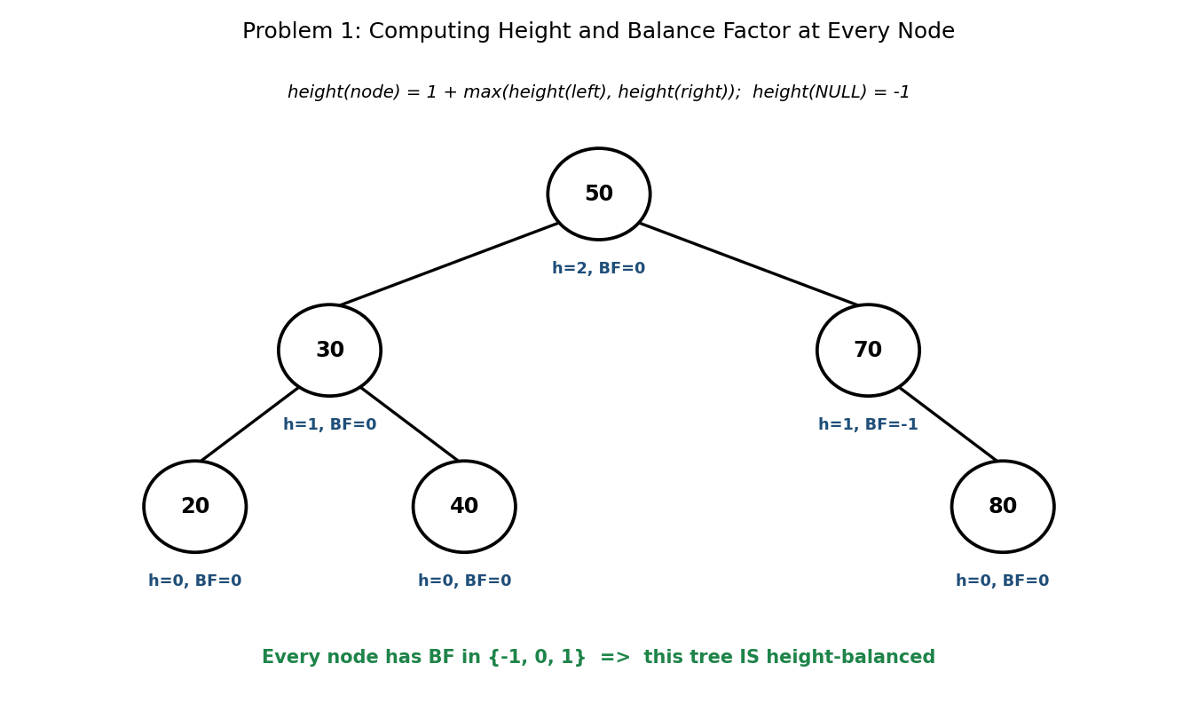

5. Java Program
public class BalanceFactorCalculator {

static class Node {
int data;
Node left, right;
Node(int data) { this.data = data; }
}

// height(NULL) is defined as -1, so a leaf has height 0
static int height(Node node) {
if (node == null) return -1;
return 1 + Math.max(height(node.left), height(node.right));
}

static int balanceFactor(Node node) {
if (node == null) return 0;
return height(node.left) - height(node.right);
}

static void printBalanceFactors(Node node) {
if (node == null) return;
printBalanceFactors(node.left);
System.out.println(" Node " + node.data + ": height="
+ height(node) + ", BF=" + balanceFactor(node));
printBalanceFactors(node.right);
}

static boolean isHeightBalanced(Node node) {
if (node == null) return true;
int bf = balanceFactor(node);
if (Math.abs(bf) > 1) return false;
return isHeightBalanced(node.left) && isHeightBalanced(node.right);
}

public static void main(String[] args) {
// Manually build the fixed example tree (no auto-balancing here)
Node root = new Node(50);
root.left = new Node(30);
root.right = new Node(70);
root.left.left = new Node(20);
root.left.right = new Node(40);
root.right.right = new Node(80);

System.out.println("Balance factors (in-order):");
printBalanceFactors(root);

System.out.println("Is the tree height-balanced? "
+ isHeightBalanced(root));
}
}

6. Expected Output
Balance factors (in-order):
Node 20: height=0, BF=0
Node 30: height=1, BF=0
Node 40: height=0, BF=0
Node 50: height=2, BF=0
Node 70: height=1, BF=-1
Node 80: height=0, BF=0
Is the tree height-balanced? true

7. Complexity Analysis
- Time Complexity: O(n) to compute balance factors and check balance for an entire tree of n nodes, since each node is visited a constant number of times.
- Naively recomputing height(node) from scratch at every node (as the standalone height() method does when called repeatedly) costs O(n) PER CALL, making the printBalanceFactors() loop above O(n squared) overall — a common inefficiency the Laboratory Exercise below asks you to fix.
- Space Complexity: O(h) for the recursion call stack, where h is the tree's height.

8. Laboratory Exercise
The printBalanceFactors() method as written recomputes height() from scratch for every node, making it O(n squared) overall. Rewrite it so that each node's height is computed ONCE via a single post-order pass (computing and returning a subtree's height as you go), reducing the total cost to O(n). Verify your rewrite reports identical balance factors to the original.

Problem 2: Perform a Single Left Rotation and Single Right Rotation on an Unbalanced BST

1. Objective
To implement the two fundamental tree-restructuring operations, left rotation and right rotation, and to use them to fix the two simplest AVL imbalance cases: LL (left-left) and RR (right-right).

2. Theory / Background
A rotation restructures a subtree locally, changing which node is the root, WITHOUT violating the BST ordering property and without needing to touch any node outside the subtree. Both rotations run in O(1) time because they only rewire a constant number of pointers.
A RIGHT rotation is used when a subtree is left-heavy in a straight line (the LL case): the left child is promoted to become the new subtree root, the old root becomes its right child, and the promoted node's old right subtree is reattached as the old root's new left subtree.
A LEFT rotation is the exact mirror image, used for the RR case: the right child is promoted, the old root becomes its left child, and the promoted node's old left subtree is reattached as the old root's new right subtree.

3. Algorithm
1. rightRotate(y): let x = y.left, and T2 = x.right. Set x.right = y and y.left = T2. Return x as the new subtree root.
2. leftRotate(x): let y = x.right, and T2 = y.left. Set y.left = x and x.right = T2. Return y as the new subtree root.
3. Both operations preserve the BST invariant automatically: T2 sits between the two nodes in sorted order both before and after the rotation, so it is always attached on the correct side.

4. Graphical Illustration
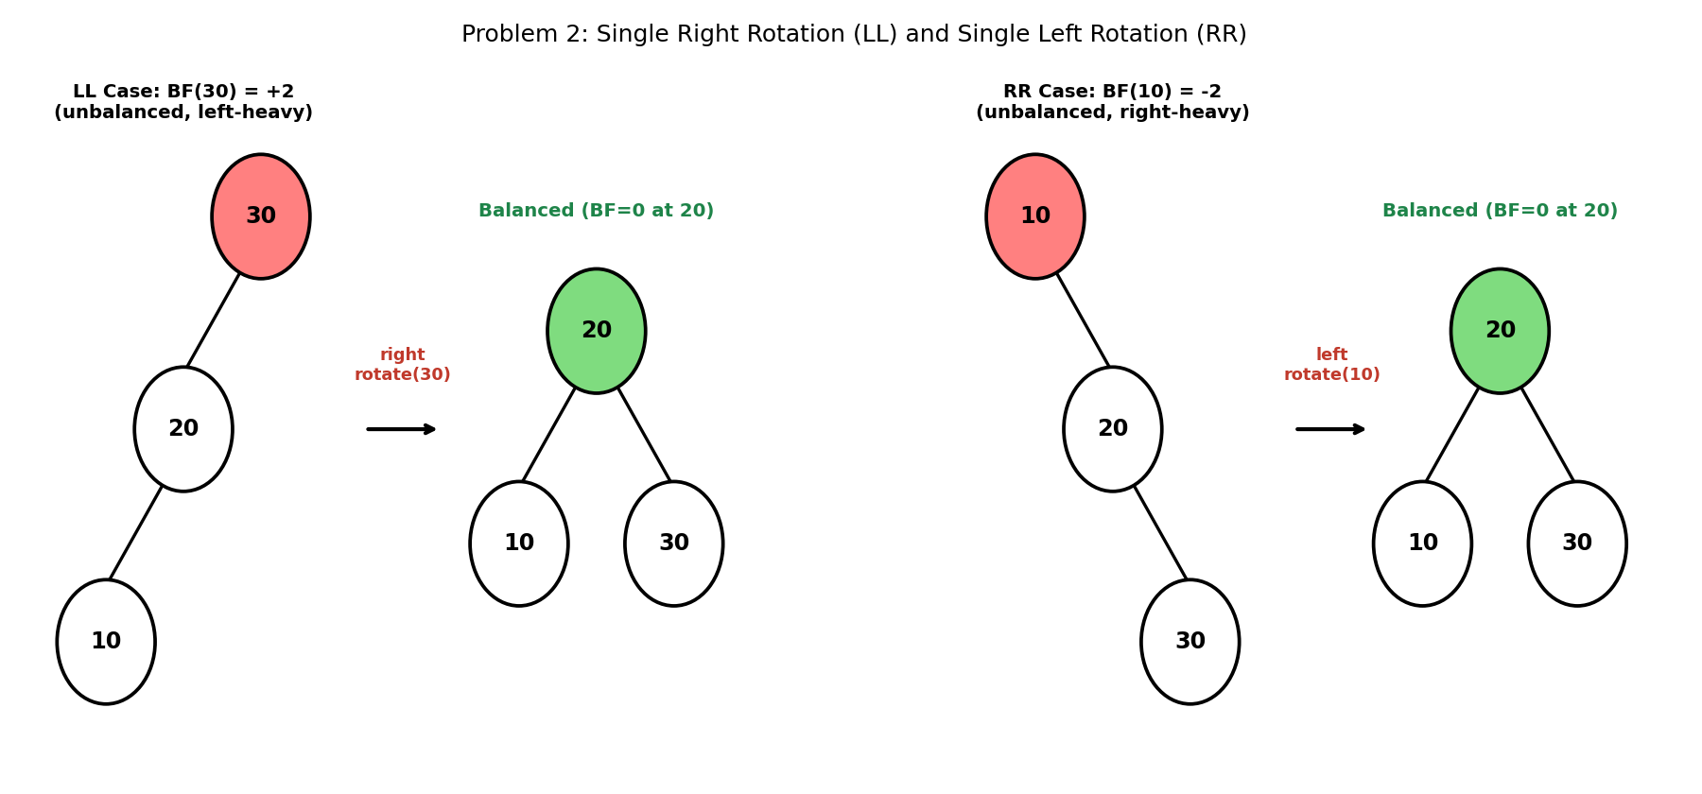

5. Java Program
public class RotationDemo {

static class Node {
int data;
Node left, right;
Node(int data) { this.data = data; }
}

// Single RIGHT rotation - fixes an LL (left-left) imbalance
static Node rightRotate(Node y) {
Node x = y.left;
Node T2 = x.right;

x.right = y; // y becomes x's right child
y.left = T2; // y adopts x's old right subtree

return x; // x is the new subtree root
}

// Single LEFT rotation - fixes an RR (right-right) imbalance
static Node leftRotate(Node x) {
Node y = x.right;
Node T2 = y.left;

y.left = x; // x becomes y's left child
x.right = T2; // x adopts y's old left subtree

return y; // y is the new subtree root
}

static void printPreorder(Node node, StringBuilder sb) {
if (node == null) return;
sb.append(node.data).append(" ");
printPreorder(node.left, sb);
printPreorder(node.right, sb);
}

public static void main(String[] args) {
// ---- LL case: chain 30 -> 20 -> 10 ----
Node llRoot = new Node(30);
llRoot.left = new Node(20);
llRoot.left.left = new Node(10);

StringBuilder before1 = new StringBuilder();
printPreorder(llRoot, before1);
System.out.println("LL before: " + before1.toString().trim());

llRoot = rightRotate(llRoot);

StringBuilder after1 = new StringBuilder();
printPreorder(llRoot, after1);
System.out.println("LL after right-rotate: "
+ after1.toString().trim());

// ---- RR case: chain 10 -> 20 -> 30 ----
Node rrRoot = new Node(10);
rrRoot.right = new Node(20);
rrRoot.right.right = new Node(30);

StringBuilder before2 = new StringBuilder();
printPreorder(rrRoot, before2);
System.out.println("RR before: " + before2.toString().trim());

rrRoot = leftRotate(rrRoot);

StringBuilder after2 = new StringBuilder();
printPreorder(rrRoot, after2);
System.out.println("RR after left-rotate: "
+ after2.toString().trim());
}
}

6. Expected Output
LL before: 30 20 10
LL after right-rotate: 20 10 30
RR before: 10 20 30
RR after left-rotate: 20 10 30

7. Complexity Analysis
- Time Complexity: O(1) per rotation — a fixed number of pointer reassignments, regardless of the size of the subtrees involved.
- Space Complexity: O(1) — rotations restructure existing nodes in place; no new nodes are allocated.
- Notice that BOTH the LL and the RR example converge on the identical final structure (root 20, children 10 and 30) — a right rotation undoes a left-leaning chain, and a left rotation undoes a right-leaning chain, and both produce the unique balanced arrangement of three nodes.

8. Laboratory Exercise
Extend the program to print each tree's IN-ORDER traversal before and after its rotation (not just the pre-order shown above), and confirm that the in-order sequence is IDENTICAL before and after rotation in both cases. Explain in one sentence why a rotation must never change the in-order traversal of a BST.

Problem 3: Insert a Sequence of Values Into an AVL Tree, Performing Rotations as Needed

1. Objective
To build a complete, self-balancing AVL tree by inserting a sequence of values one at a time, automatically detecting and correcting any of the four imbalance cases (LL, RR, LR, RL) after every single insertion.

2. Theory / Background
AVL insertion begins exactly like ordinary BST insertion (Module 6), but after each recursive insertion call returns, the current node's height is recomputed and its balance factor is checked. If the balance factor has drifted outside {-1, 0, +1}, precisely one of four rotation patterns is applied, determined by comparing the newly inserted value against the child and grandchild along the unbalanced path.
LL and RR (Problem 2) are single rotations. The two remaining cases are DOUBLE rotations: LR (left-right) occurs when the new value lands in the RIGHT subtree of a LEFT child, and is fixed by first left-rotating the left child, then right-rotating the node itself. RL (right-left) is its mirror: the new value lands in the LEFT subtree of a RIGHT child, fixed by first right-rotating the right child, then left-rotating the node itself.
Crucially, because rotations are applied immediately after each insertion (not deferred), the AVL tree is NEVER more than one rotation away from balanced at any point — this is what guarantees O(log n) height at all times.

3. Algorithm
1. Insert value recursively exactly as in a plain BST, then update the current node's height on the way back up the recursion.
2. Compute the current node's balance factor.
3. If BF > 1 and the new value is less than the left child's value: LL case -> right rotate this node.
4. If BF < -1 and the new value is greater than the right child's value: RR case -> left rotate this node.
5. If BF > 1 and the new value is greater than the left child's value: LR case -> left rotate the left child, then right rotate this node.
6. If BF < -1 and the new value is less than the right child's value: RL case -> right rotate the right child, then left rotate this node.

4. Graphical Illustration
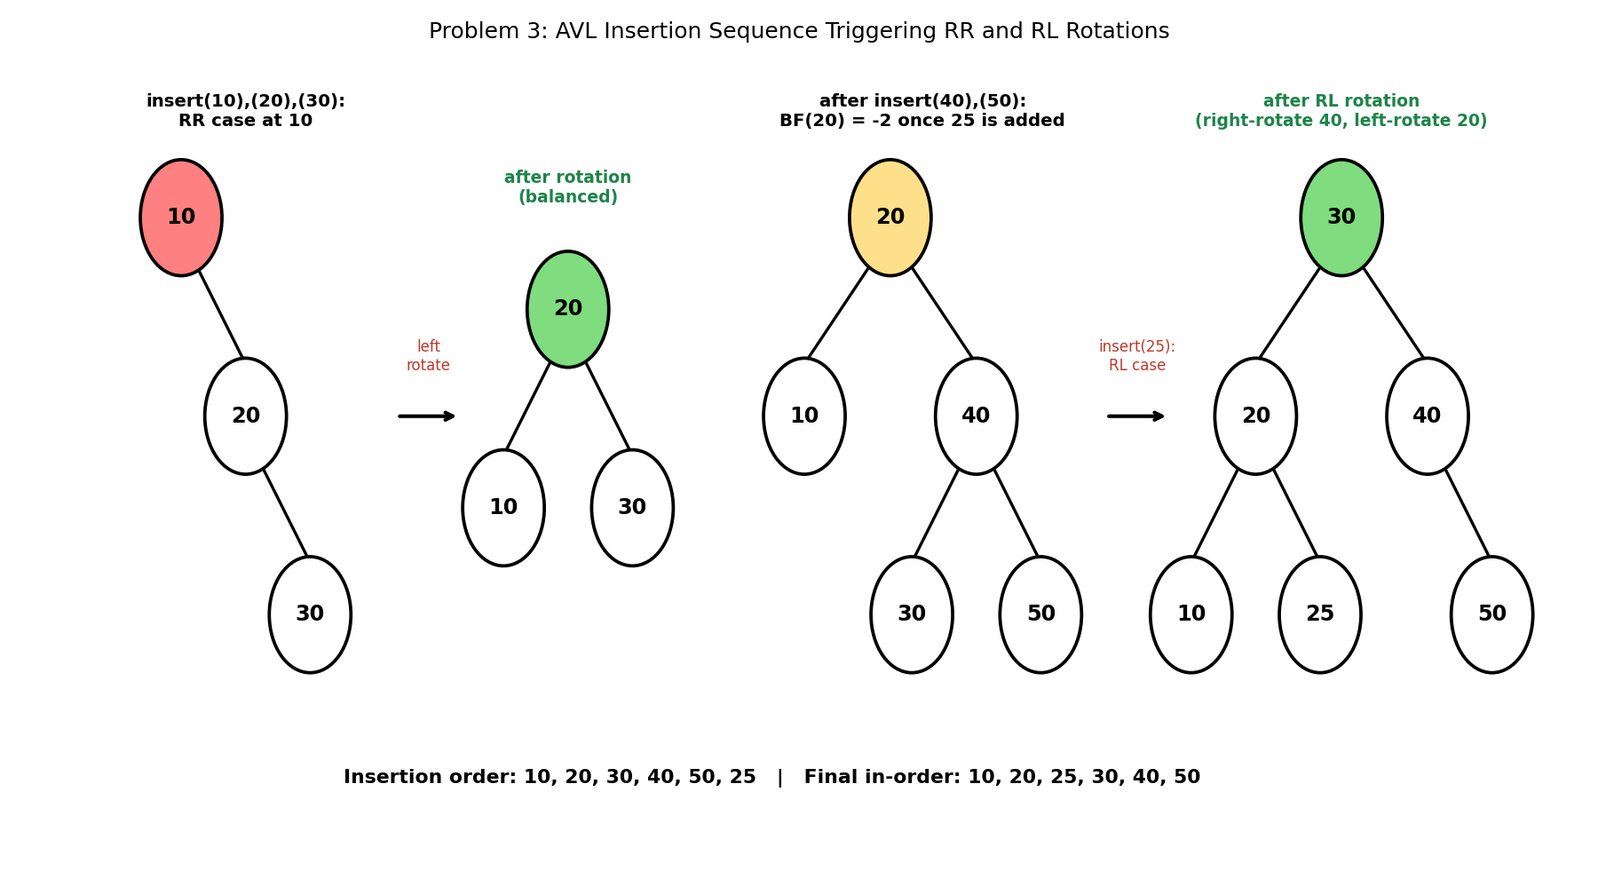

5. Java Program
public class AVLInsertion {

static class Node {
int data, height;
Node left, right;
Node(int data) {
this.data = data;
this.height = 0; // a new node is always a leaf: height 0
}
}

static Node root;

static int height(Node n) { return (n == null) ? -1 : n.height; }

static int balanceFactor(Node n) {
return (n == null) ? 0 : height(n.left) - height(n.right);
}

static void updateHeight(Node n) {
n.height = 1 + Math.max(height(n.left), height(n.right));
}

static Node rightRotate(Node y) {
Node x = y.left;
Node T2 = x.right;
x.right = y;
y.left = T2;
updateHeight(y);
updateHeight(x);
return x;
}

static Node leftRotate(Node x) {
Node y = x.right;
Node T2 = y.left;
y.left = x;
x.right = T2;
updateHeight(x);
updateHeight(y);
return y;
}

static Node insert(Node node, int value) {
if (node == null) return new Node(value);

if (value < node.data) node.left = insert(node.left, value);
else if (value > node.data) node.right = insert(node.right, value);
else return node; // no duplicates

updateHeight(node);
int bf = balanceFactor(node);

// LL case
if (bf > 1 && value < node.left.data) return rightRotate(node);
// RR case
if (bf < -1 && value > node.right.data) return leftRotate(node);
// LR case
if (bf > 1 && value > node.left.data) {
node.left = leftRotate(node.left);
return rightRotate(node);
}
// RL case
if (bf < -1 && value < node.right.data) {
node.right = rightRotate(node.right);
return leftRotate(node);
}

return node; // already balanced
}

static void inorder(Node node, StringBuilder sb) {
if (node == null) return;
inorder(node.left, sb);
sb.append(node.data).append(" ");
inorder(node.right, sb);
}

public static void main(String[] args) {
int[] values = {10, 20, 30, 40, 50, 25};

for (int v : values) {
root = insert(root, v);
System.out.println("insert(" + v + ") -> root is now "
+ root.data + ", height=" + root.height);
}

StringBuilder sb = new StringBuilder();
inorder(root, sb);
System.out.println("\nFinal in-order: " + sb.toString().trim());
}
}

6. Expected Output
insert(10) -> root is now 10, height=0
insert(20) -> root is now 10, height=1
insert(30) -> root is now 20, height=1
insert(40) -> root is now 20, height=2
insert(50) -> root is now 20, height=2
insert(25) -> root is now 30, height=2

Final in-order: 10 20 25 30 40 50

7. Complexity Analysis
- Time Complexity: O(log n) per insertion — the recursive descent is bounded by the tree's height, which AVL's own invariant guarantees stays O(log n); at most one single or double rotation is then applied on the way back up.
- Space Complexity: O(log n) for the recursion call stack during insertion, plus O(n) overall to store all n nodes.
- Trace the root changes above: it changes at insert(30) (RR rotation promotes 20) and again at insert(25) (RL rotation promotes 30) — but stays put during insert(40) and insert(50), since those insertions kept every balance factor within {-1,0,1} without requiring a rotation.

8. Laboratory Exercise
Insert the values 1, 2, 3, 4, 5, 6, 7 (already sorted) into a fresh AVL tree, one at a time, printing the root after each insertion. Compare the number of rotations triggered against the plain BST from Module 6's Laboratory Exercise (Problem 1), which degenerates into a straight chain for this same input, and state the final tree's height.

Problem 4: Delete a Node From an AVL Tree and Rebalance the Tree Afterward

1. Objective
To remove a specified value from an AVL tree while restoring the height-balance invariant at every affected ancestor, which may require rotations even when the deleted node itself had no imbalance.

2. Theory / Background
AVL deletion begins with standard BST deletion (Module 6, Problem 3): a leaf is simply removed, a node with one child is replaced by that child, and a node with two children has its value replaced by its inorder successor before that successor is deleted from its original position.
The distinguishing AVL step happens AFTER removal: as the recursion unwinds back up to the root, EVERY ancestor of the removed node has its height recomputed and its balance factor rechecked — not just the immediate parent. Deletion can therefore trigger a rotation much higher up the tree than the node that was actually removed, unlike insertion, where only one imbalance can ever occur along the insertion path.
The rotation selection logic mirrors Problem 3's four cases, but the direction test uses the CHILD subtree's OWN balance factor (rather than comparing against the inserted value, since there is no single 'new value' driving a deletion).

3. Algorithm
1. Recursively locate and remove the target value using standard BST deletion logic.
2. On the way back up the recursion, update the current node's height, then compute its balance factor.
3. If BF > 1 and balanceFactor(left child) >= 0: LL case -> right rotate.
4. If BF > 1 and balanceFactor(left child) < 0: LR case -> left rotate the left child, then right rotate.
5. If BF < -1 and balanceFactor(right child) <= 0: RR case -> left rotate.
6. If BF < -1 and balanceFactor(right child) > 0: RL case -> right rotate the right child, then left rotate.

4. Graphical Illustration
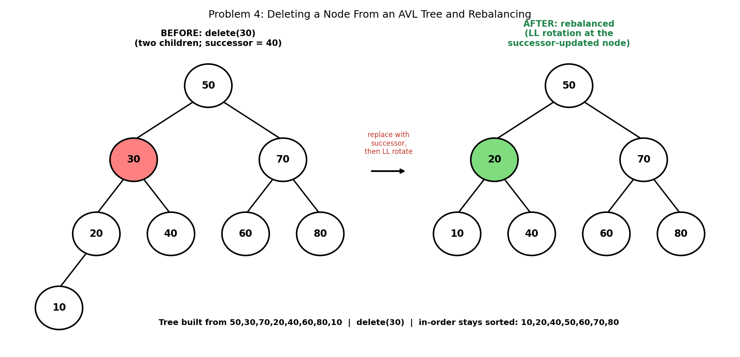

5. Java Program
public class AVLDeletion {

static class Node {
int data, height;
Node left, right;
Node(int data) { this.data = data; this.height = 0; }
}

static int height(Node n) { return (n == null) ? -1 : n.height; }
static int balanceFactor(Node n) {
return (n == null) ? 0 : height(n.left) - height(n.right);
}
static void updateHeight(Node n) {
n.height = 1 + Math.max(height(n.left), height(n.right));
}

static Node rightRotate(Node y) {
Node x = y.left;
Node T2 = x.right;
x.right = y;
y.left = T2;
updateHeight(y);
updateHeight(x);
return x;
}

static Node leftRotate(Node x) {
Node y = x.right;
Node T2 = y.left;
y.left = x;
x.right = T2;
updateHeight(x);
updateHeight(y);
return y;
}

static Node insert(Node node, int value) {
if (node == null) return new Node(value);
if (value < node.data) node.left = insert(node.left, value);
else if (value > node.data) node.right = insert(node.right, value);
else return node;

updateHeight(node);
int bf = balanceFactor(node);

if (bf > 1 && value < node.left.data) return rightRotate(node);
if (bf < -1 && value > node.right.data) return leftRotate(node);
if (bf > 1 && value > node.left.data) {
node.left = leftRotate(node.left);
return rightRotate(node);
}
if (bf < -1 && value < node.right.data) {
node.right = rightRotate(node.right);
return leftRotate(node);
}
return node;
}

static Node minValueNode(Node node) {
while (node.left != null) node = node.left;
return node;
}

static Node delete(Node node, int value) {
if (node == null) return null;

if (value < node.data) {
node.left = delete(node.left, value);
} else if (value > node.data) {
node.right = delete(node.right, value);
} else {
// node found - standard BST deletion first
if (node.left == null) return node.right;
if (node.right == null) return node.left;

Node successor = minValueNode(node.right);
node.data = successor.data;
node.right = delete(node.right, successor.data);
}

updateHeight(node);
int bf = balanceFactor(node);

// LL / LR cases (left-heavy after deletion)
if (bf > 1 && balanceFactor(node.left) >= 0) return rightRotate(node);
if (bf > 1 && balanceFactor(node.left) < 0) {
node.left = leftRotate(node.left);
return rightRotate(node);
}
// RR / RL cases (right-heavy after deletion)
if (bf < -1 && balanceFactor(node.right) <= 0) {
return leftRotate(node);
}
if (bf < -1 && balanceFactor(node.right) > 0) {
node.right = rightRotate(node.right);
return leftRotate(node);
}

return node;
}

static void inorder(Node node, StringBuilder sb) {
if (node == null) return;
inorder(node.left, sb);
sb.append(node.data).append(" ");
inorder(node.right, sb);
}

public static void main(String[] args) {
int[] values = {50, 30, 70, 20, 40, 60, 80, 10};
Node root = null;
for (int v : values) root = insert(root, v);

StringBuilder before = new StringBuilder();
inorder(root, before);
System.out.println("Before delete(30): " + before.toString().trim());
System.out.println("Root before: " + root.data);

root = delete(root, 30);

StringBuilder after = new StringBuilder();
inorder(root, after);
System.out.println("After delete(30): " + after.toString().trim());
System.out.println("Root's left child after rebalance: "
+ root.left.data);
}
}

6. Expected Output
Before delete(30): 10 20 30 40 50 60 70 80
Root before: 50
After delete(30): 10 20 40 50 60 70 80
Root's left child after rebalance: 20

7. Complexity Analysis
- Time Complexity: O(log n) — bounded by the tree's height for the initial search/removal, plus at most O(log n) more rotations as imbalance is checked and corrected at every ancestor on the way back to the root (though in practice, AVL deletion can require rotations at MULTIPLE ancestors, unlike insertion's single rotation).
- Space Complexity: O(log n) for the recursion call stack.
- This example combines TWO mechanics at once: deleting 30 (a two-children node) first triggers ordinary BST successor-replacement (30 is overwritten with 40), and this structural change then leaves the affected node left-heavy (BF=+2), triggering an LL rotation that promotes 20.

8. Laboratory Exercise
Build the same AVL tree used in this problem (50,30,70,20,40,60,80,10), then delete 70 instead of 30. Trace through the algorithm by hand first to predict whether any rotation will trigger, then verify your prediction by running the program with delete(70) and printing the tree's in-order result and root before/after.

Problem 5: Implement Red-Black Tree Insertion With Proper Recoloring and Rotations

1. Objective
To implement insertion into a Red-Black tree, a second major self-balancing scheme, maintaining its colour-based invariants using a combination of recolouring and rotation rather than AVL's strict height-based rebalancing.

2. Theory / Background
A Red-Black tree enforces balance through FIVE invariants: (1) every node is coloured red or black; (2) the root is always black; (3) every leaf (represented conceptually as NIL) is black; (4) a red node never has a red child (no two reds in a row on any path); (5) every path from a given node to any of its descendant NIL leaves passes through the SAME number of black nodes (the node's 'black-height'). These invariants together guarantee the tree's height never exceeds roughly 2*log2(n+1).
A newly inserted node is always coloured RED. If its parent is black, no invariant is broken and insertion is complete. If its parent is RED, invariant (4) is violated, and one of two fixes applies depending on the colour of the node's UNCLE (the parent's sibling): if the uncle is RED, a simple RECOLOUR pushes the violation up to the grandparent, which is then rechecked. If the uncle is BLACK (or absent/NIL), a ROTATION (single or double, depending on whether the node forms a 'line' or a 'triangle' with its parent and grandparent) permanently resolves the violation without needing to recurse further.
Red-Black trees are used in preference to AVL trees when insertions and deletions are frequent relative to lookups, because Red-Black rebalancing touches fewer nodes per operation on average, even though the resulting tree may be very slightly less strictly height-balanced than an equivalent AVL tree.

3. Algorithm
1. Insert the new node exactly as in an ordinary BST insertion, colouring it RED, then call the fix-up procedure.
2. While the new node's parent exists and is RED:
3. a. If the uncle is RED: recolour the parent and uncle BLACK, recolour the grandparent RED, then continue the fix-up from the grandparent (the violation has moved up one level).
4. b. If the uncle is BLACK: if the node and its parent form a 'triangle' (opposite sides), rotate at the parent first to convert it into a 'line'. Then recolour the parent BLACK and the grandparent RED, and rotate at the grandparent (in the opposite direction of the triangle-fixing rotation, if one was needed).
5. After the loop ends (either the parent is black, or the node became the root), unconditionally colour the root BLACK — insertion may have coloured it red, but invariant (2) must always hold.

4. Graphical Illustration
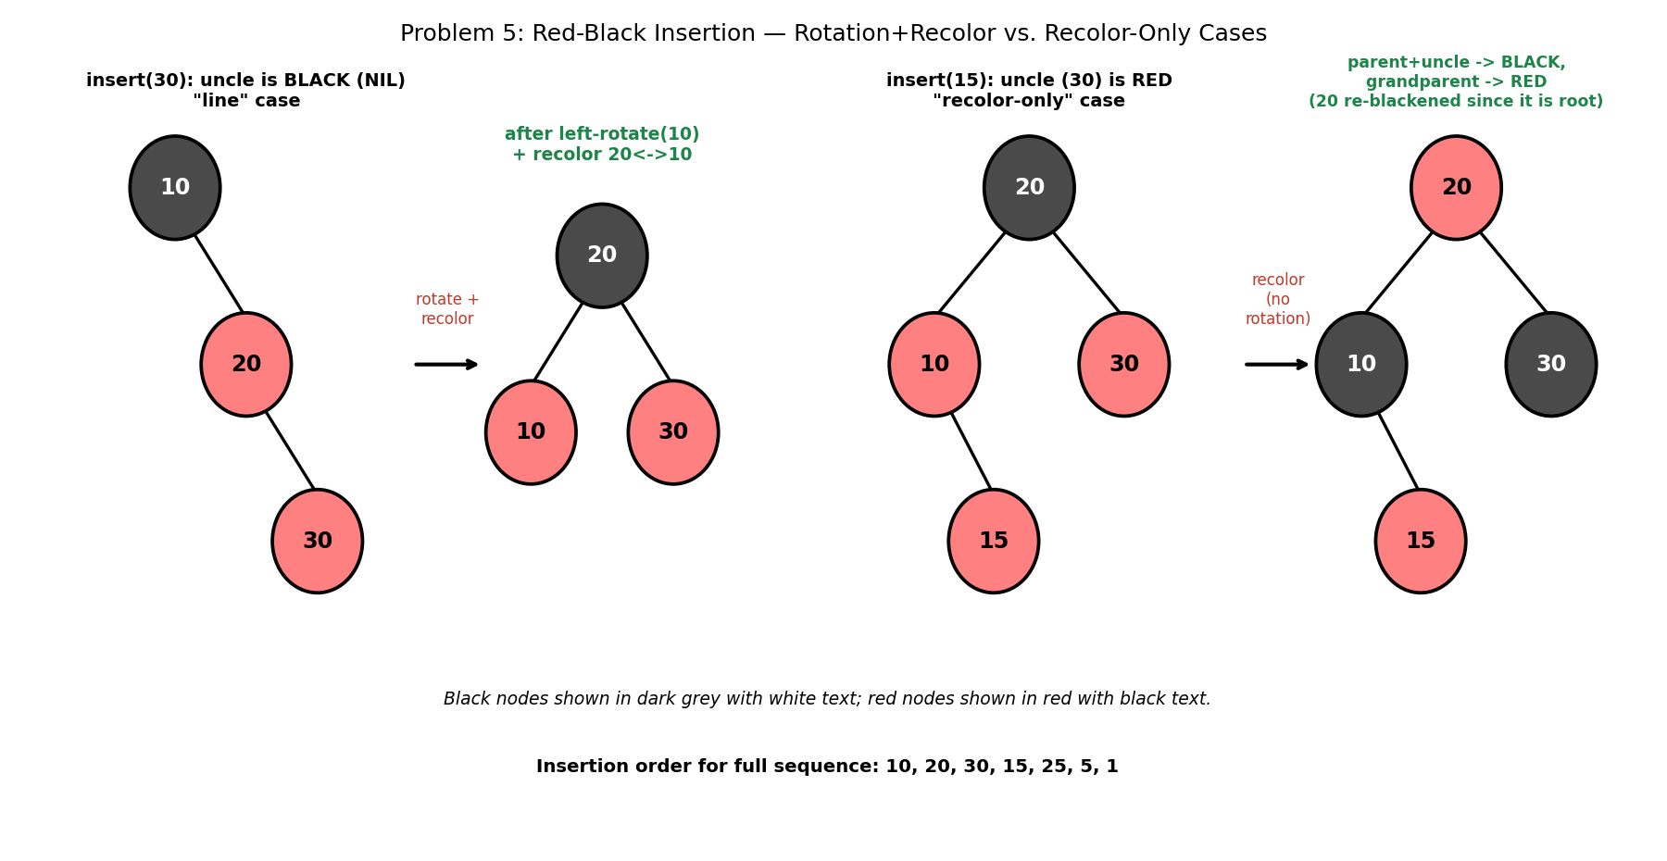

5. Java Program
public class RedBlackInsertion {

static final boolean RED = true;
static final boolean BLACK = false;

static class Node {
int data;
boolean color;
Node left, right, parent;
Node(int data) { this.data = data; this.color = RED; }
}

static Node root;

static void leftRotate(Node x) {
Node y = x.right;
x.right = y.left;
if (y.left != null) y.left.parent = x;
y.parent = x.parent;
if (x.parent == null) root = y;
else if (x == x.parent.left) x.parent.left = y;
else x.parent.right = y;
y.left = x;
x.parent = y;
}

static void rightRotate(Node x) {
Node y = x.left;
x.left = y.right;
if (y.right != null) y.right.parent = x;
y.parent = x.parent;
if (x.parent == null) root = y;
else if (x == x.parent.right) x.parent.right = y;
else x.parent.left = y;
y.right = x;
x.parent = y;
}

static boolean colorOf(Node n) { return (n == null) ? BLACK : n.color; }

static void insert(int value) {
Node z = new Node(value);
Node y = null;
Node x = root;

while (x != null) {
y = x;
x = (z.data < x.data) ? x.left : x.right;
}
z.parent = y;
if (y == null) root = z;
else if (z.data < y.data) y.left = z;
else y.right = z;

fixup(z);
}

static void fixup(Node z) {
while (z.parent != null && z.parent.color == RED) {
Node gp = z.parent.parent;
if (z.parent == gp.left) {
Node uncle = gp.right;
if (colorOf(uncle) == RED) {
z.parent.color = BLACK;
uncle.color = BLACK;
gp.color = RED;
z = gp;
} else {
if (z == z.parent.right) {
z = z.parent;
leftRotate(z);
}
z.parent.color = BLACK;
z.parent.parent.color = RED;
rightRotate(z.parent.parent);
}
} else {
Node uncle = gp.left;
if (colorOf(uncle) == RED) {
z.parent.color = BLACK;
uncle.color = BLACK;
gp.color = RED;
z = gp;
} else {
if (z == z.parent.left) {
z = z.parent;
rightRotate(z);
}
z.parent.color = BLACK;
z.parent.parent.color = RED;
leftRotate(z.parent.parent);
}
}
}
root.color = BLACK; // the root is always black
}

static void inorder(Node n, StringBuilder sb) {
if (n == null) return;
inorder(n.left, sb);
sb.append(n.data).append(n.color == RED ? "(R) " : "(B) ");
inorder(n.right, sb);
}

public static void main(String[] args) {
int[] values = {10, 20, 30, 15, 25, 5, 1};

for (int v : values) {
insert(v);
}

System.out.println("Root: " + root.data
+ (root.color == RED ? "(R)" : "(B)"));

StringBuilder sb = new StringBuilder();
inorder(root, sb);
System.out.println("In-order (value+color): " + sb.toString().trim());
}
}

6. Expected Output
Root: 20(B)
In-order (value+color): 1(R) 5(B) 10(R) 15(B) 20(B) 25(R) 30(B)

7. Complexity Analysis
- Time Complexity: O(log n) per insertion — the initial descent is bounded by the tree's height (guaranteed O(log n) by the colour invariants), and the fix-up loop performs at most O(log n) recolourings followed by at most ONE rotation (single or double) before terminating.
- Space Complexity: O(log n) for the recursion/iteration state during fix-up; O(n) overall to store all nodes plus one colour bit each.
- Trace the two illustrated cases: inserting 30 hits a BLACK uncle (NIL) in a 'line' formation, resolved with a single rotation plus a two-node recolour. Inserting 15 hits a RED uncle (30), resolved with a pure recolour and NO rotation at all — the violation is pushed up to the grandparent (20), which happens to be the root, so it is simply forced back to black.

8. Laboratory Exercise
Continue the insertion sequence by hand for the remaining values (25, 5, 1) using the diagrams and algorithm above, predicting at each step whether the fix-up triggers a recolour, a rotation, or nothing at all. Then run the provided program to confirm your predictions against its final in-order (value+colour) output.

Probable Examination Question — Module 7 (Balanced Trees)
(a) Theory
Define the AVL balance factor and state the condition under which a tree is considered height-balanced. Explain the difference between a SINGLE rotation and a DOUBLE rotation, and state which of the four imbalance cases (LL, RR, LR, RL) require each.
(b) Trace / Dry-run
Starting from an empty AVL tree, insert the values 40, 20, 10 in that order. Show the balance factor of each affected node immediately before any rotation is applied, name the imbalance case, and draw the tree after rebalancing. Then insert 25 and repeat the same analysis.
(c) Programming
Write a complete Java program that:
- (i) Builds an AVL tree from a given array of integers using repeated insertion (as in Problem 3);
- (ii) Counts and prints the TOTAL number of rotations (single and double each counted once) performed during the entire build; and
- (iii) Prints the final tree's height and confirms it does not exceed the theoretical AVL bound of approximately 1.44 * log2(n + 2).
Your program should compile and run without error on the array {1, 2, 3, 4, 5, 6, 7}. State the time complexity of building the whole tree from an empty tree, in terms of the number of elements n.
(d) Short Answer
Both AVL trees and Red-Black trees guarantee O(log n) search, insertion, and deletion. Give one concrete reason a system designer might prefer a Red-Black tree over an AVL tree for a workload with frequent insertions and deletions, and one reason they might prefer an AVL tree instead for a read-heavy (lookup-dominated) workload.

Lab Module 8: The Heap (Priority Queue) Data Structure
Level: 300 (Third Year) | Language: Java (JDK 17+)
Learning Objectives
- Understand the heap-order property and how a complete binary tree is represented implicitly as an array.
- Implement heap construction (heapify) and heap sort in Java, and analyse why both run in better than O(n log n) / exactly O(n log n) respectively.
- Use Java's PriorityQueue to solve classical selection and merging problems that would otherwise require full sorting.
- Design a two-heap data structure for maintaining a running statistic (the median) over a live stream of data.
General Instructions
- Type each program into a .java file matching its public class name exactly (e.g., HeapSort.java), then compile with: javac ClassName.java
- Run the compiled program with: java ClassName, and compare your output against the 'Expected Output' shown in this manual.
- Attempt the 'Laboratory Exercise' at the end of each problem before moving to the next.

Problem 1: Build a Max-Heap From an Unsorted Array

1. Objective
To rearrange an arbitrary array in place so that it satisfies the max-heap property: every parent is greater than or equal to both of its children.

2. Theory / Background
A binary heap is a COMPLETE binary tree (every level is full except possibly the last, which fills left to right) stored implicitly in a plain array — no pointers are needed. For a node at index i, its children live at indices 2i+1 and 2i+2, and its parent lives at index (i-1)/2 (integer division). This compact representation is what makes heaps so memory-efficient compared to pointer-based trees.
The HEAP-ORDER property (as opposed to the BST ordering property from Modules 6-7) is much weaker: it only constrains a node relative to its own children, not to the entire subtree. This weaker constraint is exactly what allows a heap to be built in linear time, unlike a BST.
Building a heap works by calling a 'sift-down' (heapifyDown) operation on every non-leaf node, starting from the LAST non-leaf node and working backward to the root. Processing bottom-up guarantees that by the time heapifyDown is called on a given node, both of its subtrees are already valid heaps.

3. Algorithm
1. heapifyDown(arr, n, i): find the largest among arr[i] and its two children (if they exist within bounds n).
2. If the largest is not arr[i] itself, swap arr[i] with the largest child, then recursively call heapifyDown on the index the swap moved the value into.
3. buildMaxHeap(arr): starting from index (n/2 - 1) — the last non-leaf node — and working backward down to index 0, call heapifyDown at each index.
4. After processing index 0, the entire array satisfies the max-heap property.

4. Graphical Illustration
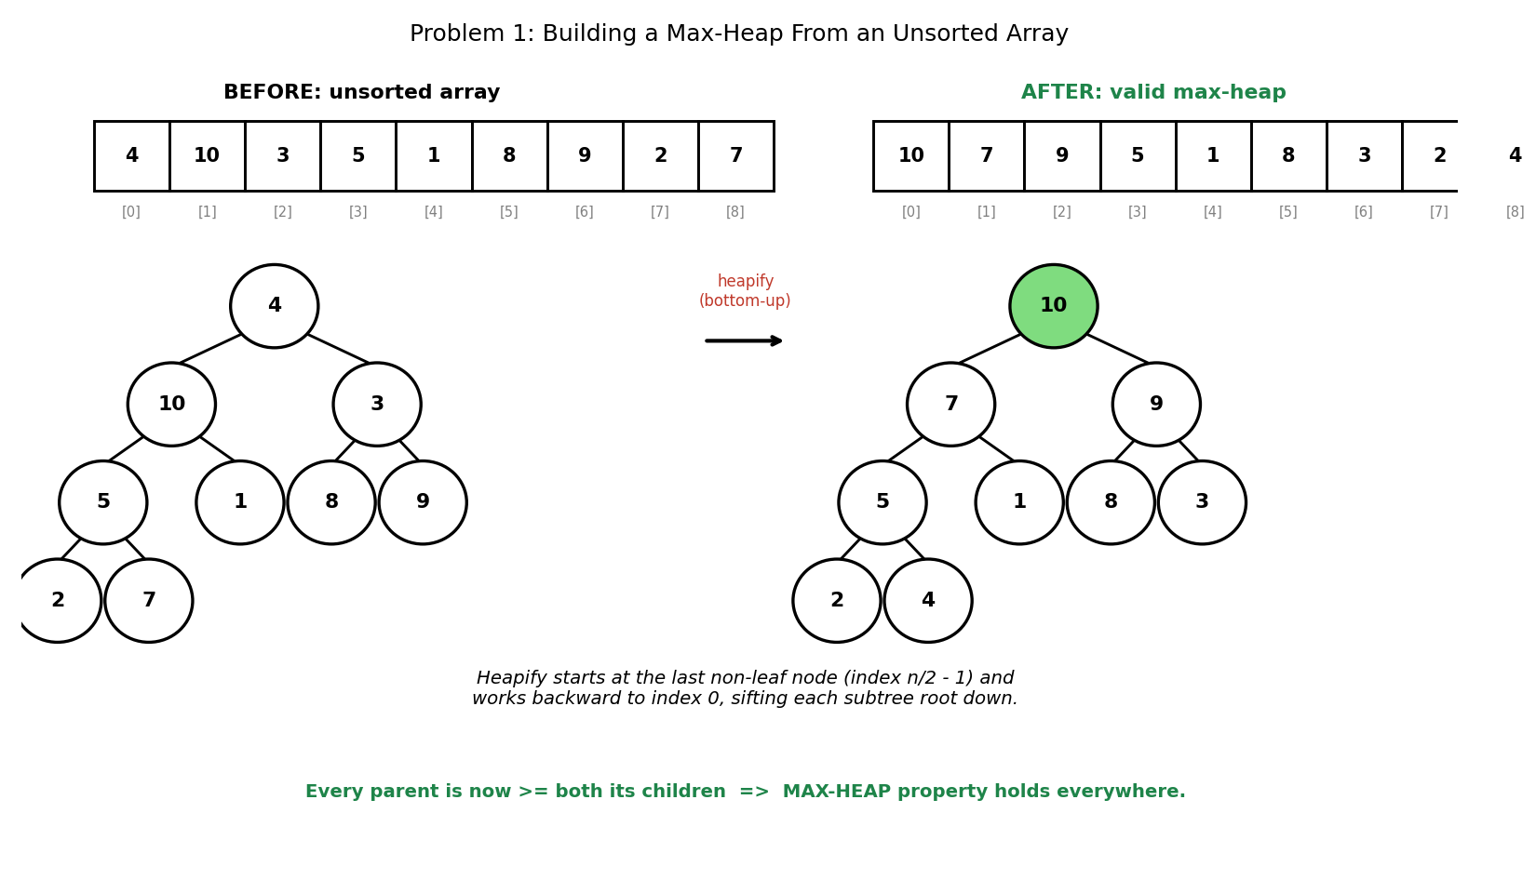

5. Java Program
import java.util.Arrays;

public class BuildMaxHeap {

static void heapifyDown(int[] arr, int n, int i) {
int largest = i;
int left = 2 * i + 1;
int right = 2 * i + 2;

if (left < n && arr[left] > arr[largest]) largest = left;
if (right < n && arr[right] > arr[largest]) largest = right;

if (largest != i) {
int temp = arr[i];
arr[i] = arr[largest];
arr[largest] = temp;
heapifyDown(arr, n, largest); // continue sifting down
}
}

static void buildMaxHeap(int[] arr) {
int n = arr.length;
// start from the last non-leaf node, work backward to the root
for (int i = n / 2 - 1; i >= 0; i--) {
heapifyDown(arr, n, i);
}
}

static boolean isMaxHeap(int[] arr) {
int n = arr.length;
for (int i = 0; i < n; i++) {
int left = 2 * i + 1, right = 2 * i + 2;
if (left < n && arr[left] > arr[i]) return false;
if (right < n && arr[right] > arr[i]) return false;
}
return true;
}

public static void main(String[] args) {
int[] arr = {4, 10, 3, 5, 1, 8, 9, 2, 7};

System.out.println("Before: " + Arrays.toString(arr));

buildMaxHeap(arr);

System.out.println("After: " + Arrays.toString(arr));
System.out.println("Valid max-heap? " + isMaxHeap(arr));
}
}

6. Expected Output
Before: [4, 10, 3, 5, 1, 8, 9, 2, 7]
After: [10, 7, 9, 5, 1, 8, 3, 2, 4]
Valid max-heap? true

7. Complexity Analysis
- Time Complexity: O(n) for the entire build process — this is a classic result that surprises many students, since it LOOKS like n calls to an O(log n) operation (suggesting O(n log n)). The tighter bound holds because most nodes are near the bottom of the tree and only sift down a short distance; the full proof sums a geometric-like series that converges to O(n).
- Space Complexity: O(log n) for the recursion stack inside heapifyDown (or O(1) if written iteratively).
- Contrast this with building a heap by inserting elements ONE AT A TIME into an initially empty heap (each insertion costs O(log n)), which totals O(n log n) — slower than the bottom-up bulk-build shown here.

8. Laboratory Exercise
Implement a second version, insertOneAtATime(), that builds the heap by calling a siftUp-based insert() method n times on an initially empty array. Compare the final heap SHAPE produced against buildMaxHeap() on the same input {4,10,3,5,1,8,9,2,7}, and state whether the two methods necessarily produce an identical array.

Problem 2: Implement Heap Sort Using a Max-Heap

1. Objective
To sort an array in ascending order by repeatedly extracting the maximum element from a max-heap and placing it at the end of the unsorted region, entirely in place with no auxiliary array.

2. Theory / Background
Heap sort combines two ideas already covered: building a max-heap (Problem 1) and the fact that a max-heap's ROOT always holds the largest remaining element. Sorting proceeds by repeatedly swapping the root (the current maximum) with the LAST element of the still-unsorted region, then shrinking the heap's logical size by one and sifting the new root down to restore the heap property.
Crucially, the swapped-out maximum is never touched again — it now occupies its final, correct sorted position at the end of the array. This is why heap sort can sort ENTIRELY IN PLACE, using the same array both as the heap and as the growing sorted output, unlike merge sort which needs auxiliary space.

3. Algorithm
1. Call buildMaxHeap(arr) once, so arr[0] holds the overall maximum.
2. For end from n-1 down to 1:
3. a. Swap arr[0] (the current maximum) with arr[end].
4. b. The region [end, n-1] is now correctly sorted and permanently fixed.
5. c. Call heapifyDown(arr, end, 0) — note the heap's logical size is now end, excluding the already-sorted tail — to restore the max-heap property on the shrunk heap.
6. When the loop finishes, the entire array is sorted in ascending order.

4. Graphical Illustration
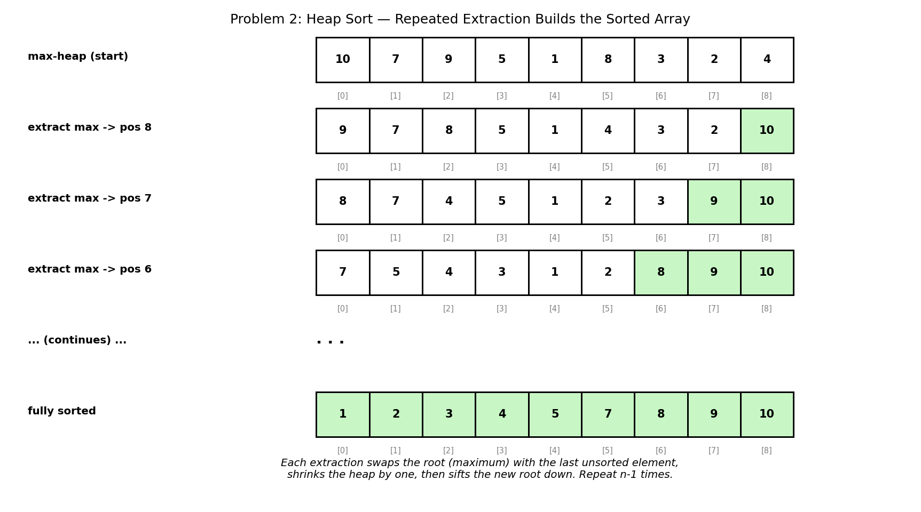

5. Java Program
import java.util.Arrays;

public class HeapSort {

static void heapifyDown(int[] arr, int n, int i) {
int largest = i;
int left = 2 * i + 1;
int right = 2 * i + 2;

if (left < n && arr[left] > arr[largest]) largest = left;
if (right < n && arr[right] > arr[largest]) largest = right;

if (largest != i) {
int temp = arr[i];
arr[i] = arr[largest];
arr[largest] = temp;
heapifyDown(arr, n, largest);
}
}

static void buildMaxHeap(int[] arr) {
int n = arr.length;
for (int i = n / 2 - 1; i >= 0; i--) {
heapifyDown(arr, n, i);
}
}

static void heapSort(int[] arr) {
int n = arr.length;
buildMaxHeap(arr);

// repeatedly move the current max (root) to the end,
// then shrink the heap and re-sift the new root down
for (int end = n - 1; end > 0; end--) {
int temp = arr[0];
arr[0] = arr[end];
arr[end] = temp;
heapifyDown(arr, end, 0); // note: heap size is now 'end', not n
}
}

public static void main(String[] args) {
int[] arr = {4, 10, 3, 5, 1, 8, 9, 2, 7};

System.out.println("Before: " + Arrays.toString(arr));

heapSort(arr);

System.out.println("After: " + Arrays.toString(arr));
}
}

6. Expected Output
Before: [4, 10, 3, 5, 1, 8, 9, 2, 7]
After: [1, 2, 3, 4, 5, 7, 8, 9, 10]

7. Complexity Analysis
- Time Complexity: O(n log n) overall — O(n) to build the initial heap, plus n-1 extractions, each costing O(log n) for the sift-down on a heap of shrinking size.
- Space Complexity: O(1) auxiliary space (ignoring the O(log n) recursion stack inside heapifyDown) — the array is sorted entirely in place, which is heap sort's key practical advantage over merge sort.
- Unlike quicksort, heap sort's O(n log n) worst case is GUARANTEED, not merely average-case — but heap sort is not STABLE (equal elements may be reordered) and, in practice, often runs slower than a well-tuned quicksort due to poor cache locality when jumping between parent and child indices.

8. Laboratory Exercise
Modify heapSort() to sort in DESCENDING order instead of ascending, using a MIN-heap instead of a max-heap (rather than simply reversing the final ascending result). State exactly which lines of the algorithm must change and why the overall time complexity remains O(n log n).

Problem 3: Find the k Largest Elements in an Array Using a Heap

1. Objective
To identify the k largest values in an array of n elements without fully sorting the array, using a heap of bounded size k.

2. Theory / Background
A naive approach sorts the entire array in O(n log n) and takes the last k elements — correct, but wasteful when k is much smaller than n. The heap-based approach instead maintains a MIN-heap of size AT MOST k: counter-intuitively, a min-heap (not a max-heap) is used because the value we most need FAST access to is the smallest of the current top-k candidates, so it can be compared against and evicted efficiently.
As each new array element arrives: if the heap has fewer than k elements, it is simply added. Once the heap is full, a new value is only worth keeping if it exceeds the heap's root (the current smallest of the top-k so far) — in which case the root is evicted and the new value takes its place. Values smaller than the current root can never make it into the final top-k and are discarded immediately.

3. Algorithm
1. Create an empty min-heap.
2. For each value in the array:
3. a. If the heap's size is less than k, insert the value.
4. b. Otherwise, if the value is greater than the heap's root, remove the root and insert the value.
5. c. Otherwise, discard the value — it cannot be among the k largest.
6. After processing the entire array, the heap contains exactly the k largest values (in no particular order internally, though they can be extracted in ascending order one at a time).

4. Graphical Illustration
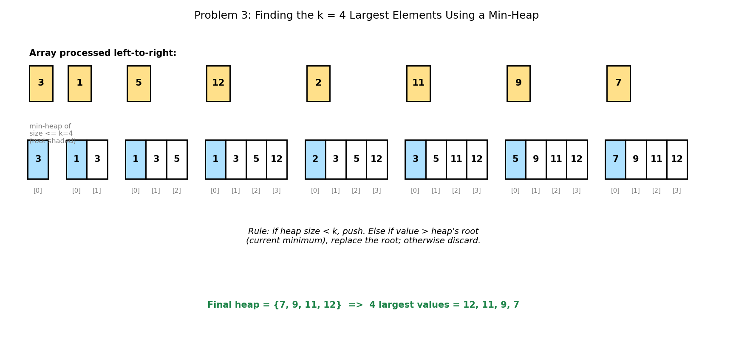

5. Java Program
import java.util.PriorityQueue;
import java.util.Arrays;

public class KLargestElements {

static int[] kLargest(int[] arr, int k) {
// a MIN-heap of size at most k: its root is always the SMALLEST
// of the k largest values seen so far
PriorityQueue<Integer> minHeap = new PriorityQueue<>();

for (int value : arr) {
if (minHeap.size() < k) {
minHeap.offer(value);
} else if (value > minHeap.peek()) {
minHeap.poll(); // discard the current smallest of the k
minHeap.offer(value);
}
// otherwise: value is too small to be in the top k, discard it
}

int[] result = new int[k];
for (int i = k - 1; i >= 0; i--) {
result[i] = minHeap.poll(); // extract in ascending order
}
return result; // result is now sorted descending
}

public static void main(String[] args) {
int[] arr = {3, 1, 5, 12, 2, 11, 9, 7};
int k = 4;

System.out.println("Array: " + Arrays.toString(arr));
System.out.println(k + " largest elements: "
+ Arrays.toString(kLargest(arr, k)));
}
}

6. Expected Output
Array: [3, 1, 5, 12, 2, 11, 9, 7]
4 largest elements: [12, 11, 9, 7]

7. Complexity Analysis
- Time Complexity: O(n log k) — each of the n array elements triggers at most one O(log k) heap operation (insertion or eviction+insertion), and k is typically much smaller than n.
- Space Complexity: O(k) — the heap never holds more than k elements at any point, regardless of how large the input array is.
- This is a significant improvement over full sorting (O(n log n)) whenever k is small relative to n — for example, finding the top 10 scores among a million records costs O(n log 10), essentially O(n), rather than O(n log n).

8. Laboratory Exercise
Adapt the program to find the k SMALLEST elements instead, using a MAX-heap of size k rather than a min-heap (mirroring the logic exactly). Test your adaptation on the same array with k=3 and state the expected result before running it to confirm.

Problem 4: Merge k Sorted Linked Lists Using a Min-Heap

1. Objective
To combine k separate sorted linked lists into one fully sorted linked list, generalising the two-list merge technique from Module 2 to an arbitrary number of lists using a heap.

2. Theory / Background
Merging just two sorted lists only ever needs to compare two candidate values at a time (Module 2, Problem 4). Merging k lists naively by repeatedly scanning all k current heads to find the minimum costs O(k) per output element, giving O(nk) overall for n total nodes — a min-heap reduces this per-element cost to O(log k).
The heap holds AT MOST one node from each of the k lists at any time — specifically, the earliest not-yet-output node from each list. Extracting the heap's minimum always yields the next correct value in the final merged order, and immediately after extracting a node, that same list's NEXT node (if any) is pushed into the heap to replace it.

3. Algorithm
1. Create a min-heap ordered by node value, and push the head node of every non-empty input list into it.
2. Create a dummy node to simplify building the result list, with a tail pointer initially pointing to it.
3. While the heap is not empty:
4. a. Remove the smallest node from the heap and append it to the result via tail.next; advance tail.
5. b. If the removed node has a next node in its ORIGINAL list, push that next node into the heap.
6. Return dummy.next as the head of the fully merged, sorted list.

4. Graphical Illustration
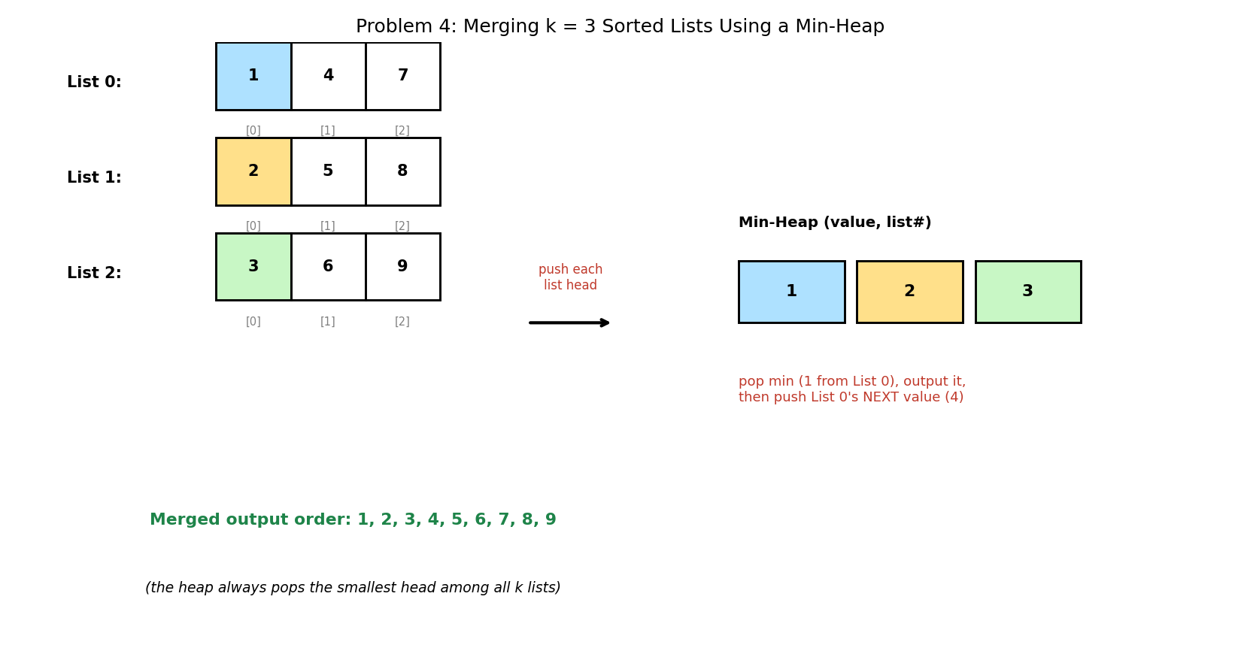

5. Java Program
import java.util.PriorityQueue;
import java.util.Arrays;

public class MergeKSortedLists {

static class Node {
int data;
Node next;
Node(int data) { this.data = data; }
}

static Node buildList(int[] values) {
Node head = null, tail = null;
for (int v : values) {
Node newNode = new Node(v);
if (head == null) { head = newNode; tail = newNode; }
else { tail.next = newNode; tail = newNode; }
}
return head;
}

static Node mergeKLists(Node[] lists) {
// min-heap ordered by each node's data value
PriorityQueue<Node> minHeap =
new PriorityQueue<>((a, b) -> a.data - b.data);

for (Node headNode : lists) {
if (headNode != null) minHeap.offer(headNode);
}

Node dummy = new Node(0);
Node tail = dummy;

while (!minHeap.isEmpty()) {
Node smallest = minHeap.poll();
tail.next = smallest;
tail = tail.next;

if (smallest.next != null) {
minHeap.offer(smallest.next); // push that list's next value
}
}

return dummy.next;
}

static void printList(Node head) {
StringBuilder sb = new StringBuilder();
while (head != null) {
sb.append(head.data);
if (head.next != null) sb.append(" -> ");
head = head.next;
}
System.out.println(sb);
}

public static void main(String[] args) {
Node[] lists = {
buildList(new int[]{1, 4, 7}),
buildList(new int[]{2, 5, 8}),
buildList(new int[]{3, 6, 9}),
};

Node merged = mergeKLists(lists);

System.out.print("Merged: ");
printList(merged);
}
}

6. Expected Output
Merged: 1 -> 2 -> 3 -> 4 -> 5 -> 6 -> 7 -> 8 -> 9

7. Complexity Analysis
- Time Complexity: O(n log k) — where n is the TOTAL number of nodes across all k lists; each node is pushed and popped from the heap exactly once, and the heap never holds more than k elements at a time.
- Space Complexity: O(k) for the heap itself (existing nodes are re-linked, not copied), though the recursive/iterative merge-pair alternative approach can achieve the same asymptotic time with different constants.
- This heap-based technique generalises directly to EXTERNAL SORTING (merging data files too large to fit in memory) and to k-way merging in distributed systems, wherever many pre-sorted streams must be combined into one.

8. Laboratory Exercise
Modify the program to also report which ORIGINAL list index each merged value came from (e.g., '1 (from list 0), 2 (from list 1), 3 (from list 2), 4 (from list 0), ...'). Use this to confirm, without just trusting the final sorted output, that the heap is indeed always selecting the globally smallest available candidate at each step.

Problem 5: Design a Data Structure to Find the Median of a Running Stream of Numbers

1. Objective
To maintain a running MEDIAN — recomputed after every new number arrives — over a stream of numbers seen one at a time, without re-sorting all numbers seen so far at every step.

2. Theory / Background
The median of a sorted collection is either its single middle element (odd count) or the average of its two middle elements (even count). Recomputing this from scratch after every new arrival by fully sorting would cost O(n log n) per number, or O(n squared log n) over an n-number stream — far too slow for a live stream.
The two-heap technique instead partitions all numbers seen so far into two balanced halves: a MAX-heap called low, holding the SMALLER half (so its root is the largest of the small half), and a MIN-heap called high, holding the LARGER half (so its root is the smallest of the large half). The two roots therefore sit immediately on either side of the true median at all times.
After every insertion, the two heaps are rebalanced so their sizes never differ by more than one. When they are exactly equal in size, the median is the average of both roots; when low has exactly one more element, the median is simply low's root.

3. Algorithm
1. Maintain two heaps: low (a max-heap) and high (a min-heap), both initially empty.
2. addNumber(num): always insert num into low first, then immediately move low's new root (its maximum) over into high — this indirect insertion guarantees num ends up on the CORRECT side relative to both heaps' existing contents.
3. Rebalance: if high's size has grown larger than low's size, move high's root back into low.
4. getMedian(): if low's size is greater than high's size, return low's root directly. Otherwise, return the average of low's root and high's root.

4. Graphical Illustration
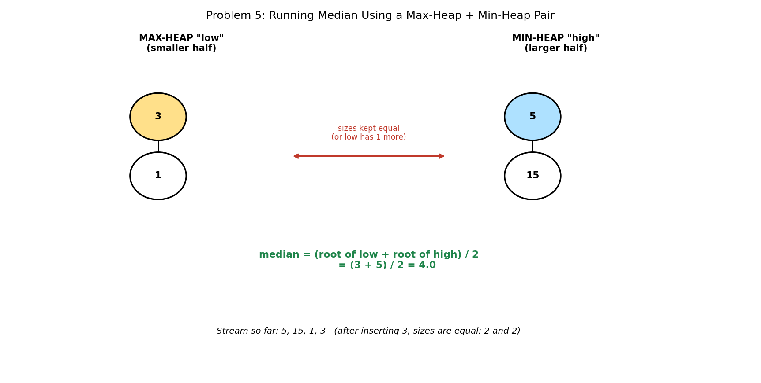

5. Java Program
import java.util.PriorityQueue;
import java.util.Collections;

public class RunningMedian {

// "low": SMALLER half of numbers seen (max-heap; root = its largest)
static PriorityQueue<Integer> low =
new PriorityQueue<>(Collections.reverseOrder());
// "high": LARGER half of numbers seen (min-heap; root = its smallest)
static PriorityQueue<Integer> high = new PriorityQueue<>();

static void addNumber(int num) {
low.offer(num); // always insert into low first
high.offer(low.poll()); // move low's largest into high

// rebalance: low is allowed at most ONE more element than high
if (high.size() > low.size()) {
low.offer(high.poll());
}
}

static double getMedian() {
if (low.size() > high.size()) {
return low.peek(); // odd total count
}
return (low.peek() + high.peek()) / 2.0; // even total count
}

public static void main(String[] args) {
int[] stream = {5, 15, 1, 3, 8, 7, 9, 2};

for (int num : stream) {
addNumber(num);
System.out.println("add(" + num + ") -> median = " + getMedian());
}
}
}

6. Expected Output
add(5) -> median = 5.0
add(15) -> median = 10.0
add(1) -> median = 5.0
add(3) -> median = 4.0
add(8) -> median = 5.0
add(7) -> median = 6.0
add(9) -> median = 7.0
add(2) -> median = 6.0

7. Complexity Analysis
- Time Complexity: O(log n) per addNumber() call — each insertion touches at most two heaps, each an O(log n) operation; getMedian() itself is O(1), just reading two roots.
- Space Complexity: O(n) — every number ever added is stored in exactly one of the two heaps.
- Trace the fourth row: after add(3), low={1,3} (root 3) and high={5,15} (root 5), both size 2, so median = (3+5)/2 = 4.0 — matching the diagram exactly. Compare this to add(9): sizes become low={1,2,3,5}(root 5), high={7,8,9,15}(root 7)? Work through the rebalancing by hand to confirm why the reported median is 7 (not 6) at that exact step.

8. Laboratory Exercise
Extend the class with a removeNumber(int num) method that removes a previously added number and correctly restores both the heap-size balance and the median. Explain why this is significantly harder than addNumber(), given that Java's PriorityQueue only supports O(n) arbitrary-element removal rather than O(log n).

Probable Examination Question — Module 8 (Heaps / Priority Queues)
(a) Theory
Explain why building a heap from an unsorted array of n elements (bottom-up heapify) runs in O(n) time, even though it performs n/2 calls to an operation that individually costs up to O(log n). Contrast this with the O(n log n) cost of building the same heap by inserting elements one at a time.
(b) Trace / Dry-run
Given the array [4, 6, 3, 5, 2, 9, 8, 1, 7, 10], apply bottom-up heapify to build a max-heap. Show the array's contents after EACH call to heapifyDown (there should be 5 such calls, since the array has 10 elements, indices 4 down to 0), and state the final max-heap array.
(c) Programming
Write a complete Java program that:
- (i) Accepts a list of (task, priority) pairs and uses a PriorityQueue to always process the HIGHEST priority task next;
- (ii) Supports adding new tasks at any time, even after processing has started; and
- (iii) Prints each task in the exact order it is processed, along with its priority.
Your program should compile and run without error on a mixed sequence of at least 5 tasks with distinct priorities. State the time complexity of processing n tasks in total, assuming each task is added once and processed once.
(d) Short Answer
The k-largest-elements algorithm (Problem 3) uses a MIN-heap even though the goal is to find the LARGEST values. Explain, in your own words, why a min-heap (not a max-heap) is the correct choice for this specific problem.

Lab Module 9: The Graph Data Structure
Level: 300 (Third Year) | Language: Java (JDK 17+)
Learning Objectives
- Represent a graph using both an adjacency list and an adjacency matrix, and compare their space/time trade-offs.
- Implement Breadth-First Search and Depth-First Search traversals, and use DFS to detect cycles.
- Implement Dijkstra's algorithm to compute single-source shortest paths in a weighted graph.
- Implement topological sorting (Kahn's algorithm) and strongly-connected-component detection (Kosaraju's algorithm) on directed graphs.
General Instructions
- Type each program into a .java file matching its public class name exactly (e.g., DijkstraShortestPath.java), then compile with: javac ClassName.java
- Run the compiled program with: java ClassName, and compare your output against the 'Expected Output' shown in this manual.
- Attempt the 'Laboratory Exercise' at the end of each problem before moving to the next.

Problem 1: Represent a Graph Using an Adjacency List and Adjacency Matrix

1. Objective
To implement the two standard in-memory representations of a graph — the adjacency list and the adjacency matrix — from the same set of edges, and to understand the trade-offs between them.

2. Theory / Background
A graph consists of a set of VERTICES (nodes) and a set of EDGES (connections between vertices). An ADJACENCY LIST stores, for each vertex, a list of the vertices it is directly connected to — this is compact and efficient whenever the graph is SPARSE (relatively few edges compared to the maximum possible).
An ADJACENCY MATRIX instead uses a V x V grid of 0s and 1s, where matrix[u][v] = 1 if and only if an edge exists between u and v. This allows an O(1) check for whether any specific edge exists, at the cost of O(V squared) memory regardless of how many edges are actually present — wasteful for sparse graphs, but often preferable for DENSE graphs or when edge-existence queries dominate.
For an UNDIRECTED graph (used in this problem), both representations are symmetric: if u is adjacent to v, then v is also adjacent to u, so each edge is recorded in both directions.

3. Algorithm
1. Adjacency list: create an empty list of lists, one per vertex. For each edge (u, v), append v to u's list AND append u to v's list (undirected).
2. Adjacency matrix: create a V x V array initialised to all zeros. For each edge (u, v), set matrix[u][v] = 1 AND matrix[v][u] = 1.
3. Both representations are built from the SAME edge list and describe the exact same graph — they are simply different data structures for answering different kinds of queries efficiently.

4. Graphical Illustration
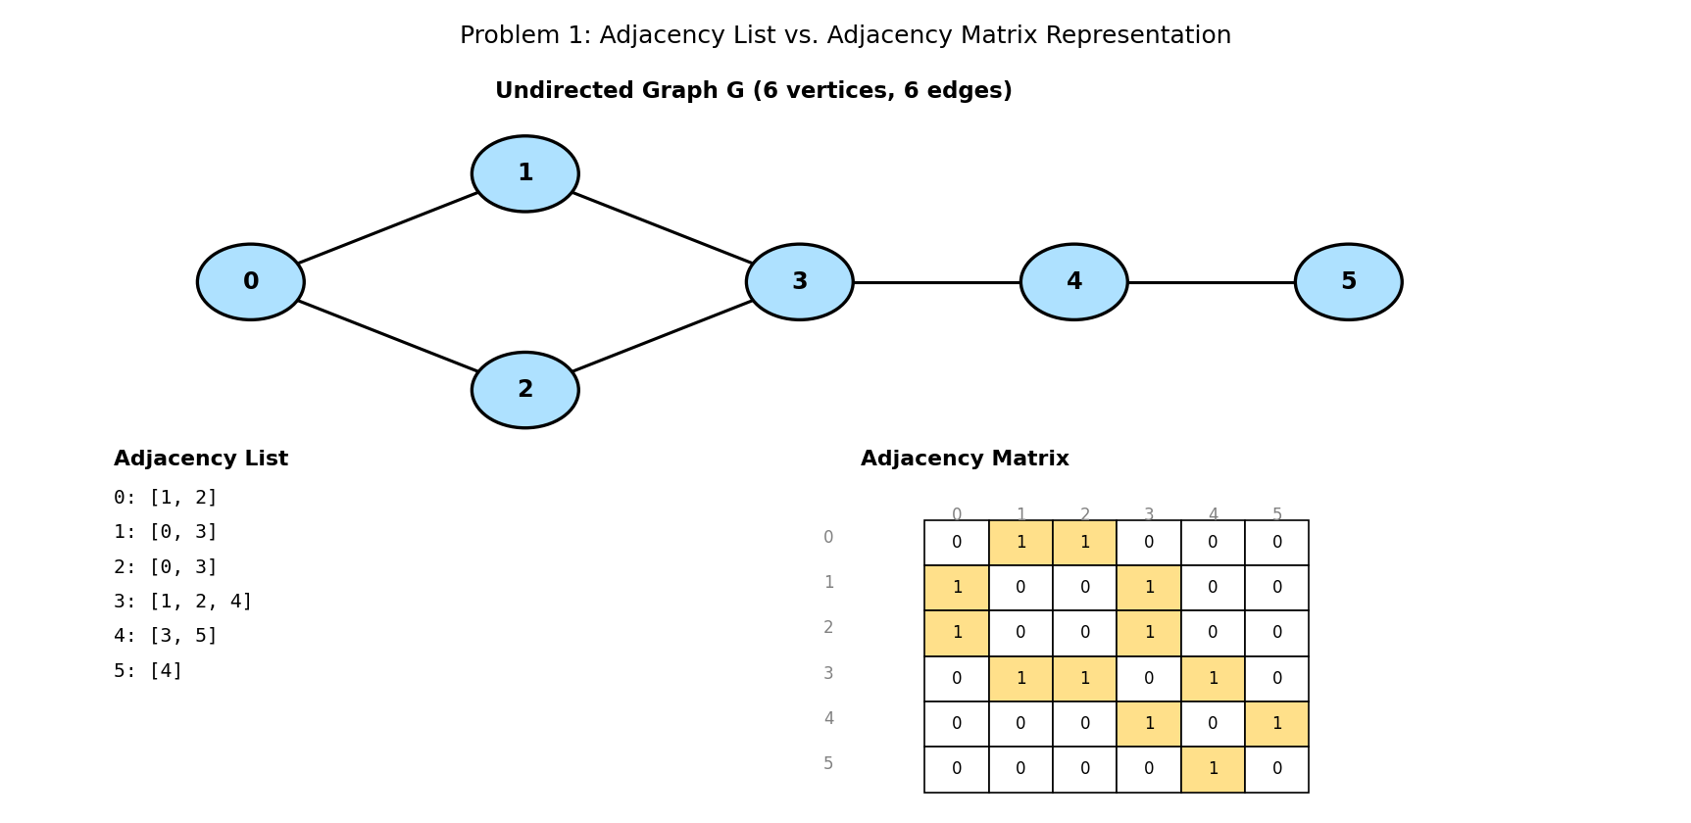

5. Java Program
import java.util.*;

public class GraphRepresentation {

static int V = 6; // number of vertices
static List<List<Integer>> adjList = new ArrayList<>();
static int[][] adjMatrix = new int[V][V];

static void addEdge(int u, int v) {
adjList.get(u).add(v);
adjList.get(v).add(u); // undirected: add both directions
adjMatrix[u][v] = 1;
adjMatrix[v][u] = 1;
}

public static void main(String[] args) {
for (int i = 0; i < V; i++) adjList.add(new ArrayList<>());

int[][] edges = {{0,1},{0,2},{1,3},{2,3},{3,4},{4,5}};
for (int[] e : edges) addEdge(e[0], e[1]);

System.out.println("Adjacency List:");
for (int i = 0; i < V; i++) {
Collections.sort(adjList.get(i));
System.out.println(" " + i + ": " + adjList.get(i));
}

System.out.println("\nAdjacency Matrix:");
for (int[] row : adjMatrix) {
System.out.println(" " + Arrays.toString(row));
}
}
}

6. Expected Output
Adjacency List:
0: [1, 2]
1: [0, 3]
2: [0, 3]
3: [1, 2, 4]
4: [3, 5]
5: [4]

Adjacency Matrix:
[0, 1, 1, 0, 0, 0]
[1, 0, 0, 1, 0, 0]
[1, 0, 0, 1, 0, 0]
[0, 1, 1, 0, 1, 0]
[0, 0, 0, 1, 0, 1]
[0, 0, 0, 0, 1, 0]

7. Complexity Analysis
- Space Complexity: adjacency list uses O(V + E) memory — proportional to the actual number of edges. Adjacency matrix uses O(V squared) memory regardless of E.
- Time Complexity: checking whether edge (u,v) exists is O(1) with a matrix, but O(degree(u)) with a list (must scan u's neighbour list). Iterating over ALL of u's neighbours is O(degree(u)) with a list, but O(V) with a matrix (must scan the entire row, including all the zeros).
- For this problem's graph (6 vertices, 6 edges — clearly sparse), the adjacency list uses far less memory than the 6x6 = 36-cell matrix, most of which is wasted zeros.

8. Laboratory Exercise
Extend the program to also support a DIRECTED, WEIGHTED graph: modify the adjacency list to store (neighbour, weight) pairs instead of plain integers, and modify the adjacency matrix to store the edge weight (or a sentinel such as -1 or infinity) instead of a plain 0/1. Rebuild both representations for a small directed weighted graph of your choice and print them.

Problem 2: Implement Breadth-First Search (BFS) Traversal on a Graph

1. Objective
To visit every vertex reachable from a given starting vertex, exploring the graph outward one 'layer' of distance at a time, using a queue to enforce this level-by-level order.

2. Theory / Background
BFS explores a graph the way ripples spread outward from a stone dropped in water: it fully visits every vertex at distance 1 from the start before visiting ANY vertex at distance 2, then all of distance 2 before distance 3, and so on. This layer-by-layer behaviour is what a FIFO queue naturally enforces: vertices are processed in exactly the order they were discovered.
A visited[] array is essential to prevent revisiting the same vertex multiple times (which would otherwise cause infinite loops in a graph containing cycles) and to prevent the same vertex being added to the queue more than once. Marking a vertex visited AT THE MOMENT it is enqueued (not when it is dequeued) is a small but important detail that avoids duplicate queue entries.

3. Algorithm
1. Create a boolean visited[] array (all false) and an empty queue.
2. Mark the start vertex visited and enqueue it.
3. While the queue is not empty: dequeue a vertex u, record it as visited (output it).
4. For each neighbour v of u that is NOT yet visited: mark v visited and enqueue it.
5. Repeat until the queue is empty — every vertex reachable from start has now been visited exactly once, in order of increasing distance from start.

4. Graphical Illustration
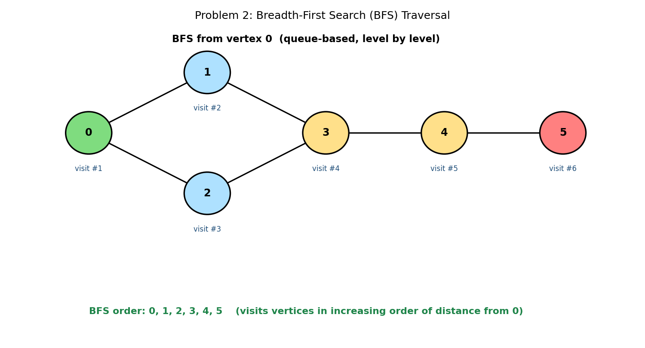

5. Java Program
import java.util.*;

public class BFSTraversal {

static int V = 6;
static List<List<Integer>> adj = new ArrayList<>();

static void addEdge(int u, int v) {
adj.get(u).add(v);
adj.get(v).add(u);
}

static List<Integer> bfs(int start) {
boolean[] visited = new boolean[V];
List<Integer> order = new ArrayList<>();
Queue<Integer> queue = new LinkedList<>();

visited[start] = true;
queue.offer(start);

while (!queue.isEmpty()) {
int u = queue.poll();
order.add(u);

for (int v : adj.get(u)) {
if (!visited[v]) {
visited[v] = true; // mark BEFORE enqueueing
queue.offer(v);
}
}
}
return order;
}

public static void main(String[] args) {
for (int i = 0; i < V; i++) adj.add(new ArrayList<>());
int[][] edges = {{0,1},{0,2},{1,3},{2,3},{3,4},{4,5}};
for (int[] e : edges) addEdge(e[0], e[1]);
for (int i = 0; i < V; i++) Collections.sort(adj.get(i));

System.out.println("BFS from vertex 0: " + bfs(0));
}
}

6. Expected Output
BFS from vertex 0: [0, 1, 2, 3, 4, 5]

7. Complexity Analysis
- Time Complexity: O(V + E) — every vertex is enqueued and dequeued exactly once (O(V) total), and every edge is examined exactly once from each endpoint that gets processed (O(E) total).
- Space Complexity: O(V) for the visited array and the queue, which in the worst case (a 'star' graph) could hold almost all vertices at once.
- BFS is the standard algorithm for finding the SHORTEST PATH in an UNWEIGHTED graph (measured by number of edges), precisely because it visits vertices in strictly increasing order of distance from the source.

8. Laboratory Exercise
Modify the program to also record, for each vertex, its DISTANCE (number of edges) from the start vertex and the PARENT vertex through which it was first discovered. Use the parent array to reconstruct and print the actual shortest path (as a sequence of vertices) from vertex 0 to vertex 5.

Problem 3: Implement Depth-First Search (DFS) Traversal, Including Detecting Cycles

1. Objective
To visit every vertex reachable from a starting vertex by exploring as DEEPLY as possible along each branch before backtracking, and to use this same traversal to detect whether the graph contains a cycle.

2. Theory / Background
Unlike BFS's layer-by-layer breadth, DFS commits fully to one path, following it as far as it can go before backtracking to try alternatives — exactly like a program's own recursive call stack (indeed, the simplest DFS implementation IS a recursive function, as shown here).
Cycle detection in an UNDIRECTED graph relies on a subtle but crucial distinction: while exploring from vertex u, encountering an already-visited neighbour v is not automatically a cycle — if v is u's own PARENT (the vertex we just arrived FROM), that is simply the edge we used to get here, traversed backward, which is normal and expected. A true cycle exists only when we reach an already-visited vertex that is NOT our immediate parent — this is called a BACK EDGE, and it proves a cycle exists.
In the illustrated graph, exploring 0 -> 1 -> 3 -> 2 reaches vertex 2, whose neighbour 0 is already visited AND is not 2's parent (3 is) — this back edge (2,0) confirms the graph contains a cycle: 0-1-3-2-0.

3. Algorithm
1. dfsVisit(u): mark u visited, record it in the traversal order, then for each unvisited neighbour v, recursively call dfsVisit(v).
2. dfs(start): initialise an empty visited array and call dfsVisit(start) once; the recorded order is the full DFS traversal.
3. hasCycleUtil(u, parent): mark u visited. For each neighbour v of u: if v is unvisited, recurse into it (passing u as v's parent) and propagate a 'cycle found' result upward; if v IS visited and v is NOT equal to parent, a back edge has been found — return true immediately.
4. hasCycle(): call hasCycleUtil on every not-yet-visited vertex (to correctly handle graphs with multiple disconnected components), returning true as soon as any call finds a cycle.

4. Graphical Illustration
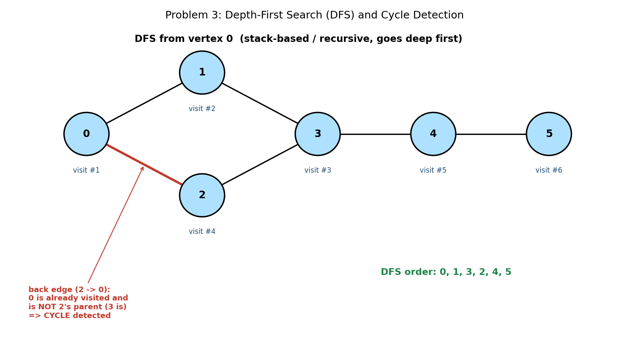

5. Java Program
import java.util.*;

public class DFSTraversalCycle {

static int V = 6;
static List<List<Integer>> adj = new ArrayList<>();

static void addEdge(int u, int v) {
adj.get(u).add(v);
adj.get(v).add(u);
}

static void dfsVisit(int u, boolean[] visited, List<Integer> order) {
visited[u] = true;
order.add(u);
for (int v : adj.get(u)) {
if (!visited[v]) {
dfsVisit(v, visited, order);
}
}
}

static List<Integer> dfs(int start) {
boolean[] visited = new boolean[V];
List<Integer> order = new ArrayList<>();
dfsVisit(start, visited, order);
return order;
}

// returns true if the undirected graph contains a cycle
static boolean hasCycleUtil(int u, int parent, boolean[] visited) {
visited[u] = true;
for (int v : adj.get(u)) {
if (!visited[v]) {
if (hasCycleUtil(v, u, visited)) return true;
} else if (v != parent) {
// v visited but not our parent -> back edge -> cycle
return true;
}
}
return false;
}

static boolean hasCycle() {
boolean[] visited = new boolean[V];
for (int i = 0; i < V; i++) {
if (!visited[i]) {
if (hasCycleUtil(i, -1, visited)) return true;
}
}
return false;
}

public static void main(String[] args) {
for (int i = 0; i < V; i++) adj.add(new ArrayList<>());
int[][] edges = {{0,1},{0,2},{1,3},{2,3},{3,4},{4,5}};
for (int[] e : edges) addEdge(e[0], e[1]);
for (int i = 0; i < V; i++) Collections.sort(adj.get(i));

System.out.println("DFS from vertex 0: " + dfs(0));
System.out.println("Graph has a cycle: " + hasCycle());
}
}

6. Expected Output
DFS from vertex 0: [0, 1, 3, 2, 4, 5]
Graph has a cycle: true

7. Complexity Analysis
- Time Complexity: O(V + E) for both plain DFS traversal and cycle detection — identical asymptotic cost to BFS, since both visit every vertex once and examine every edge a constant number of times.
- Space Complexity: O(V) for the visited array, PLUS O(V) in the worst case for the recursion call stack (a long, thin graph could recurse as deep as V levels) — this is DFS's main practical difference from BFS's explicit queue, and can risk a StackOverflowError on very large or deep graphs if implemented recursively.
- Compare the traversal orders: BFS visited 0,1,2,3,... (both of 0's neighbours before going deeper), while DFS visited 0,1,3,2,... (committing to the 0->1->3 branch fully before backtracking to visit 2).

8. Laboratory Exercise
Rewrite dfs() using an EXPLICIT stack instead of recursion (an iterative DFS), and confirm it produces the same visited order as the recursive version on this problem's graph. Explain one practical advantage the iterative version has over the recursive version for very large graphs.

Problem 4: Find the Shortest Path Between Two Nodes Using Dijkstra's Algorithm

1. Objective
To compute the shortest-distance path from a single source vertex to every other vertex in a WEIGHTED graph, where edge weights represent costs (such as distance or time) that must be minimised, not merely counted.

2. Theory / Background
Plain BFS finds shortest paths by EDGE COUNT, which is meaningless once edges have different weights — the path with fewer edges is not necessarily the cheapest. Dijkstra's algorithm instead always expands the UNVISITED vertex with the smallest currently-known distance, using a min-heap (PriorityQueue) to efficiently find that vertex at every step.
The core operation is called RELAXATION: for the vertex u just finalised, every edge (u, v) is checked — if travelling from the source to u, then across this edge to v, is CHEAPER than the best route to v found so far, v's distance is updated (improved). This is repeated until every reachable vertex has been finalised.
Dijkstra's algorithm requires all edge weights to be NON-NEGATIVE; a negative weight could cause an already-finalised vertex's distance to become invalid, since the algorithm never revisits a vertex once finalised.

3. Algorithm
1. Initialise dist[] to infinity for every vertex except the source, which is 0. Add the source to a min-heap keyed by distance.
2. While the heap is not empty: remove the vertex u with the smallest tentative distance. If u was already finalised (a stale heap entry), skip it.
3. Mark u as finalised — its dist[u] value is now guaranteed to be the true shortest distance from the source.
4. For every edge (u, v, weight): if dist[u] + weight < dist[v], update dist[v] to this smaller value and push (v, new distance) onto the heap.
5. Repeat until the heap is empty. Every dist[] value is now the shortest distance from the source to that vertex (or remains infinity if unreachable).

4. Graphical Illustration
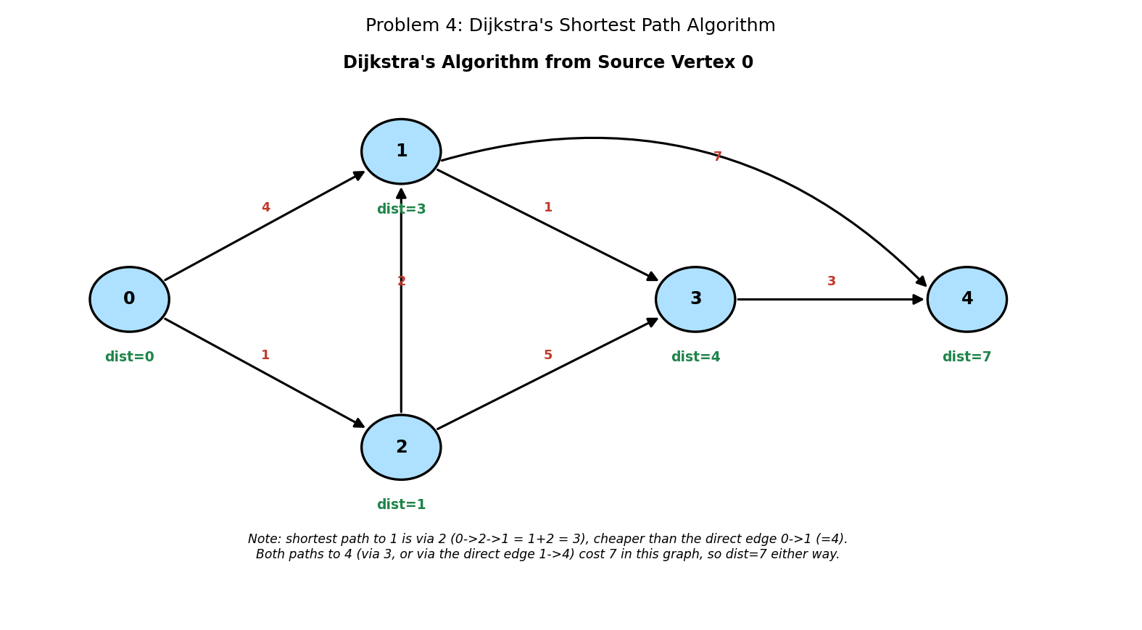

5. Java Program
import java.util.*;

public class DijkstraShortestPath {

static class Edge {
int to, weight;
Edge(int to, int weight) { this.to = to; this.weight = weight; }
}

static int V = 5;
static List<List<Edge>> adj = new ArrayList<>();

static void addEdge(int from, int to, int weight) {
adj.get(from).add(new Edge(to, weight));
}

static int[] dijkstra(int src) {
int[] dist = new int[V];
Arrays.fill(dist, Integer.MAX_VALUE);
dist[src] = 0;

// min-heap ordered by current known distance
PriorityQueue<int[]> pq = new PriorityQueue<>((a, b) -> a[1] - b[1]);
pq.offer(new int[]{src, 0});
boolean[] finalized = new boolean[V];

while (!pq.isEmpty()) {
int[] top = pq.poll();
int u = top[0];
if (finalized[u]) continue; // skip stale queue entries
finalized[u] = true;

for (Edge e : adj.get(u)) {
if (!finalized[e.to] && dist[u] + e.weight < dist[e.to]) {
dist[e.to] = dist[u] + e.weight; // relax the edge
pq.offer(new int[]{e.to, dist[e.to]});
}
}
}
return dist;
}

public static void main(String[] args) {
for (int i = 0; i < V; i++) adj.add(new ArrayList<>());

addEdge(0, 1, 4);
addEdge(0, 2, 1);
addEdge(2, 1, 2);
addEdge(1, 3, 1);
addEdge(2, 3, 5);
addEdge(3, 4, 3);
addEdge(1, 4, 7);

int[] dist = dijkstra(0);

System.out.println("Shortest distances from vertex 0:");
for (int i = 0; i < V; i++) {
System.out.println(" to " + i + ": " + dist[i]);
}
}
}

6. Expected Output
Shortest distances from vertex 0:
to 0: 0
to 1: 3
to 2: 1
to 3: 4
to 4: 7

7. Complexity Analysis
- Time Complexity: O((V + E) log V) using a binary heap — each vertex is extracted from the heap once (O(log V) each), and each edge can trigger at most one heap insertion (also O(log V) each).
- Space Complexity: O(V + E) for the adjacency list plus O(V) for the distance array and heap contents.
- Trace the key relaxation in this example: the direct edge 0->1 has weight 4, but the algorithm finds a CHEAPER route 0->2->1 costing 1+2=3, correctly overriding the direct edge — this is exactly the kind of improvement relaxation is designed to catch.

8. Laboratory Exercise
Extend the program to also reconstruct and print the ACTUAL shortest PATH (sequence of vertices), not just its total distance, for the route from vertex 0 to vertex 4. (Hint: maintain a parent[] array, updated every time dist[v] is improved, then walk backward from the destination to the source.)

Problem 5: Topological Sort and Strongly Connected Components on a Directed Graph

1. Objective
To order the vertices of a Directed Acyclic Graph (DAG) so that every edge points from an earlier vertex to a later one (topological sort), and separately, to identify maximal groups of vertices that are all mutually reachable from one another in a general directed graph (strongly connected components).

2. Theory / Background
A TOPOLOGICAL SORT only makes sense for a DAG (a directed graph with NO cycles) and models real dependency orderings — such as course prerequisites or build-system compilation order — where an edge (u, v) means 'u must come before v'. KAHN'S ALGORITHM computes this order by repeatedly removing vertices whose IN-DEGREE (number of incoming edges) is currently zero, since such a vertex has no remaining unprocessed prerequisites.
A STRONGLY CONNECTED COMPONENT (SCC) is a maximal set of vertices where EVERY vertex can reach EVERY OTHER vertex in the set via directed paths. Unlike a DAG, a general directed graph can contain cycles, and KOSARAJU'S ALGORITHM identifies all SCCs using two passes of DFS: one on the original graph to compute a 'finishing order', and one on the TRANSPOSE graph (all edges reversed) processed in reverse finishing order.
These two techniques are complementary: collapsing every SCC of a directed graph down to a single 'super-vertex' always produces a DAG, upon which topological sorting can then meaningfully be applied — this combined technique is used in compilers and dependency-resolution systems to detect and separately handle circular dependencies.

3. Algorithm
1. Kahn's Algorithm: compute the in-degree of every vertex. Enqueue all vertices with in-degree zero. Repeatedly dequeue a vertex, append it to the output order, and decrement the in-degree of each of its neighbours — enqueueing any neighbour whose in-degree drops to zero. (If the final order has fewer than V vertices, the graph contains a cycle and has no valid topological order.)
2. Kosaraju's Algorithm, Pass 1: perform a DFS from every unvisited vertex on the ORIGINAL graph, pushing each vertex onto a stack AFTER all of its neighbours have been fully explored (post-order).
3. Build the TRANSPOSE graph by reversing the direction of every edge.
4. Kosaraju's Algorithm, Pass 2: pop vertices off the stack one at a time; for each not-yet-visited vertex, perform a DFS on the TRANSPOSE graph — every vertex reached in this single DFS call forms one complete strongly connected component.

4. Graphical Illustration
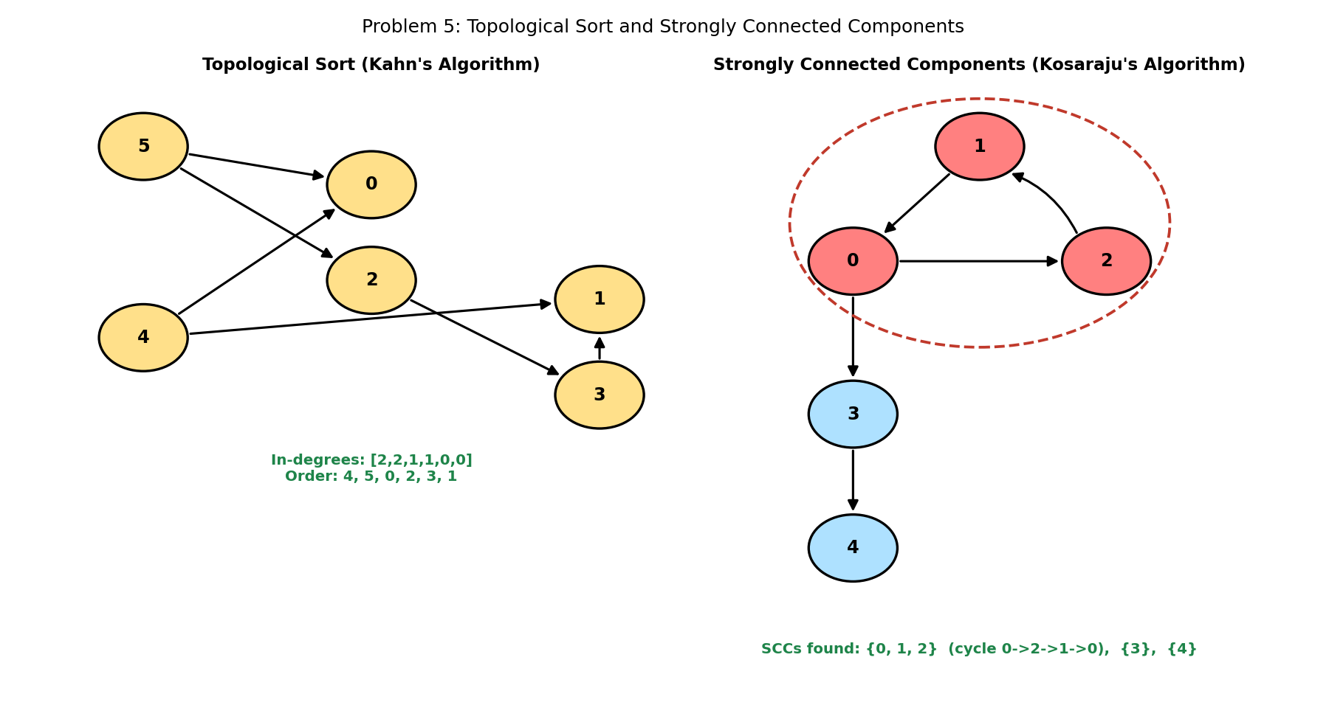

5. Java Program
import java.util.*;

public class TopoSortAndSCC {

// ---------- Part A: Topological Sort (Kahn's Algorithm) ----------
static List<Integer> topologicalSort(int V, List<List<Integer>> adj) {
int[] indegree = new int[V];
for (int u = 0; u < V; u++) {
for (int v : adj.get(u)) indegree[v]++;
}

Queue<Integer> queue = new LinkedList<>();
for (int i = 0; i < V; i++) {
if (indegree[i] == 0) queue.offer(i);
}

List<Integer> order = new ArrayList<>();
while (!queue.isEmpty()) {
int u = queue.poll();
order.add(u);
for (int v : adj.get(u)) {
indegree[v]--;
if (indegree[v] == 0) queue.offer(v);
}
}
return order; // if order.size() < V, the graph has a cycle
}

// ---------- Part B: Strongly Connected Components (Kosaraju's) ----
static void fillOrder(int u, boolean[] visited, Deque<Integer> stack,
List<List<Integer>> adj) {
visited[u] = true;
for (int v : adj.get(u)) {
if (!visited[v]) fillOrder(v, visited, stack, adj);
}
stack.push(u); // push AFTER exploring all neighbours (post-order)
}

static void collectComponent(int u, boolean[] visited,
List<Integer> component, List<List<Integer>> radj) {
visited[u] = true;
component.add(u);
for (int v : radj.get(u)) {
if (!visited[v]) collectComponent(v, visited, component, radj);
}
}

static List<List<Integer>> stronglyConnectedComponents(
int V, List<List<Integer>> adj) {
Deque<Integer> stack = new ArrayDeque<>();
boolean[] visited = new boolean[V];
for (int i = 0; i < V; i++) {
if (!visited[i]) fillOrder(i, visited, stack, adj);
}

// build the reverse (transpose) graph
List<List<Integer>> radj = new ArrayList<>();
for (int i = 0; i < V; i++) radj.add(new ArrayList<>());
for (int u = 0; u < V; u++) {
for (int v : adj.get(u)) radj.get(v).add(u);
}

Arrays.fill(visited, false);
List<List<Integer>> components = new ArrayList<>();
while (!stack.isEmpty()) {
int u = stack.pop();
if (!visited[u]) {
List<Integer> component = new ArrayList<>();
collectComponent(u, visited, component, radj);
Collections.sort(component);
components.add(component);
}
}
return components;
}

public static void main(String[] args) {
// ---- Topological sort on a DAG ----
int V1 = 6;
List<List<Integer>> dag = new ArrayList<>();
for (int i = 0; i < V1; i++) dag.add(new ArrayList<>());
int[][] dagEdges = {{5,0},{5,2},{4,0},{4,1},{2,3},{3,1}};
for (int[] e : dagEdges) dag.get(e[0]).add(e[1]);
for (int i = 0; i < V1; i++) Collections.sort(dag.get(i));

System.out.println("Topological order: " + topologicalSort(V1, dag));

// ---- SCC on a graph with cycles ----
int V2 = 5;
List<List<Integer>> g = new ArrayList<>();
for (int i = 0; i < V2; i++) g.add(new ArrayList<>());
int[][] sccEdges = {{1,0},{0,2},{2,1},{0,3},{3,4}};
for (int[] e : sccEdges) g.get(e[0]).add(e[1]);

System.out.println("Strongly connected components: " +
stronglyConnectedComponents(V2, g));
}
}

6. Expected Output
Topological order: [4, 5, 0, 2, 3, 1]
Strongly connected components: [[0, 1, 2], [3], [4]]

7. Complexity Analysis
- Time Complexity: O(V + E) for BOTH Kahn's algorithm and Kosaraju's algorithm — each performs a small constant number of full graph traversals (in-degree computation plus one queue pass for Kahn's; two DFS passes plus transpose construction for Kosaraju's).
- Space Complexity: O(V + E) for the adjacency list(s) — Kosaraju's additionally needs O(V + E) for the transpose graph and O(V) for the stack.
- Notice the SCC result: {0, 1, 2} form one component because of the cycle 0 -> 2 -> 1 -> 0, while 3 and 4 are each their OWN single-vertex component, since neither has a path back to any earlier vertex — a directed edge alone (without a return path) never creates a shared SCC.

8. Laboratory Exercise
Verify computationally that collapsing the SCC {0,1,2} from this problem's second graph into a single super-vertex (call it X) produces a valid DAG with edges X->3 and 3->4. Write a short program that performs this collapse programmatically, then runs Kahn's algorithm on the resulting condensed graph, and prints its topological order.

Probable Examination Question — Module 9 (Graphs)
(a) Theory
Compare the adjacency list and adjacency matrix representations of a graph in terms of space complexity and the time complexity of checking whether a specific edge exists. State, with justification, which representation you would choose for a graph with 10,000 vertices and 15,000 edges.
(b) Trace / Dry-run
Given the directed weighted graph with edges (0,1,2), (0,2,4), (1,2,1), (1,3,7), (2,4,3), (4,3,2), run Dijkstra's algorithm from source vertex 0. Show the vertex finalised and the full distance array after each step, and state the final shortest distance to vertex 3.
(c) Programming
Write a complete Java program that:
- (i) Accepts a directed graph and determines whether it contains a cycle (a DIFFERENT check from Problem 3, which was for undirected graphs — a directed cycle requires detecting a 'vertex currently on the recursion stack', not merely 'visited');
- (ii) If the graph is acyclic, prints a valid topological order; and
- (iii) If the graph contains a cycle, prints a clear message stating that no topological order exists.
Your program should compile and run without error on both a DAG and a graph containing a cycle. State the time complexity of your cycle-detection step and explain why a simple 'visited[]' array alone (as used for undirected cycle detection) is NOT sufficient for directed graphs.
(d) Short Answer
Explain why Dijkstra's algorithm produces incorrect results if the graph contains an edge with a NEGATIVE weight, and name one other shortest-path algorithm capable of correctly handling negative edge weights (without negative cycles).

Lab Module 10: The Trie (Prefix Tree) Data Structure
Level: 300 (Third Year) | Language: Java (JDK 17+)
Learning Objectives
- Understand how a trie stores strings character-by-character along shared paths, and why this enables prefix-based operations that a hash table cannot.
- Implement insertion, exact-word search, and prefix search in Java.
- Implement correct trie node deletion, including safely preserving nodes still needed by other words.
- Apply a trie to two realistic applications: autocomplete suggestion and Trie-guided pattern matching on a 2D board.
General Instructions
- Type each program into a .java file matching its public class name exactly (e.g., DeleteWord.java), then compile with: javac ClassName.java
- Run the compiled program with: java ClassName, and compare your output against the 'Expected Output' shown in this manual.
- Attempt the 'Laboratory Exercise' at the end of each problem before moving to the next.

Problem 1: Implement a Basic Trie With Insert and Search Operations

1. Objective
To implement a trie (prefix tree) that supports inserting words and checking whether an exact word has previously been inserted.

2. Theory / Background
A trie stores a set of strings by breaking each one into individual characters and threading them along a path from a shared ROOT node, one edge per character. Words that share a common prefix — such as 'car', 'card', and 'care' — literally share the same path through the tree for as long as their characters agree, only branching apart at the first point where they differ.
Each node holds a map from character to child node (here, a HashMap<Character, TrieNode>), plus a single boolean flag, isEnd, marking whether the path from the root to THIS node spells out a complete, previously-inserted word — not merely a prefix of one. This distinction is essential: the node reached by 'ca' exists (because 'car', 'card', etc. all pass through it), but isEnd is false there, since 'ca' itself was never inserted as its own word.
This character-by-character sharing is what fundamentally distinguishes a trie from a hash table for storing strings: a hash table treats every string as an opaque, indivisible unit, while a trie exposes and exploits the shared structure BETWEEN strings.

3. Algorithm
1. insert(word): starting at the root, for each character in word, move to the corresponding child node — creating a new node first if that character's edge does not yet exist. After processing the last character, mark the final node's isEnd flag true.
2. findNode(s): starting at the root, follow the child edge for each character of s in turn. If any required edge is missing, return null immediately (s is not a path in the trie at all). Otherwise return the node reached after the last character.
3. search(word): call findNode(word). Return true only if a node was found AND that node's isEnd flag is true — both conditions matter, since a node can exist without marking a complete word.

4. Graphical Illustration
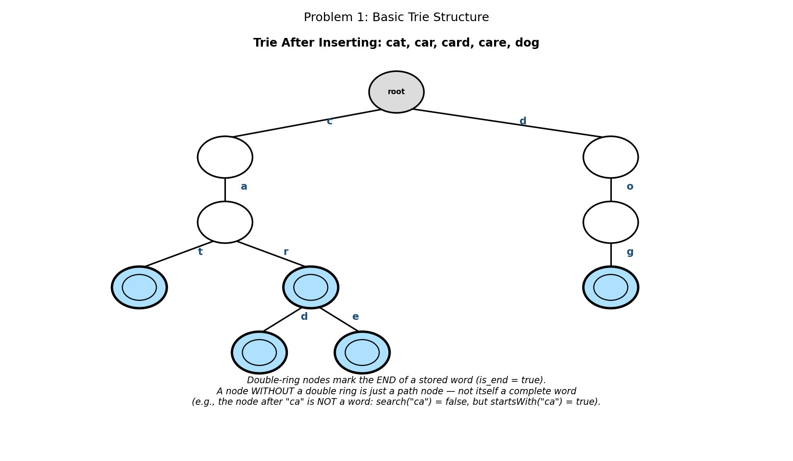

5. Java Program
import java.util.HashMap;
import java.util.Map;

public class BasicTrie {

static class TrieNode {
Map<Character, TrieNode> children = new HashMap<>();
boolean isEnd = false;
}

static TrieNode root = new TrieNode();

static void insert(String word) {
TrieNode node = root;
for (char ch : word.toCharArray()) {
node = node.children.computeIfAbsent(ch, k -> new TrieNode());
}
node.isEnd = true;
}

static boolean search(String word) {
TrieNode node = findNode(word);
return node != null && node.isEnd;
}

static TrieNode findNode(String s) {
TrieNode node = root;
for (char ch : s.toCharArray()) {
node = node.children.get(ch);
if (node == null) return null;
}
return node;
}

public static void main(String[] args) {
String[] words = {"cat", "car", "card", "care", "dog"};
for (String w : words) insert(w);

System.out.println("Words inserted: " + String.join(", ", words));
System.out.println("search(\"car\") = " + search("car"));
System.out.println("search(\"ca\") = " + search("ca"));
System.out.println("search(\"card\") = " + search("card"));
System.out.println("search(\"care\") = " + search("care"));
System.out.println("search(\"cars\") = " + search("cars"));
}
}

6. Expected Output
Words inserted: cat, car, card, care, dog
search("car") = true
search("ca") = false
search("card") = true
search("care") = true
search("cars") = false

7. Complexity Analysis
- Time Complexity: O(L) for both insert and search, where L is the length of the word being processed — NOT O(n) in the number of stored words, unlike a naive linear scan through a list of strings.
- Space Complexity: O(ALPHABET_SIZE * N * L) in the worst case, where N is the number of words and L is their average length — though shared prefixes mean the ACTUAL memory used is usually far less than this worst-case bound, since common prefixes are stored only once.
- Notice that search("car") and search("ca") take exactly the same TIME (both proportional to their own length), yet return different answers — this is entirely due to the isEnd flag, not the path-following logic itself.

8. Laboratory Exercise
Modify the TrieNode class to also store a count field tracking how many words currently pass through that node (incremented during every insert along the path). Use this count to implement a countWordsWithPrefix(prefix) method that returns how many stored words begin with a given prefix, without needing to traverse the whole subtree.

Problem 2: Implement a "Starts With" Prefix Search Function Using a Trie

1. Objective
To implement a startsWith(prefix) method that determines whether ANY previously inserted word begins with the given prefix — a query a plain hash table cannot answer efficiently.

2. Theory / Background
This is precisely the operation that motivates a trie's existence: a hash table can tell you instantly whether an EXACT string was inserted, but answering 'does any stored word start with these letters?' would require scanning every stored word and checking its prefix one by one — O(N * L) in the worst case, where N is the number of words.
A trie answers the same question in time proportional ONLY to the length of the prefix itself, completely independent of how many words are stored: simply follow the prefix's characters down from the root, exactly as in search() (Problem 1) — but critically, WITHOUT checking the isEnd flag at the end. Reaching the node at all is sufficient proof that the prefix is valid; whether that exact node also happens to mark a complete word is irrelevant to this particular query.

3. Algorithm
1. startsWith(prefix): call findNode(prefix), the same helper used by search().
2. Return true if and only if the returned node is NOT null — the isEnd flag is deliberately never consulted here.
3. Contrast directly with search(word), which performs this identical traversal but ADDITIONALLY requires the final node's isEnd flag to be true.

4. Graphical Illustration
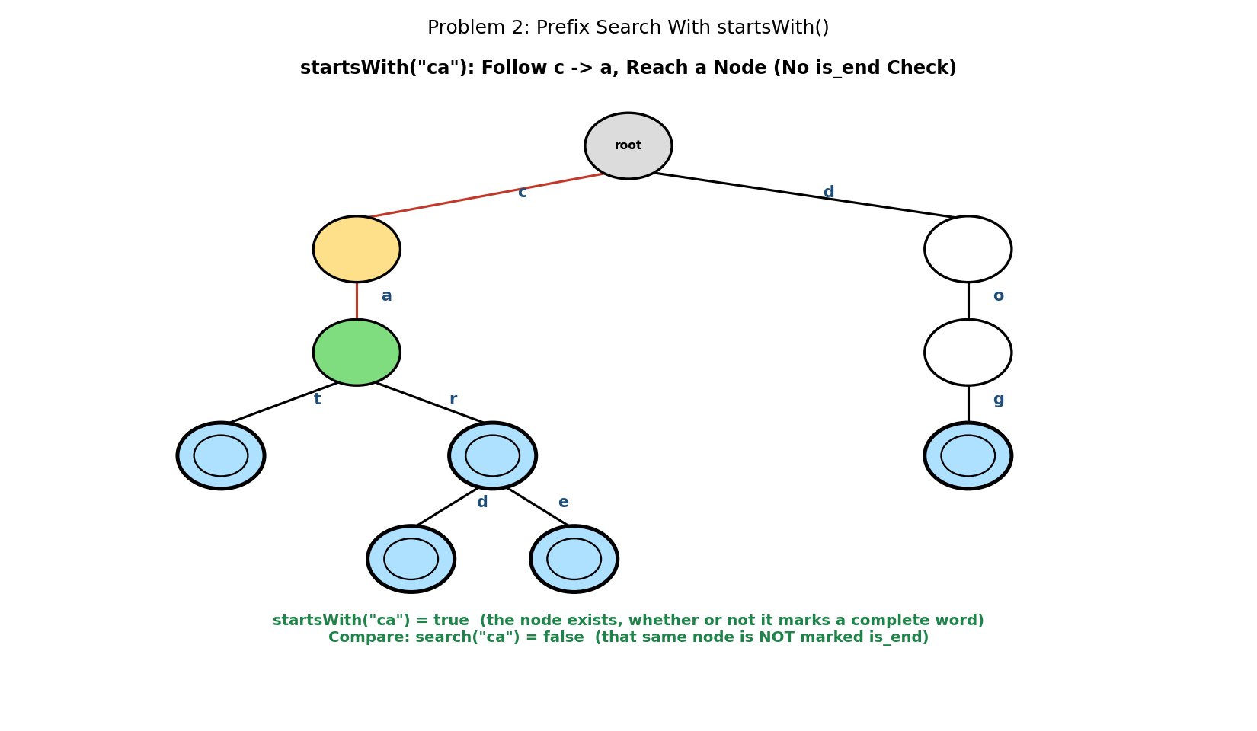

5. Java Program
import java.util.HashMap;
import java.util.Map;

public class PrefixSearch {

static class TrieNode {
Map<Character, TrieNode> children = new HashMap<>();
boolean isEnd = false;
}

static TrieNode root = new TrieNode();

static void insert(String word) {
TrieNode node = root;
for (char ch : word.toCharArray()) {
node = node.children.computeIfAbsent(ch, k -> new TrieNode());
}
node.isEnd = true;
}

static TrieNode findNode(String s) {
TrieNode node = root;
for (char ch : s.toCharArray()) {
node = node.children.get(ch);
if (node == null) return null;
}
return node;
}

static boolean search(String word) {
TrieNode node = findNode(word);
return node != null && node.isEnd;
}

// returns true if ANY stored word begins with this prefix
static boolean startsWith(String prefix) {
return findNode(prefix) != null;
}

public static void main(String[] args) {
String[] words = {"cat", "car", "card", "care", "dog"};
for (String w : words) insert(w);

System.out.println("startsWith(\"ca\") = " + startsWith("ca"));
System.out.println("startsWith(\"do\") = " + startsWith("do"));
System.out.println("startsWith(\"cars\") = " + startsWith("cars"));
System.out.println();
System.out.println("Compare: search(\"ca\") = " + search("ca") +
" (prefix exists, but not a stored word)");
}
}

6. Expected Output
startsWith("ca") = true
startsWith("do") = true
startsWith("cars") = false

Compare: search("ca") = false (prefix exists, but not a stored word)

7. Complexity Analysis
- Time Complexity: O(P) — where P is the length of the prefix string — completely independent of N, the number of words stored in the trie.
- Space Complexity: O(1) additional space beyond the trie itself; findNode() uses no extra data structures.
- This single method is the foundation that Problem 4's autocomplete feature builds directly on top of: startsWith() answers 'does this prefix exist?', while autocomplete extends the same traversal to then also collect every complete word reachable from that point.

8. Laboratory Exercise
Add a longestCommonPrefix() method that returns the longest string which is a prefix of EVERY word currently stored in the trie (or an empty string if the trie is empty or the words share no common prefix). Test it on the words in this problem — the expected result is an empty string, since 'cat'/'car'/'card'/'care' share only 'ca' while 'dog' shares nothing with them.

Problem 3: Delete a Word From a Trie While Preserving Other Words

1. Objective
To remove a specific word from a trie so that search() correctly reports it as absent afterward, while leaving every OTHER stored word — including ones that share part of the deleted word's path — completely intact.

2. Theory / Background
Deleting a word from a trie is subtler than it first appears, precisely because of the path-sharing that makes tries efficient in the first place. Simply unmarking the final node's isEnd flag is often correct by itself (if no other word extends past that point), but a node must NEVER be physically removed from the trie if it still has children, because some OTHER longer word may depend on that exact path to exist.
In the illustrated example, deleting 'car' must NOT delete the node reached by 'c'-'a'-'r', because 'card' and 'care' both continue through that exact node via their 'd' and 'e' children respectively. The correct behaviour is to unmark that node's isEnd flag (so search("car") becomes false) while leaving the node itself, and both of its children, completely untouched.
The general rule for whether a node may be safely pruned (physically removed from its parent) is: it must have NO children remaining AND it must NOT itself mark the end of some other, shorter word that is still stored.

3. Algorithm
1. deleteHelper(node, word, depth): if depth has reached the end of word, this is the target node. If it was not marked isEnd, the word was never present — return false (nothing to prune). Otherwise, unmark isEnd, then return true only if this node now has zero children (safe to prune).
2. Otherwise, look up the child for the current character. If that child does not exist, the word was never present — return false.
3. Recursively call deleteHelper on that child for the next character. If the recursive call reports the child is now prunable, remove it from this node's children map.
4. Return whether THIS node can also now be pruned: true only if it has no remaining children AND its own isEnd flag is false (it does not mark some other, shorter stored word).

4. Graphical Illustration
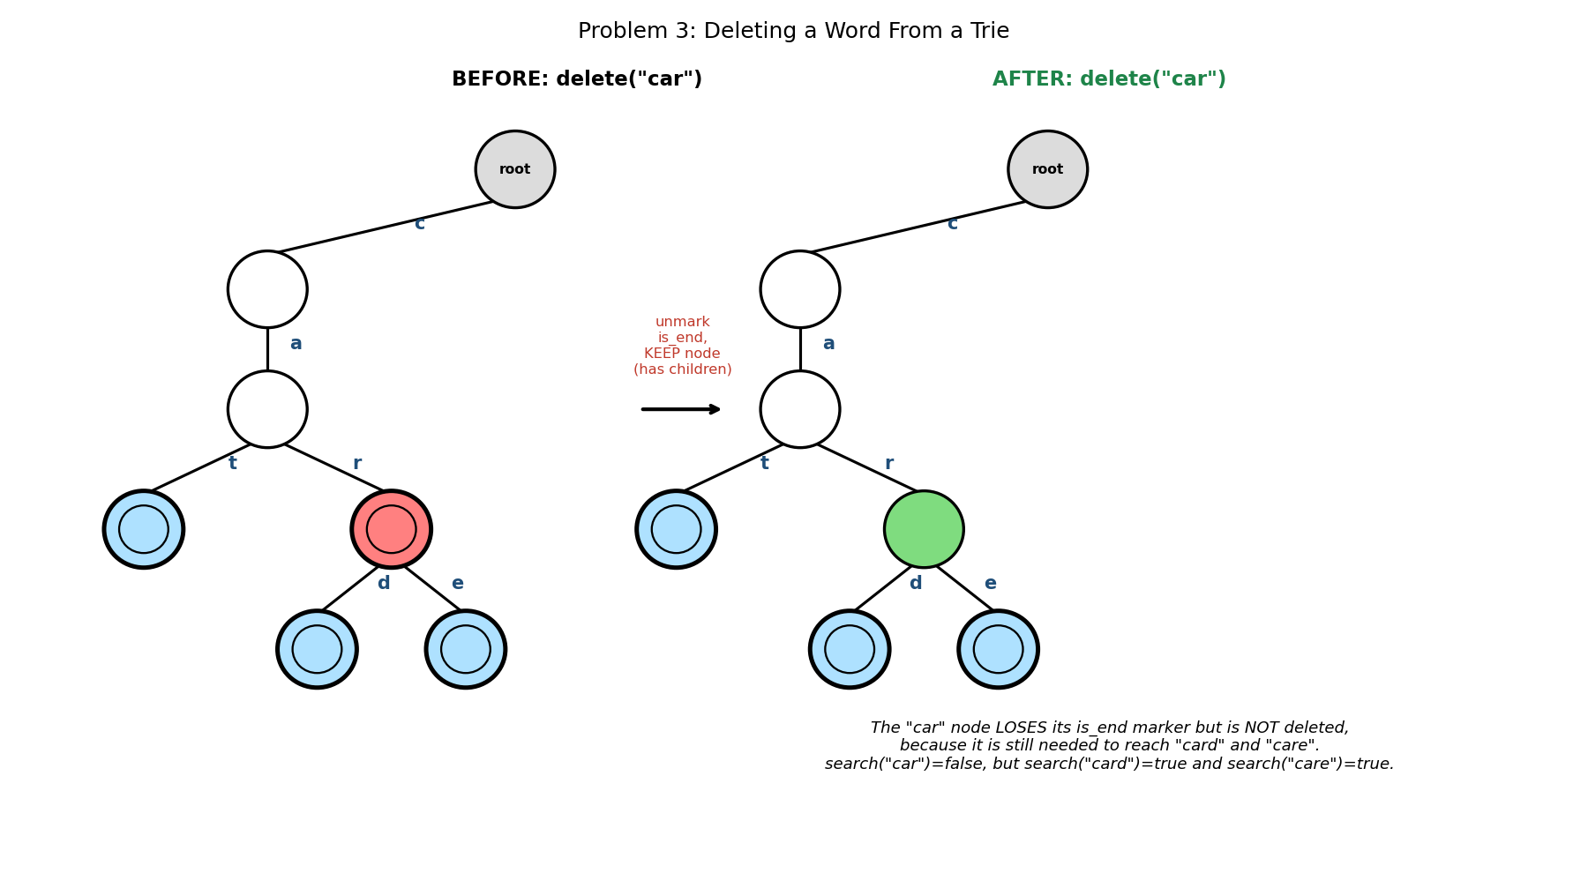

5. Java Program
import java.util.HashMap;
import java.util.Map;

public class DeleteWord {

static class TrieNode {
Map<Character, TrieNode> children = new HashMap<>();
boolean isEnd = false;
}

static TrieNode root = new TrieNode();

static void insert(String word) {
TrieNode node = root;
for (char ch : word.toCharArray()) {
node = node.children.computeIfAbsent(ch, k -> new TrieNode());
}
node.isEnd = true;
}

static boolean search(String word) {
TrieNode node = root;
for (char ch : word.toCharArray()) {
node = node.children.get(ch);
if (node == null) return false;
}
return node.isEnd;
}

static void delete(String word) {
deleteHelper(root, word, 0);
}

// returns true if the CALLER should unlink the child just processed
static boolean deleteHelper(TrieNode node, String word, int depth) {
if (depth == word.length()) {
if (!node.isEnd) return false; // word was never present
node.isEnd = false;
// safe to prune this node only if it has no children of its own
return node.children.isEmpty();
}

char ch = word.charAt(depth);
TrieNode child = node.children.get(ch);
if (child == null) return false; // word was never present

boolean shouldPruneChild = deleteHelper(child, word, depth + 1);
if (shouldPruneChild) {
node.children.remove(ch);
}

// this node can also be pruned if it has no children AND is not
// itself the end of some OTHER shorter word
return node.children.isEmpty() && !node.isEnd;
}

public static void main(String[] args) {
String[] words = {"cat", "car", "card", "care", "dog"};
for (String w : words) insert(w);

System.out.println("BEFORE delete(\"car\"):");
System.out.println(" search(\"car\") = " + search("car"));
System.out.println(" search(\"card\") = " + search("card"));
System.out.println(" search(\"care\") = " + search("care"));

delete("car");

System.out.println("AFTER delete(\"car\"):");
System.out.println(" search(\"car\") = " + search("car"));
System.out.println(" search(\"card\") = " + search("card"));
System.out.println(" search(\"care\") = " + search("care"));
}
}

6. Expected Output
BEFORE delete("car"):
search("car") = true
search("card") = true
search("care") = true
AFTER delete("car"):
search("car") = false
search("card") = true
search("care") = true

7. Complexity Analysis
- Time Complexity: O(L) — where L is the length of the word being deleted; the recursion depth and the work at each level are both bounded by L.
- Space Complexity: O(L) for the recursion call stack.
- The recursive return-value design here (each call reports upward whether ITS child is now safely prunable) is a clean pattern worth internalising: it lets the deletion correctly 'unwind' back up the trie, pruning a whole chain of now-useless nodes in one pass, but stopping IMMEDIATELY at the first node still needed by another word — exactly what happens at the 'car' node in this example.

8. Laboratory Exercise
Delete 'dog' from the trie (the ONLY word passing through the 'd' branch) and verify, by printing startsWith("d") before and after, that the entire d-o-g chain is correctly pruned all the way back to the root — unlike the 'car' deletion, where pruning stopped partway due to shared nodes.

Problem 4: Implement Autocomplete Suggestions for a Given Prefix

1. Objective
To return every stored word that begins with a given prefix, in alphabetical order — the exact feature behind search-box and IDE autocomplete suggestions.

2. Theory / Background
This problem directly extends Problem 2's startsWith() logic: rather than merely confirming a prefix's node EXISTS, autocomplete continues past that node with a full depth-first traversal, collecting every complete word (every isEnd node) found anywhere in the subtree rooted at the prefix's node.
Using a TreeMap (rather than a plain HashMap) for each node's children automatically keeps those children in sorted character order, which means a straightforward DFS visits — and therefore collects — matching words in alphabetical order with no separate sorting step required afterward.

3. Algorithm
1. autocomplete(prefix): call findNode(prefix) (identical to Problem 2). If null, no word has this prefix — return an empty list immediately.
2. Otherwise, call a recursive collectWords(node, currentWord, results) helper starting from the prefix's node, with currentWord initialised to prefix itself.
3. collectWords(node, currentWord, results): if node.isEnd is true, append currentWord to results (it is a complete stored word). Then, for every child in this node's (sorted) children map, recursively call collectWords on that child, extending currentWord by the child's character.
4. Return the accumulated results list once the entire subtree has been explored.

4. Graphical Illustration
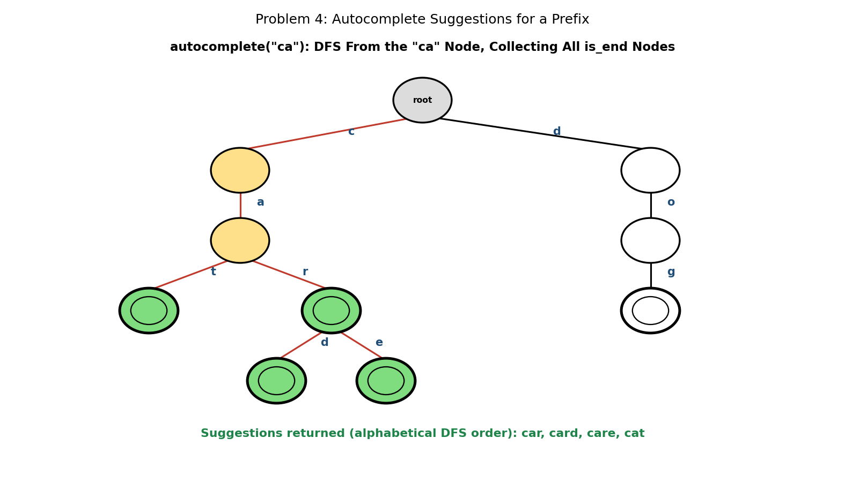

5. Java Program
import java.util.ArrayList;
import java.util.HashMap;
import java.util.List;
import java.util.Map;
import java.util.TreeMap;

public class Autocomplete {

static class TrieNode {
// TreeMap keeps children in sorted character order, giving
// alphabetically-ordered suggestions "for free" during DFS
Map<Character, TrieNode> children = new TreeMap<>();
boolean isEnd = false;
}

static TrieNode root = new TrieNode();

static void insert(String word) {
TrieNode node = root;
for (char ch : word.toCharArray()) {
node = node.children.computeIfAbsent(ch, k -> new TrieNode());
}
node.isEnd = true;
}

static TrieNode findNode(String s) {
TrieNode node = root;
for (char ch : s.toCharArray()) {
node = node.children.get(ch);
if (node == null) return null;
}
return node;
}

static List<String> autocomplete(String prefix) {
List<String> results = new ArrayList<>();
TrieNode prefixNode = findNode(prefix);
if (prefixNode == null) return results; // no word has this prefix

collectWords(prefixNode, prefix, results);
return results;
}

static void collectWords(TrieNode node, String currentWord,
List<String> results) {
if (node.isEnd) {
results.add(currentWord);
}
for (Map.Entry<Character, TrieNode> entry :
node.children.entrySet()) {
collectWords(entry.getValue(),
currentWord + entry.getKey(), results);
}
}

public static void main(String[] args) {
String[] words = {"cat", "car", "card", "care", "dog"};
for (String w : words) insert(w);

System.out.println("autocomplete(\"ca\") = " + autocomplete("ca"));
System.out.println("autocomplete(\"c\") = " + autocomplete("c"));
System.out.println("autocomplete(\"xyz\") = " + autocomplete("xyz"));
}
}

6. Expected Output
autocomplete("ca") = [car, card, care, cat]
autocomplete("c") = [car, card, care, cat]
autocomplete("xyz") = []

7. Complexity Analysis
- Time Complexity: O(P + M) — where P is the prefix length (to locate the starting node) and M is the TOTAL number of characters across all matching words (the size of the subtree explored) — this is optimal, since every returned character must be visited at least once.
- Space Complexity: O(M) for the results list itself, plus O(H) for the recursion stack, where H is the height of the explored subtree.
- Notice that autocomplete("ca") and autocomplete("c") return the IDENTICAL list here, since 'dog' is the only word NOT starting with 'ca', but it also happens to be the only word not starting with plain 'c' either coincidentally excluded — verify this is really because of the shared 'ca' prefix, not a coincidence, by inserting a hypothetical word like 'cup' and re-running both queries.

8. Laboratory Exercise
Modify autocomplete() to accept a maximum result count, limit, and stop collecting as soon as that many words have been found — without exploring the remaining subtree unnecessarily. Test it with limit=2 on autocomplete("ca") and confirm exactly 2 results are returned, taken in the same alphabetical order as the unlimited version.

Problem 5: Design a Trie-Based Solution for Word Search in a 2D Board With Wildcard Support

1. Objective
To determine whether a given pattern — which may include the wildcard character '.', matching any single letter — can be traced out along adjacent cells of a 2D letter board, AND corresponds to an actual word stored in a dictionary Trie.

2. Theory / Background
This problem combines THREE ideas from earlier in this course: 2D board backtracking (visiting up/down/left/right neighbours, marking cells visited to avoid reuse within a single path, then unmarking on backtrack), a dictionary Trie (Problem 1) that defines which letter sequences are valid words, and wildcard matching, where a '.' in the pattern may match ANY board letter at that position, provided the path still leads to a real dictionary word.
The key efficiency insight is that the Trie is consulted at EVERY step of the board search, not just at the end: a board cell is only worth exploring further if its letter continues a valid Trie edge from the current node. This means the search never wastes time following a path that could not possibly spell a dictionary word, regardless of how the wildcard characters are eventually resolved.
In the worked example, board cell letters are checked against the Trie node's children map directly (board_letter must have a corresponding child edge), while the PATTERN character only additionally constrains this: a literal pattern character must equal the board letter, but a '.' imposes no extra constraint beyond what the Trie already requires.

3. Algorithm
1. Build a Trie of dictionary words exactly as in Problem 1.
2. exists(board, pattern): try starting the search from every cell (r, c) on the board; return true as soon as any starting cell succeeds.
3. dfs(r, c, node, pattern, idx): if (r,c) is out of bounds or already visited on this path, fail. Let boardChar = board[r][c] and patternChar = pattern[idx]. If patternChar is not '.' and does not equal boardChar, fail.
4. Look up boardChar (not patternChar) as an edge from the current Trie node. If no such edge exists, fail — this is the Trie-pruning step.
5. If idx is the last character of pattern, succeed if and only if the reached Trie node's isEnd flag is true. Otherwise, mark (r,c) visited, recursively try all four neighbours with idx+1, then unmark (r,c) (backtrack) before returning the combined result.

4. Graphical Illustration
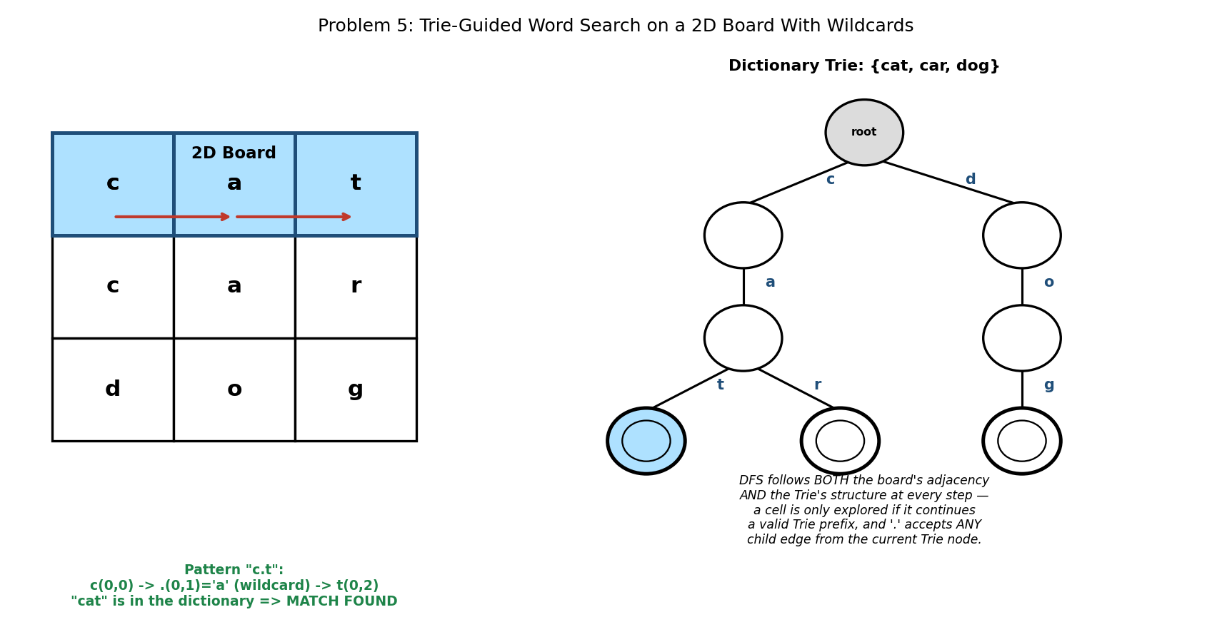

5. Java Program
import java.util.HashMap;
import java.util.Map;

public class WildcardBoardSearch {

static class TrieNode {
Map<Character, TrieNode> children = new HashMap<>();
boolean isEnd = false;
}

TrieNode root = new TrieNode();

void insert(String word) {
TrieNode node = root;
for (char ch : word.toCharArray()) {
node = node.children.computeIfAbsent(ch, k -> new TrieNode());
}
node.isEnd = true;
}

char[][] board;
boolean[][] visited;
int rows, cols;

boolean exists(char[][] board, String pattern) {
this.board = board;
this.rows = board.length;
this.cols = board[0].length;
this.visited = new boolean[rows][cols];

for (int r = 0; r < rows; r++) {
for (int c = 0; c < cols; c++) {
if (dfs(r, c, root, pattern, 0)) return true;
}
}
return false;
}

boolean dfs(int r, int c, TrieNode node, String pattern, int idx) {
if (r < 0 || r >= rows || c < 0 || c >= cols || visited[r][c]) {
return false;
}

char patternChar = pattern.charAt(idx);
char boardChar = board[r][c];

// a specific (non-wildcard) pattern character must match exactly
if (patternChar != '.' && patternChar != boardChar) {
return false;
}
// the board letter must also continue a valid path in the TRIE,
// regardless of whether the pattern character was a wildcard
TrieNode nextNode = node.children.get(boardChar);
if (nextNode == null) {
return false;
}

if (idx == pattern.length() - 1) {
return nextNode.isEnd; // full match AND it's a real word
}

visited[r][c] = true;
boolean found =
dfs(r-1, c, nextNode, pattern, idx+1) ||
dfs(r+1, c, nextNode, pattern, idx+1) ||
dfs(r, c-1, nextNode, pattern, idx+1) ||
dfs(r, c+1, nextNode, pattern, idx+1);
visited[r][c] = false; // backtrack

return found;
}

public static void main(String[] args) {
WildcardBoardSearch solver = new WildcardBoardSearch();
String[] dictionary = {"cat", "car", "dog", "cot"};
for (String w : dictionary) solver.insert(w);

char[][] board = {
{'c','a','t'},
{'c','a','r'},
{'d','o','g'},
};

String[] patterns = {"c.t", "c.r", "d.g", "co.", "ca.", ".ar"};
for (String pattern : patterns) {
boolean result = solver.exists(board, pattern);
System.out.println("exists(board, \"" + pattern
+ "\") = " + result);
}
}
}

6. Expected Output
exists(board, "c.t") = true
exists(board, "c.r") = true
exists(board, "d.g") = true
exists(board, "co.") = false
exists(board, "ca.") = true
exists(board, ".ar") = true

7. Complexity Analysis
- Time Complexity: O(rows * cols * 4^L) in the worst case, where L is the pattern length — from each of the (rows * cols) starting cells, up to 4 neighbours are explored at each of L steps; the Trie pruning (failing fast whenever no matching child edge exists) makes the PRACTICAL running time far better than this bound on most real dictionaries and boards.
- Space Complexity: O(rows * cols) for the visited array, plus O(dictionary size) for the Trie itself, plus O(L) for the recursion stack.
- Study the 'co.' failure carefully: 'cot' IS a valid dictionary word (so the Trie itself contains a path for it), yet exists() correctly returns false, because no 'c' cell is adjacent to any 'o' cell on THIS particular board — proving the algorithm correctly requires BOTH dictionary membership AND physical traceability on the board, neither alone being sufficient.

8. Laboratory Exercise
Extend the program to support a SECOND wildcard character, '*', which (unlike '.') may match ZERO OR MORE board cells in a straight continuing direction (not a full regex '*' — just a simplified single-direction stretch). Explain in a comment why this is significantly harder to implement with simple backtracking than the single-character '.' wildcard, and describe (in words, without necessarily implementing it) what additional state your DFS would need to track.

Probable Examination Question — Module 10 (Tries)
(a) Theory
Explain why a trie can answer 'does any stored word start with this prefix?' in time proportional only to the prefix length, while a hash table storing the same words cannot answer this query without scanning every stored word. Illustrate your answer with reference to the isEnd flag's role in distinguishing search() from startsWith().
(b) Trace / Dry-run
Starting from an empty trie, insert the words "go", "gone", "good", "goat" in that order. Draw the resulting trie, marking every isEnd node clearly. Then trace delete("gone") step by step, stating at each node along the g-o-n-e path whether it is pruned or preserved, and why.
(c) Programming
Write a complete Java program that:
- (i) Builds a trie from a dictionary of at least 6 words of your choosing;
- (ii) Implements a method suggestTop(prefix, k) that returns AT MOST k autocomplete suggestions for a given prefix (as in Problem 4, but bounded); and
- (iii) Implements a method countWords() that returns the total number of complete words currently stored in the trie, computed by traversing the trie itself (not from a separately maintained counter variable).
Your program should compile and run without error, and countWords() must still report the correct count after at least one deletion. State the time complexity of countWords() in terms of the total number of nodes in the trie.
(d) Short Answer [5 marks]
The board-search algorithm in Problem 5 checks the board letter against the Trie's children map at EVERY step, even when the corresponding pattern character is a specific letter (not a wildcard). Explain what would go wrong — or what efficiency would be lost — if this Trie check were skipped whenever the pattern character is not '.'.
Marking Guide Note: Part (b) requires the pruning decision to be justified individually at EACH node along the deletion path, not just the final trie shape — a candidate who correctly draws the final trie but cannot explain why the 'g' and 'go' nodes are preserved while 'n' and the final 'e' node are removed should receive only partial credit. Part (c)'s countWords() must genuinely traverse the trie structure; a solution that simply maintains and returns a separately incremented/decremented integer field defeats the purpose of the exercise and should not receive full marks.

